PreventX Social Script
I will be attending the PreventX conference at the Melbourne Conference and Exhibition Centre. There are two entrances; the entrance closest to PreventX is at 2 Clarendon Street, South Wharf, 3006.

I will see:
- Cars
- Bikes
- People walking
- Roadworks
- Trams
I will hear:
- Cars
- Roadworks
- People talking
- Trams

To enter the building, I will head up the ramp or stairs in front of me. There is an automatic opening door in front of the ramp, the other doors are pull to open.
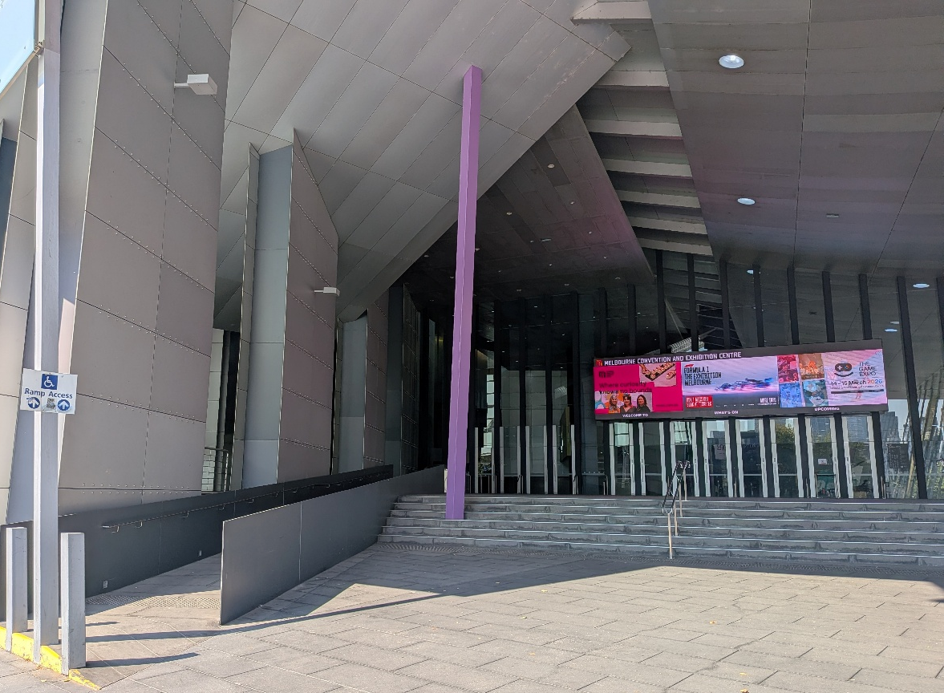

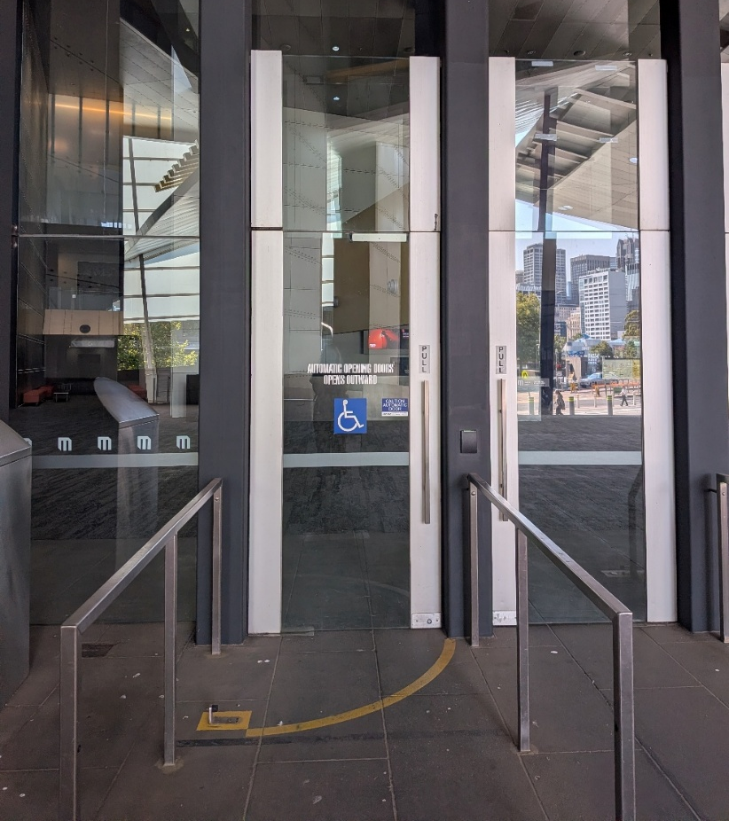

As I enter the building, I will see other people walking around. Some of these people will be heading to PreventX, others will be going to other events in the venue. There will be a customer service desk in front of me, I can ask them for directions or for help. They are friendly, and there to assist me if I need. As I walk into MCEC the area will be filled with natural light, and the floor is carpeted.

I will see:
- Customer service desk
- Children laughing, running or playing
- People talking and walking around
- Screens directing people to different events
I will hear:
- People talking
- Children laughing, running or playing
- People laughing and talking

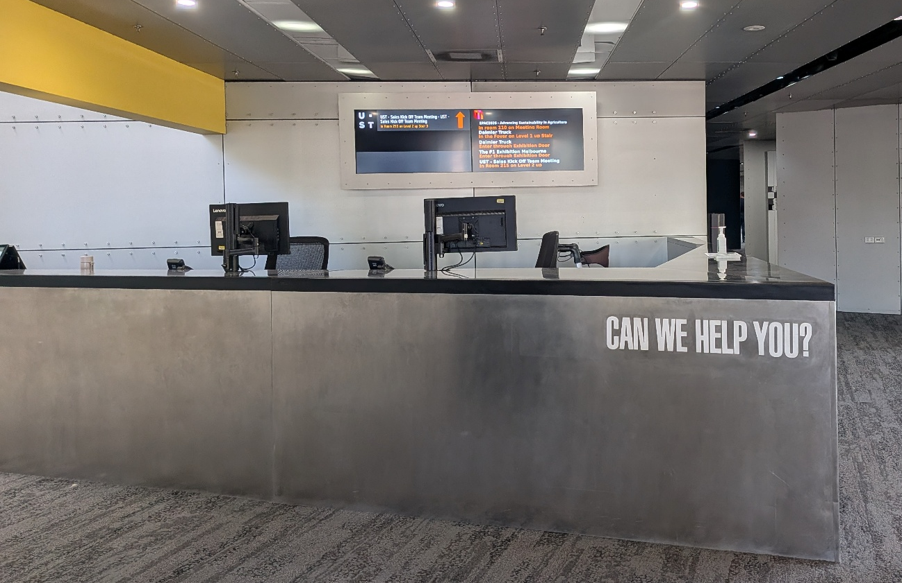

PreventX will take place in the Clarendon rooms, and to register I need to go to the registration desks on level 1. As I pass the customer service desk on the left, I will see a staircase. I can walk up the stairs to the registration desks or take the lifts on the right to level 1. To use the lift, I will click the arrow pointing upwards and select level 1 inside the lift. The registration desks will be to my right as I exit the lifts.
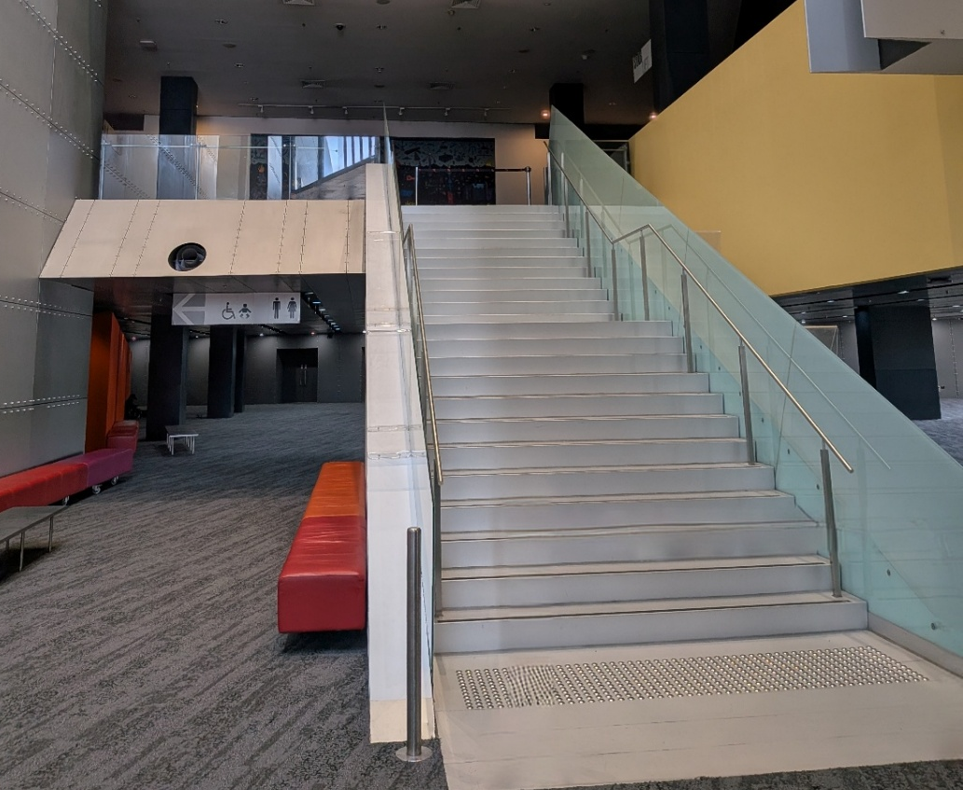

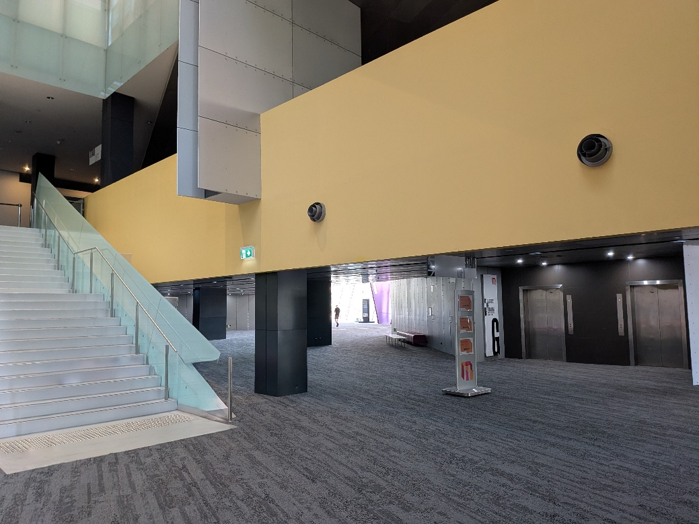

The registration desks will be between these two pillars. There will be people registering at the desks and chatting with each other. The space will have lots of natural light, and some warm lights above. The floor will be carpeted.

I will see:
- Many people talking, smiling, and walking around
- Safe and Equal staff registering delegates at the desks
- Some people sitting on chairs and couches
I will hear
- People talking
- People laughing

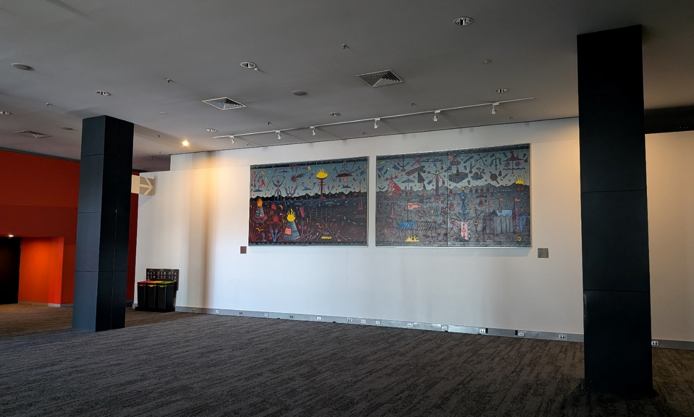

Registration is open from 8.00 – 9.30am on the first day of PreventX. Safe and Equal staff will be there to welcome me, ask for my name, and register me for the conference. They will hand me a tote bag with a printed program in it to read.
After I have registered, I can explore the exhibitor booths located to the right of the registration desks, take a seat throughout the foyer area on level 1, get a coffee, or head to the low sensory space in Clarendon Room C (level 1).
The opening session will take place in the auditorium on level 1, to the left of the registration desks at 9.30am.
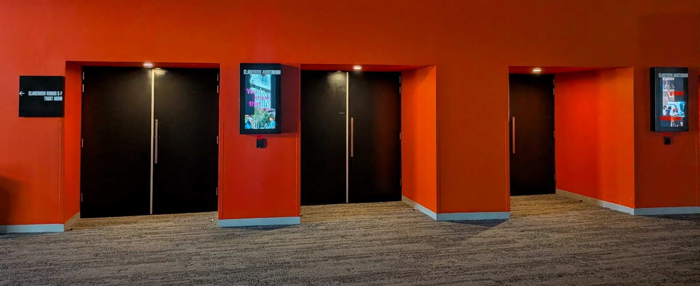
These are the doors that will lead into the auditorium. They are pull to open, and there will be Safe and Equal staff near the doors to welcome and help guests enter the auditorium. The auditorium is to the left of the registration desks.

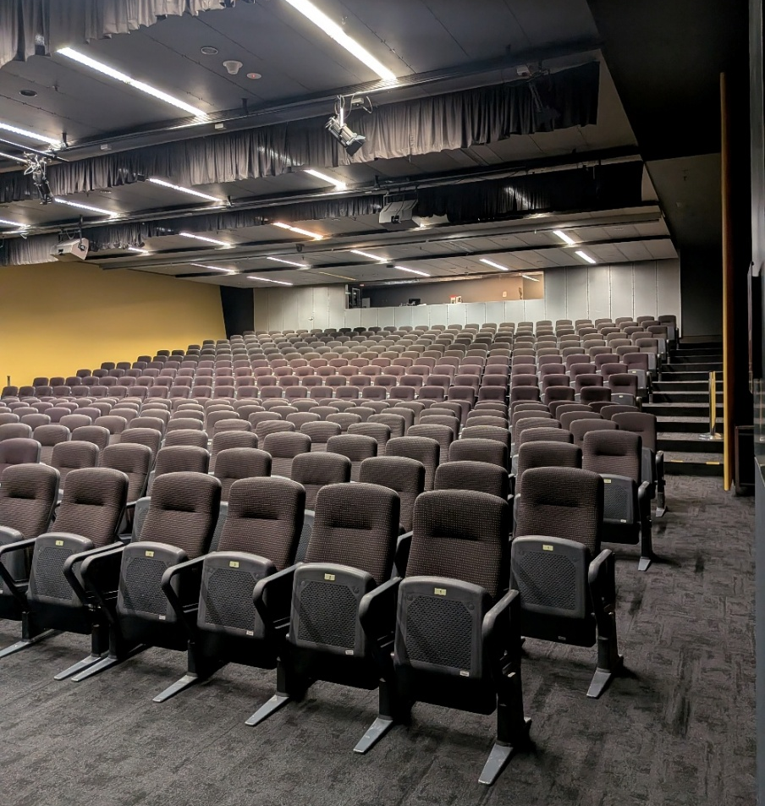
This is the seating inside the auditorium. This room will have all plenary sessions and will become full of people. There will be some seats removed from the front row to allow access for wheelchair users, guests with support animals, and anyone else who may need them.
There will be priority seating signs on some of the chairs by the aisles. This means that other delegates will keep these seats free for those who need them. If I need an aisle seat, I can take a priority aisle seat.
I can leave the auditorium whenever I would like to and head to the low-sensory space at any time.
The auditorium does not have windows, and will have lights in the ceiling; they are a warmer light and not fluorescent light.
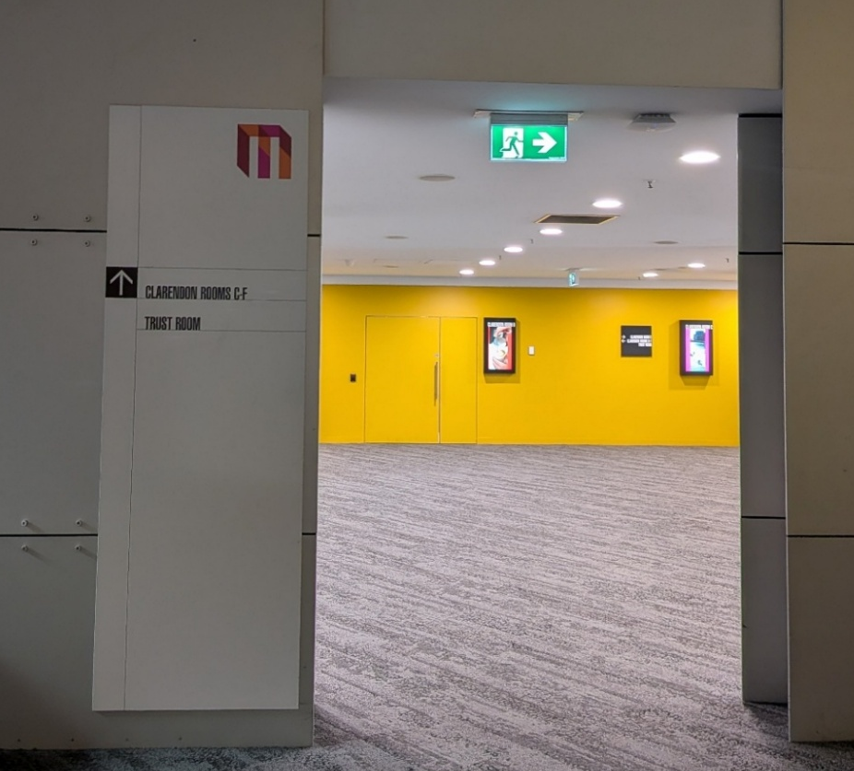
The low sensory space will be in Clarendon Room C on level 1. To get there, I can follow the signs. I will walk through the doorframe towards the yellow walls.
Clarendon Room C is to the right of the yellow walls and down a small hall. This is where the low sensory room will be. This door will remain open so people can enter and leave as they like. The room may be a little dimmed to relax. Locky and Sam from Restorative Yarns will be there, welcoming people.
I will see:
- Locky and Sam
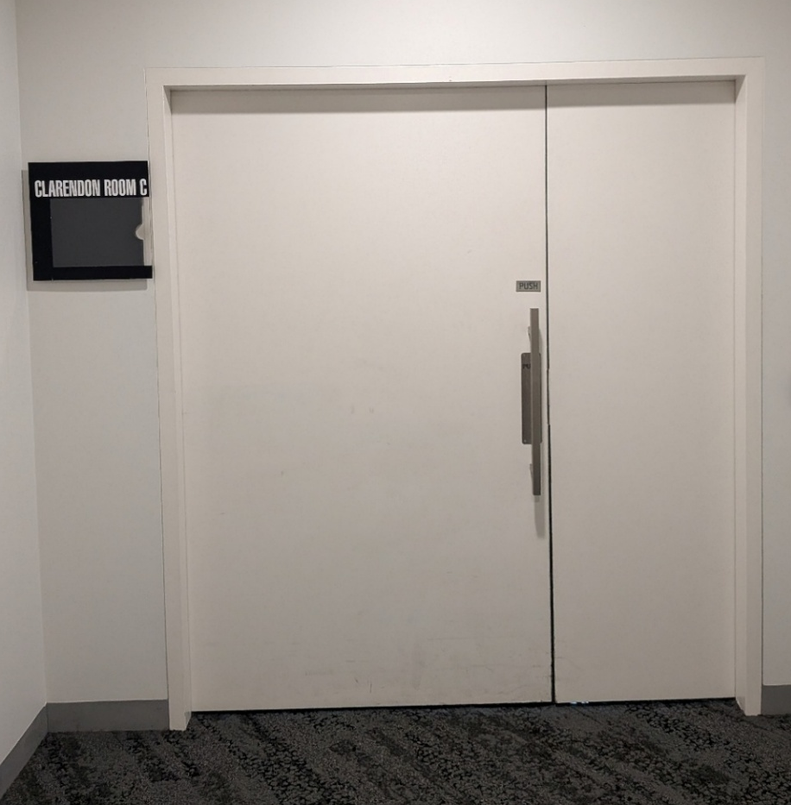
- Pictures on the walls
- Comfortable seating
- Craft materials
- People sewing
I will hear:
- Some soft music at low volume
- People talking in low voices
During the morning of day 1, Locky and Sam will be creating weighted cushions. I don’t need any sewing experience to join, and they will provide all the materials. They will show me how to make the cushions and I can work at my own pace.
Throughout PreventX, Sam and Locky will hold some other activities and grounding exercises. I am welcome to join at any time, for as long as I like.
The activity details will be in the printed program Safe and Equal gave me.
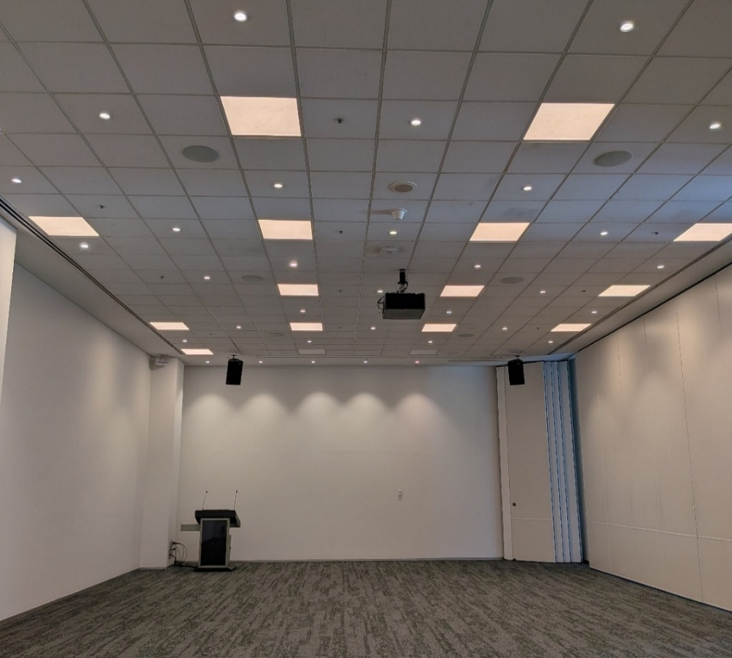
Sessions in Clarendon Room A + B take place on level 4. To get there, I will take the lift from the ground floor or level 1, and select 4 in the lift. The conference rooms are to my right.
Like the auditorium, Clarendon Room B does not have windows. This room has lights in the ceiling, and they give off a warmer light than a white, fluorescent light.

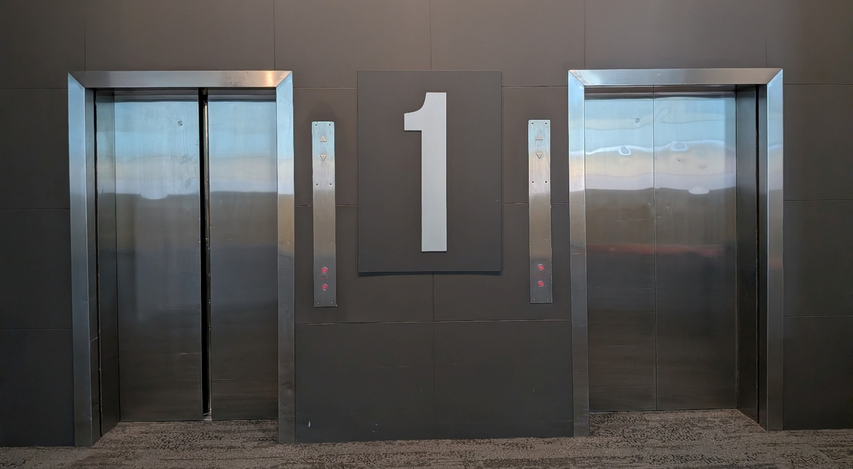

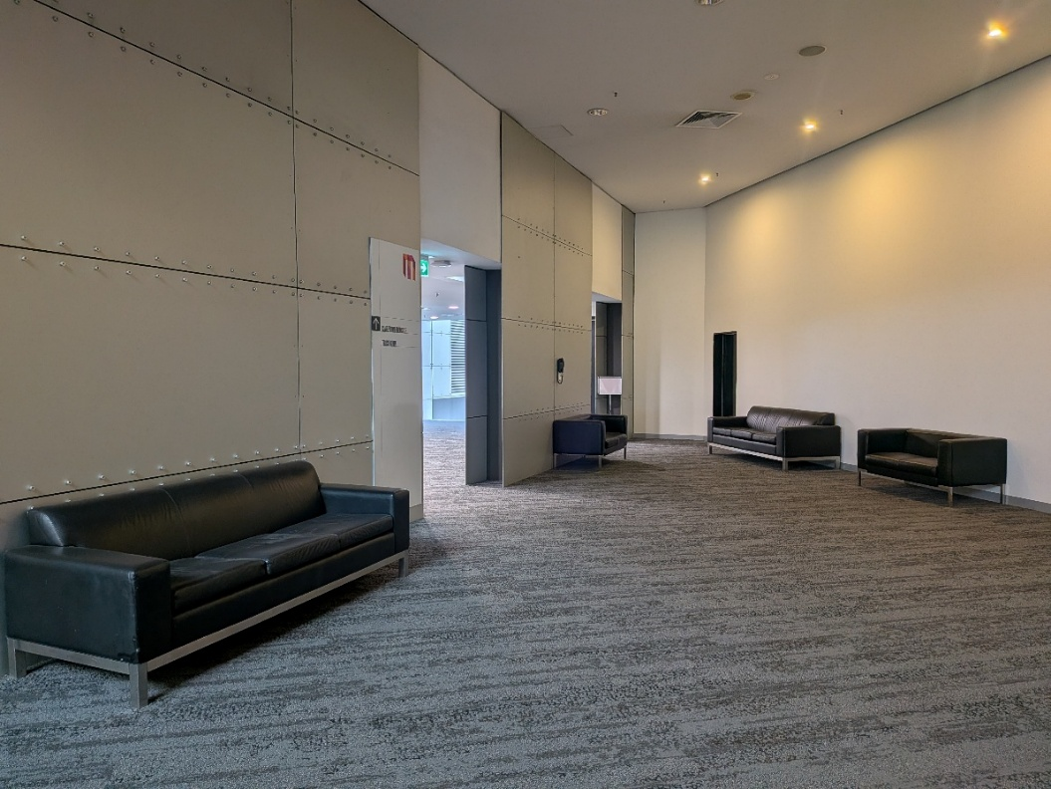
There will be lounges and chairs throughout level 1. These are for PreventX delegates. Anyone can sit here throughout the conference and at mealtimes. Some may have priority seat signs on them. This means that if another delegate needs to sit down, we can offer this seat to them. If I need seat, I can take, or ask for, a priority lounge seat.

What I will see:
- People sitting on lounges
- People standing and chatting or eating
What I will hear:
- Laughter or chatter from people

