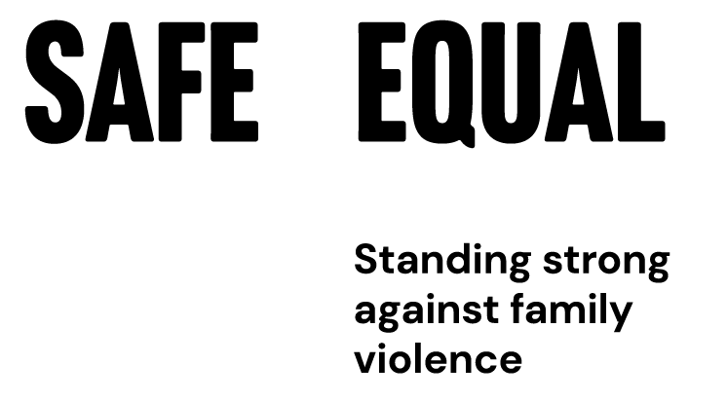

Annual Report 2024–2025
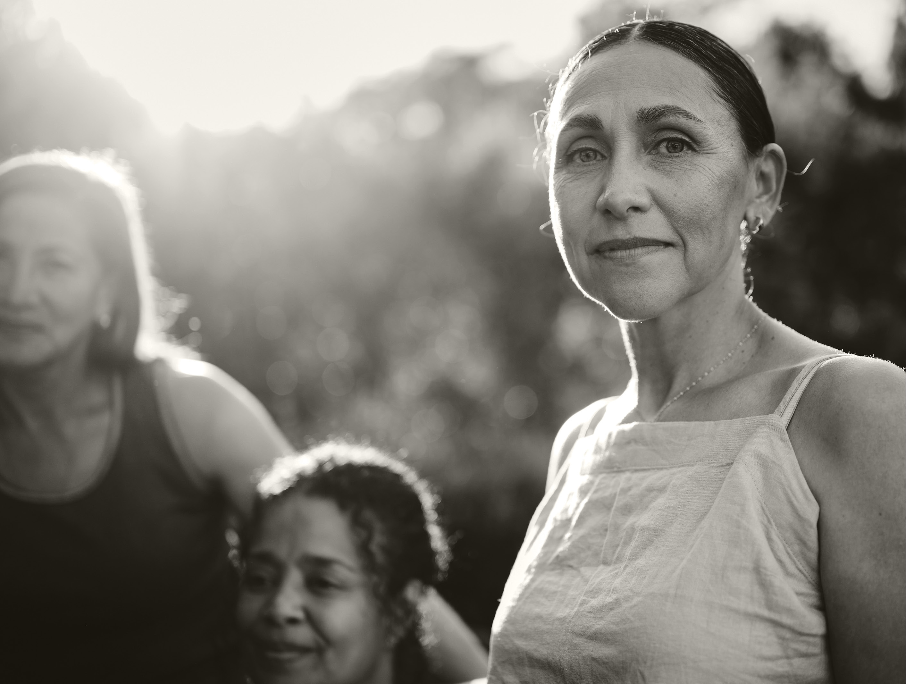

Acknowledgements

Acknowledgement of Traditional Owners
Safe and Equal acknowledges Aboriginal and Torres Strait Islander peoples as the traditional and ongoing custodians of the lands on which we live and work. We pay respect to Elders past and present.
We acknowledge that sovereignty has never been ceded and recognise First Nations peoples’ rights to self-determination and continuing connections to land, waters and community.


Honouring victim survivors
Safe and Equal honours the strength and resilience of adults, children and young people who have experienced family violence and recognises that it is essential that responses to family violence are informed by their expert knowledge and advocacy.
We pay respect to those who have not survived and acknowledge the lasting impacts of this preventable violence on families and communities.

Celebrating diversity
At Safe and Equal we value different perspectives, ways of thinking and ways of knowing. Our diversity is our strength. We welcome people from diverse backgrounds and experiences, including people with disability and people with different cultural backgrounds, ethnicities, lived experiences, gender identities, sexual orientations and religions. Together we foster a culture where everybody can belong, connect and succeed. We endeavour to be flexible and meet people where they are with openness and curiosity.
We respect and honour First Nations peoples’ rights to self-determination and cultural safety, and we work in solidarity with Aboriginal and Torres Strait Islander peoples. We are bold in our advocacy for a more just world. We are an Equal Opportunity employer, an accredited Rainbow Tick workplace and do not tolerate any form of discrimination or harassment.
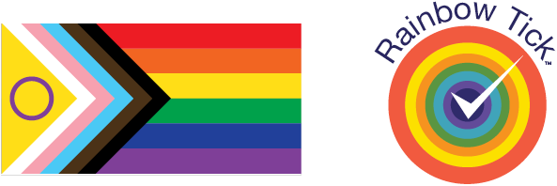

Contents
Acknowledgements 2
Introduction 5
About us 5
Strategic Plan 2024–2027 6
Chair Report 8
CEO Report 11
Strategic priority 1: Lead and provoke change and influence policy, systems and the public agenda 14
Policy and Advocacy 14
Media and Communications 14
Workplace Consultancy 15
Strategic priority 2: Drive practice excellence and workforce development 16
Training 16
Communities of Practice and Networks 17
Leadership Development 18
Partnerships 19
Lived Experience 21
Strategic priority 3: Bolster an enduring specialist sector and peak 22
Impact Measurement 22
Safety Measures 22
Inclusion at Safe and Equal 23
Safe and Equal Members 23
Funders and Supporters 23
Financial Report 23
Board Members 24

Introduction

About us
We are the peak body for Victorian organisations that specialise in family and gender-based violence across the continuum, including primary prevention, early intervention, response and recovery. Our vision is a world where everyone is safe, respected and thriving, living free from family and gender-based violence.
As a peak, we work with and for our members to prevent and respond to violence, building a better future for adults, children and young people experiencing, at risk of, or recovering from family and gender-based violence. While we know that most family violence is perpetrated by men against women and children, we recognise that family violence impacts people across a diversity of gender identities, social and cultural contexts, and within various intimate, family and other relationships. We apply an intersectional feminist lens to our work to address the gendered drivers of violence and how these overlap and intersect with additional forms of violence, oppression and inequality. We bring together evidence, lived experience, practice expertise and collaborative partnerships to mobilise for and effect social, policy and system change. We advocate on behalf of and support the development of high-quality services and programs across the continuum. We drive the continued development of an innovative and leading family violence sector.

Strategic Plan 2024–2027

Our vision
A world where everyone is safe, respected and thriving, living free from family and gender-based violence.

Our values
- Accountability + Integrity
- Equality + Justice
- Compassion + Humility
- Expertise + Collaboration
- Boldness + Courage
- Curiosity + Reflection

Priority 1: Lead and provoke change and influence policy, systems and the public agenda
Our voice is more essential than ever. We seek to drive change in policy and service systems, and also in community attitudes and public discussion of the program. We will:
- keep family and gender-based violence on the agenda and drive change
- unequivocally use our voice to effect change, backed by evidence, lived experience, member authorisation and practice expertise
- work in partnership to do better, and to deliver more impact

Priority 2: Drive practice excellence and workforce development
A core part of our role is to support the capability, sustainability and connectedness of the specialist family violence workforce, the prevention workforce and broader workforces whose works intersects with family violence. We will:
- set standards for and support the pathways to an even stronger, skilled sector
- lead the continuous evolution of specialist practice, and share this with others in related systems and sectors
- share lessons and insights from evidence, expertise and lived experience

Priority 3: Bolster an enduring specialist sector and peak
We work in a mutually supportive ecosystem of services and programs and as a peak we work closely to support and be supported by our members. We collectively play a critical and specialist role. We will:
- work over the next three years to strengthen the sector, our members, and us as a peak in order to support them
- gather and share data and evidence
- support financial sustainability across the sector
- strengthen our own organisation’s culture and practice

Chair Report
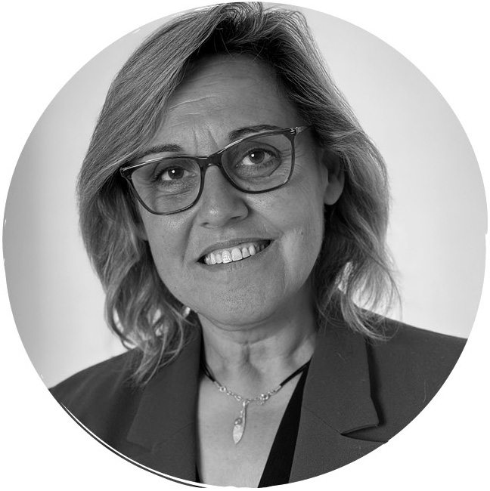
This year has unfolded at a time of profound significance in Victoria’s story. As the State advances its Treaty process with First Peoples, we are collectively challenged to reckon with truth, to repair relationships, and to transform systems that continue to cause harm. For Safe and Equal, this is not symbolic. It is central to our purpose and to the kind of family violence system we are working to shape.
Our ongoing partnerships with Djirra and Elizabeth Morgan House have continued to guide us in this work. These relationships call us to listen deeply, to acknowledge the harms of colonisation as living conditions, not history, and to recognise that genuine accountability requires structural change. I want to particularly acknowledge the cultural and strategic leadership of First Nations leaders across the sector, especially our Board colleague Sue-Anne Hunter, whose grounding, truth-telling and strength have sharpened our thinking and our resolve.
This year has also been defined by the unwavering leadership of our CEO, Tania Farha. Tania’s vision is not only strategic, but firmly principled. At a time when the sector is facing escalating demand, political complexity and reform fatigue, she has held firmly to the belief that we can do more than respond to crisis: we can prevent violence before it occurs; we can build systems that are safe, accountable and culturally responsive; we can shape a future where all communities live free from violence. Her leadership has been pivotal in positioning Safe and Equal as a clear, steady and courageous voice, across government, across the sector, and in public discourse.

While strategic advances and system insights have shaped much of our work this year, what has moved me most has been our people. Some of my most meaningful moments have been sitting with staff: hearing about the work they do every day, the decisions they carry, the advocacy they hold, the care they give, and the complexity they navigate quietly and bravely.
It is our staff who turn the vision of the Board into practice. It is our staff who quietly shift systems, one conversation, one risk assessment, one policy change, one relationship at a time. Their expertise and commitment are the beating heart of this organisation.
Since the merger in 2021, Safe and Equal has moved beyond establishing identity. We are now shaping what comes next. This year has been one of strategic consolidation and forward momentum: strengthening the core architecture of the organisation while positioning ourselves to lead in a rapidly evolving landscape.
The development of our Impact Measurement Framework marks a significant milestone. It represents our commitment to evidence-based leadership and clear accountability, to not only do the work, but to show what changes because of it. Our system monitoring work, including the 2024 Measuring Family Violence Demand and Capacity report and our 2025 early intervention scoping research, provides a sharper, more honest picture of where pressure continues to build, particularly in access to mental health supports, alcohol and other drug services, and safe housing. These insights are vital for shaping the next decade of reform.
We are also clear-eyed about the challenges ahead. Workforce wellbeing remains one of the most significant pressures facing the sector. The emotional, intellectual and relational labour required to respond to family violence is immense. A safe, well-supported workforce is not a resourcing question rather it is a precondition for a functioning system. Safe and Equal will continue to advocate for sustained investment, safe workloads, professional pathways, and organisational cultures that honour safety, dignity and care.
To my fellow Board members, thank you for your governance, clarity, and commitment. I acknowledge our outgoing members: Joe Ball, Libby Jewson and Chris Mathieson with deep appreciation for their contribution. And I warmly welcomed the wisdom and leadership of Sue-Anne Hunter, who joined us in July 2024 until her recent appointment as National Commissioner for Aboriginal and Torres Strait Islander Children and Young People.
Finally, to Tania and to every member of the Safe and Equal team: thank you. Your work is both essential and transformative. The courage you bring to your daily practice, the integrity with which you hold victim survivors, and the clarity you bring to advocacy and reform are reshaping what safety, justice and dignity look like in this state.
We stand at a defining moment, one that asks us to be bold, to imagine more than incremental change, and to insist that the systems we build must be capable of real safety, real accountability and real equity. This is systems reform. It is long-term work. Structural work.
As Arundhati Roy reminds us:
“Another world is not only possible – she is on her way. On a quiet day, I can hear her breathing.”
But she will not arrive by accident. She will not arrive through small steps or short-term cycles of funding. She will only arrive if governments commit to the long arc of change, to sustained investment, to stable workforces, to culturally grounded leadership, and to systems built for safety, justice and dignity, not crisis alone.
This work requires courage. It requires endurance.
And it requires us collectively to believe that the future can be different from the past.
I believe this. I believe it deeply.
And I believe, unequivocally, that Safe and Equal is ready to help lead that future.
Maria Dimopoulos
Chair, Safe and Equal

CEO Report
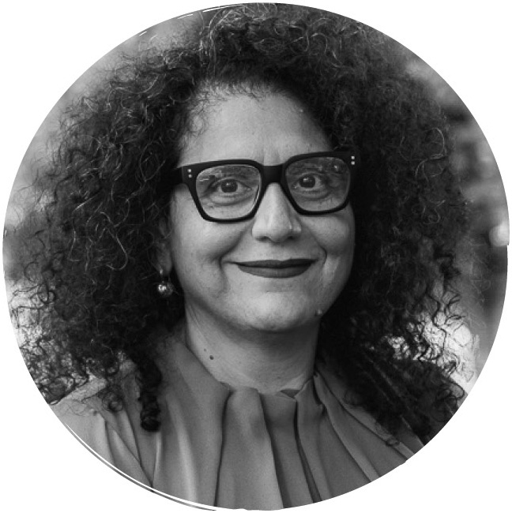
More than most in recent memory, this year has underscored the urgent need for bold, sustained action to end family and gender-based violence. I am proud to reflect on the significant efforts of Safe and Equal across the last twelve months to drive long-term, sustainable change – both here in Victoria, and on a national scale.
As the peak body, we aim to be a consistent and informed voice for members and partners, amplifying what the sector is experiencing on the ground and pushing for comprehensive and coordinated action and investment across the system.
This includes advocating for system reform that enables safer, accessible support for all victim survivors. No one should be left behind. Every person experiencing family violence should be able to receive the tailored support they need, when they need it, from crisis through to long-term therapeutic care and housing – regardless of their age, gender, identity, where they live, or their circumstances. We also know that long-term change is needed across society to change attitudes and behaviours, with a focus on intervening early and stopping violence before it starts. This needs to be holistic, with a simultaneous, collective focus across the continuum.
In the first year of implementing our 2024-27 Strategic Plan, we have leaned into bold advocacy to support an inclusive and strengthened system. Our focus is underscored by our three strategic and four advocacy priorities, and sits in alignment with the Victorian Government’s Third Rolling Action Plan to end family and sexual violence. Much of our advocacy has been driven by the fact our sector is at a critical crossroads: at the end of the next financial year, we are expecting to see a significant lapse in funding. To this end, a central focus this year through budget submissions, joint statements and public campaigns, has been in demonstrating the need for sustainable, multi-year funding across the continuum. It is absolutely vital that our sector is adequately funded, not only to meet rising demand, but to ensure primary prevention programs are implemented, and that the workforce is supported to deliver innovative, integrated and culturally responsive supports and programs.
Alongside this advocacy, we have continued working to understand the capacity of the specialist family violence sector to better support victim survivors. We know the pressures facing specialist services remain significant, and findings from the 2024 Measuring Family Violence Demand and Capacity Report highlight the struggles of the sector under increasing demand and without adequate resourcing. Longer wait times, barriers to safe pathways, and lack of access to housing and supports for mental health and alcohol and other drugs are the reality for many victim survivors. We require sustained, coordinated investment across systems, not just within the family violence service system.
In the last year, we delivered Foundations for Action, an important piece of work mapping the primary prevention workforce across sectors, settings, locations and communities. This workforce continues to be supported by our rapidly growing Partners in Prevention (PiP) network, which went from strength to strength this year. Our members doing prevention and the PiP members have continued to bring practice wisdom that sharpens our advocacy and informs future direction. This is vital as we navigate a climate of backlash to gender equity, racism, homophobia, transphobia, mis and disinformation. We remain vigilant, connected and steadfast, because we know that real change takes time, persistence, and a united sector willing to challenge harmful norms to build a better future.
I am also proud of the work undertaken to ensure ongoing system improvements. A key part of this has been the Early Intervention in Family and Gender-based Violence scoping paper, which charts a pathway for Victoria to strengthen targeted, evidence-informed supports earlier in people’s journeys, so fewer families reach crisis. This work complements our continued collaboration with government on the development and upcoming implementation of the Children and Young People MARAM tools. Through sector engagement, we’re focused on ensuring practitioners have the capability, resources and tailored supports they need to embed these tools in practice.
A continued priority for Safe and Equal is embedding lived experience at the heart of our work. Through the lived experience program, underpinned by the Family Violence Experts by Experience Framework, we continue to be committed to centering the perspectives and expertise of survivor advocates across all areas of our organisation. Earlier this year, we undertook a reflective process with some of the survivor advocates and staff involved in the program since its inception, to shape the future of this work both within Safe and Equal and across the broader sector. This is a vital part of strengthening specialist family violence practice, which must always be informed by the lived experiences, knowledge and leadership of victim survivors.
Our work to develop a client-centred, inclusive family violence system is only possible through intentional and meaningful partnerships. I deeply value our continued collaboration with Djirra and Elizabeth Morgan House to support non-Aboriginal services to embed cultural safety in tangible, accountable ways. I also acknowledge our ongoing partnerships with organisations that provide programs for LGBTIQA+ communities, including Rainbow Health Australia and Zoe Belle Gender Collective, whose advocacy strengthens inclusive practice across the sector. We have continued partnerships with the Multicultural Centre for Women’s Health and Women with Disabilities Victoria to help build our primary prevention and response workforces to deliver culturally responsive and accessible services and programs. This work has been further enhanced by an expansion of Multicultural Advisor and Disability Advisor roles. Finally, we continue to work closely with partner peak bodies to maximise collective impact, including Sexual Assault Services Victoria, No to Violence, and the Centre for Excellence in Child and Family Welfare.
I wish to acknowledge our Board and its stewardship, with particular thanks to our Chair, Maria Dimopoulos. We are grateful for the Board’s continuity, care and unwavering focus on accountability, transparency, and strategic impact. I also extend deep thanks to the Victorian Government and our philanthropic partners for their support and collaboration.
I also want to recognise and thank the staff of Safe and Equal. Your expertise, courage, and dedication underpin everything we do, from practice leadership and workforce development to advocacy and partnership. I am immensely proud of the organisation Safe and Equal has become and of all the people who work in this organisation. Everyone who works here, without exception, not only works to achieve the goals and priorities of the organisation but does this this whilst living the values that are the foundation of this work.
Finally, to our member organisations: thank you for the collaborative impact you continue to drive across the continuum. If we stay connected and work collectively, with courage, compassion and a shared commitment, I believe we can continue to drive the change that all victim survivors deserve.
Tania Farha
CEO, Safe and Equal

Strategic priority 1: Lead and provoke change and influence policy, systems and the public agenda

Policy and Advocacy
Policy analysis, development and advocacy are key aspects of our work. Our submissions are underpinned by specialist expertise and developed in consultation with member organisations, survivor advocates, and other subject matter experts to ensure the experiences of victim survivors and the specialist family violence sector inform and shape government policy and legislation at all levels.
In FY25, the organisation made 38 formal submissions, with its reports and recommendations referenced extensively in official inquiries and legislative reforms. Notably, government reports cited Safe and Equal’s work dozens of times, demonstrating its credibility and impact. The 2024 Demand and Capacity Survey provided robust sector data, strengthening advocacy for sustained investment and improved service delivery. These activities have strengthened Safe and Equal’s ability to shape policy decisions, drive systemic improvements, and elevate the public conversation around family and gender-based violence, ensuring that advocacy efforts translate into meaningful change across the sector and society as a whole.

Media and Communications
A key part of our role is to provide expert commentary on issues relating to family and gender-based violence in the Victorian context and beyond. In FY25, we circulated our media releases across a wide range of publications and news outlets. See Safe and Equal – Media releases.
Campaigns such as “16 Days of Activism” and “Are You Safe at Home? Day” drove significant online interaction. The organisation gained thousands of new followers across LinkedIn, Facebook, and Instagram, and its resources were accessed and shared widely by individuals and partner organisations. This uplift in digital engagement demonstrates that Safe and Equal’s messaging is resonating with a broad and diverse audience, amplifying advocacy and increasing public awareness of family and gender-based violence.

- 305,000+ webpage users in FY25
- 38,500 Facebook REACH (Impressions) in FY25
- 168,500 Instagram reach (impressions) in FY25
- 343,700 LinkedIn reach (impressions) in FY25
- 16 Days of Activism 2024 social media campaign videos were viewed over 16,000 times
- Are You Safe at Home? Day 2025 had almost
18,000 Instagram views in total throughout the campaign, plus
- 9,000 views on its animated reel in a single day

Workplace Consultancy
Over FY25, we continued to grow partnerships across non-family violence sectors nation-wide, through consultancy and training. Our objective is to help strengthen the way organisations and businesses understand and respond to family violence, for both employees and customers. Safe and Equal consulted with 25 workplaces, across a range of sectors, to prevent and respond to family and gender-based violence. Sectors included utility companies; regulators; other government agencies at the local, state and federal levels; insurance organisations; public health companies; community organisations; and hospitality businesses.
Through this work, we’ve seen that meaningful change is most achievable when strong leadership and dedicated resourcing are in place. Organisations with executive and board-level commitment were able to embed family violence responses more deeply, not only updating policies and procedures, but also shifting workplace culture and building safer, more supportive environments for both staff and customers. Where leadership support was limited, progress became more transactional. These insights reinforce the importance of sustained investment and dedicated roles to drive whole-of-organisation change and ensure that family violence responses are not only implemented but embedded.

Victorian Water Corporation
Safe and Equal reviewed this utility provider’s family violence related procedures, offering recommendations to strengthen accessibility, clarity, and alignment with better practice. The engagement led to the development of a training package for 950 staff, including an eLearn and facilitated workshops, as well as establishing ongoing collaboration to support employee and customer safety.

Strategic priority 2: Drive practice excellence and workforce development

Training
Safe and Equal’s primary prevention training equips practitioners with the foundational knowledge, practical tools and confidence to prevent family and gender-based violence. It builds capability to deliver best practice primary prevention, while fostering a common language and shared understanding of key concepts across the sector.
Our response training, including the suite of MARAM packages, is delivered to specialist family violence practitioners, alongside broader workforces. These programs are designed to build consistent and capable responses and support for victim survivors across all service settings.
In FY25, Safe and Equal delivered a wide range of training packages aimed at strengthening workforce capability:
- Over 5,000 practitioners completed response training programs, including MARAM training modules such as Screening and Identification, Brief and Intermediate, Comprehensive Risk Assessment and Management, Working with Adults Using Family Violence, and Predominant Aggressor Identification and Responding to Misidentification. Specialist modules were also delivered to The Orange Door, alongside public sessions on Responding to Disclosures and Case Notes, Family Violence and the Law.
- ~1,000 people participated in primary prevention training, including bystander action, responding to interpersonal and organisational resistance, prevention in practice, and responding to disclosures in prevention work.
- Specialist modules, such as the Unlearning Ableism e-learn developed in partnership with Women and Disabilities Victoria, were developed to address emerging sector needs and strengthen intersectional practice.
For more information, see Safe and Equal – Training and professional development.
Post-training evaluations consistently demonstrated strong improvements in participant confidence and capability. Notably, 89% of prevention training participants agreed or strongly agreed that the training enhanced their understanding and confidence. Response training participants also reported significant gains, with average self-reported knowledge and skills increasing from 1.9 to 2.7 after training. These findings are supported by focus groups and interviews, which confirm that practitioners feel more confident, skilled and validated in their roles, often indicating improvements in practice as a result of the training.

Misidentification Training
Safe and Equal’s Misidentification Training helps practitioners accurately identify the predominant aggressor in complex cases, reducing the risk of victim survivors being wrongly labelled. Using specialist tools and lived experience insights, the program builds confidence and equips practitioners to advocate effectively and apply nuanced strategies in their daily work.

Unlearning Ableism: From Bias to Best Practice e-learn
At the launch webinar for the Unlearning Ableism e-learn, co-hosted with Women with Disabilities Victoria, 83% of the 200 participants rated the content as highly relevant and 84% rated the session as excellent or very good. Feedback shows the program strengthened knowledge and confidence to embed disability-inclusive practice.

Communities of Practice and Networks
In FY25, Safe and Equal facilitated a range of networks and communities of practice to build capability across the prevention and response sectors. Safe and Equal supports practitioners to connect with peers and share learnings and expertise through communities of practice, face-to-face and virtual events and discussions. In the last year we delivered:
- 11 Communities of Practice to support capability and capacity building across the specialist family violence workforce. These included role-specific Communities of Practice, as well as those focused on strengthening inclusive practice. These included the Disability Practice Leader CoP and the Multicultural Inclusion CoP, which create spaces for reflection and collaboration across the response sector.
- 6 Communities of Practice supporting the primary prevention workforce across various themes including Respectful Relationships Education and In-School Settings, Resistance in Gender Equality and Primary Prevention, Workforce Development, Emerging Prevention Practitioners, Mid-Senior Prevention Practitioners and a dedicated CoP for the Victorian RRE workforce on backlash and resistance.
- The Partners in Prevention (PiP) Network, connecting thousands of members across the primary prevention workforce, providing events, resources, training and communities of practice. This Network continues to grow from its establishment in 2007.
- The newly established Refuge Practice Development Network (PDN), a group for frontline practitioners in refuge to share information, discuss practice issues and collaborate.
- 99% of participants at the Connecting Communities “Around the Table” event said it strengthened their connections with other prevention practitioners.
- 89% of survey respondents agreed that Safe and Equal’s prevention workforce development activities helped them build and strengthen professional connections.
- 97% of attendees at prevention-focused Communities of Practice agreed these sessions provided a safe space to share challenges and successes.

Leadership Development
Safe and Equal provides leadership development as a core pillar of capability building across the specialist family violence and primary prevention workforces, building practitioner confidence and capability.
Fast Track intensive leadership programs include comprehensive multi-modal support for emerging leaders, through response, prevention, and Leadership Foundations courses.
Across response and prevention, 100% of respondents reported increased confidence to apply new skills, 91% had done so in practice, and 96% reported developing supportive peer relationships. For Leadership Foundations, all participants reported increased confidence and agreed the program met or exceed their expectations.
Lead + Adapt strengthened executive and senior leadership capability across family violence, sexual assault and primary prevention sectors. It supported leaders to navigate complexity, lead through change, and embed inclusive, intersectional practice. 100% reported enhanced leadership capability and
self-awareness, over 90% achieved learning outcomes, and 93% saw improved coordination and collaboration across the sector.

Partnerships
Addressing family and gender-based violence requires a coordinated effort across all levels of government, the community, and the sector. We continue to be informed by the knowledge, experience and leadership of member services, survivor advocates, community organisations and sector partners. These relationships are foundational to our work. Throughout 2024-25, we have deepened existing relationships and partnerships and forged new ones to strengthen workforce capability, embed lived experience and support culturally responsive and accessible programs and services. We are grateful to all those we have collaborated with us for their trust, commitment and shared vision for a future where all victim survivors can access the support they need, when they need it – and where prevention, recovery and healing are possible.
A number of partnerships were advanced or initiated over the last year:
- Women with Disabilities Victoria (WDV): Ongoing collaboration over many years advancing disability inclusion through capability and capacity building, consultation with the WDV Experts by Experience Advisory Group, the Unlearning Ableism eLearn, and Safe and Equal participating in WDV’s organisational credentialling program.
- Rainbow Health Australia: An ongoing partnership since 2019, with a focus on ensuring that LGBTIQA+ people are in scope in all prevention and response family violence work, and to further challenge the drivers of violence experienced by LGBTIQA+ people.
- Multicultural Centre for Women’s Health (MCWH): An ongoing partnership since 2021 delivering the Connecting Communities Program designed to support practitioners working in and with multicultural and faith-based communities
- Jesuit Social Services (The Men’s Project) and the Women’s Health Services Network: Commenced a new partnership in 2025 to support and share practice about men and masculinities in primary prevention and early intervention of family and gender-based violence in Victoria.
- Sexual Assault Services Victoria: We continued to work in partnership with Sexual Assault Services Victoria, Youth Affairs Council Victoria and Victorian Legal Aid to support programming to help young people understand affirmative consent. We also work collaboratively to strengthen systems responses to sexual and family violence through policy, practice and joint project work.
- Zoe Belle Gender Collective (ZBGC): established a new partnership to support Safe and Equal to build capability in trans and gender diverse inclusive practice, as well as supporting ZBGC to continue to provide consultation and capability building to the prevention and response sectors.
- OPEN Expansion Project: Initiated Phase 2 of a partnership between Safe and Equal, No to Violence, Sexual Assault Services Victoria and the Centre for Excellence in Child and Family Welfare to increase knowledge sharing and best practice across sectors.
In addition, a number of key relationships were strengthened over the last year to support program delivery and advocacy for change:
- Leadership Victoria: Co-delivering the Lead and Adapt leadership program for senior executives and senior leaders
- Respect Victoria: Collaborating to deliver a program of work in the lead up to the 16 Days of Activism campaign, distributing funds and supporting grassroots prevention campaigns across Victoria.
- COTA & Seniors Rights Victoria: Collaboration on sector frameworks and a partnership project to build statewide elder abuse capability
- Victorian Housing Peaks Alliance: Improving housing safety and accessibility for victim survivors through strategic relationships
- Consumer Action Law Centre: Addressing family violence and financial abuse through a cross-sector project

The National Alliance of Domestic and Family Violence Specialist Services (NADFVSS)
NADFVSS unites peak bodies and networks across Australia to strengthen sector coordination, advocacy and policy reform. It represents both funded and unfunded specialist DFV services, including Aboriginal-led organisations, through a collaborative national framework. The Alliance advances shared priorities across jurisdictions, amplifies frontline expertise, and informs national responses to DFV.
Safe and Equal is an active member, contributing intersectional feminist leadership and sector intelligence. Secretariat support is currently provided by WESNET, ensuring continuity and coordination across the Alliance’s strategic initiatives. These strategic initiatives include sector strengthening and coordination, workforce capability and training, early intervention and recovery, and closing the gap commitments.

Partnership between Safe and Equal, Djirra and Elizabeth Morgan House
Safe and Equal partners with Djirra and Elizabeth Morgan House to strengthen cultural safety in the specialist family violence sector.
Together, we have been through a deep process that has created an Insights Report, Commitment to Action and Story of Change from non-Aboriginal family violence services in Victoria towards a responsive and accountable sector. This includes non-Aboriginal family violence services taking action to embed Aboriginal-led frameworks, build equitable partnerships, and ensure culturally safe, person-centred support. It emphasises the need for monitored accountability, workforce capability grounded in cultural humility, and systemic change that confronts racism and upholds Aboriginal self-determination.

Lived Experience
Our work brings together evidence, practice expertise and lived experience. We are committed to centering and platforming the lived experience of all victim survivors of family violence. The Safe and Equal lived experience program, underpinned by the Family Violence Experts by Experience Framework, is a formal mechanism to further embed experiences, perspectives and the expertise of survivor advocates into our organisation, the wider Victorian family violence system and sectors outside of our own. This is part of the ongoing development of specialist family violence practice, which must always be informed by victim survivors’ lived experiences, knowledge and expertise.
Earlier this year, Safe and Equal embarked on a process of reflection with some of the survivor advocates and staff involved in the lived experience program since its inception in 2021. The purpose of the reflection was to garner insights and recommendations to shape the future of lived experience work within Safe and Equal and the sector more broadly. We look forward to sharing the outcomes of these reflections once finalised.

Strategic priority 3: Bolster an enduring specialist sector and peak

Impact Measurement
In line with our 2024-27 Strategic Plan, Safe and Equal is committed to focusing our efforts where we can have the greatest impact. This means leading where appropriate, amplifying others’ voices where needed, and contributing our expertise where it adds value. To support this, in 2024 Safe and Equal developed its first organisational Impact Measurement Framework, which aims to define, measure, and help communicate how our work contributes to long-term outcomes across the continuum.
The framework centres on three interconnected areas of impact: reducing violence, supporting victim survivors, and strengthening the system response. It provides a structured approach to track progress, support learning, and ensures Safe and Equal’s work remains both aligned with our purpose and responsive to the needs of victim survivors and the sector. While we recognise the complexity of measuring impact as a peak body, this framework is an important step in building transparency and accountability, and in working to recognise the powerful work being led together with members and partners.

Safety Measures
Safety Measures is a landmark initiative driven by Safe and Equal. It is designed to quantify and improve Australia’s DFV service system by measuring need, demand, capacity and impact. Its goal is to address a critical gap: no government or agency in Australia currently holds a full, accurate picture of the scale and nature of DFV support needs nationwide. The initiative involves a partnership between six domestic and family violence organisations across the Northern Territory, South Australia and Victoria, including three Aboriginal-led organisations.
Safety Measures has made significant progress in its first year, establishing the Technical, Sector, and Lived Experience advisory groups, to guide program design and research. The program was launched to the sector through a well-attended webinar in June 2025, unveiling its visual brand and website. Extensive sector engagement has included 19 presentations and briefings to over 150 stakeholders. Based on its work, the Safety Measures team were invited to present at the World Conference of Women’s Shelters this year in Sydney.
To find out more, visit the Safety Measures website.

Inclusion at Safe and Equal
A key priority for Safe and Equal over the year has been internal work to strengthen access, inclusion, equity, and cultural safety at the organisation. This has included establishing a cross-organisational advisory group to lead on the development of a roadmap outlining activities and outcomes to strengthen these areas in Safe and Equal’s practices and organisational culture. This year Safe and Equal also achieved Rainbow Tick re-accreditation, demonstrating its continued and genuine commitment to LGBTIQA+ inclusion across all areas of its work and organisational processes.
This work is ongoing, and Safe and Equal is committed to fostering an accessible, inclusive and equitable workplace and organisation.
See Safe and Equal – Our inclusion statement for more information.

Safe and Equal Members
We extend our deep gratitude and thanks to our current and former members and colleagues, without whom we could not create this level of impact. We recognise the passion and commitment of our members to create a world where everyone is safe, respected and thriving.
See Safe and Equal – Our members for more information.

Funders and Supporters
We would like to acknowledge and thank our funders and supporters, including the Department of Families, Fairness and Housing, Respect Victoria, the Department of Education, Monash University, the William Buckland Foundation, and the Paul Ramsey Foundation Limited, who generously funded the organisation across the financial year. We also wish to give our heartfelt thank you to the many individuals, companies and funds that donated to support our work over the financial year.

Financial Report
See Safe and Equal’s Financial Statements for FY25.

Board Members
We would like to acknowledge and thank our Board Members for their governance and leadership.
See Safe and Equal – Our Board for more information.
- Maria Dimopoulos (Chair)
- Maragaret Augerinos (Deputy Chair)
- Tania Rose (Treasurer)
- Janet Jukes (Secretary)
- Sue-Anne Hunter
- Libby Jewson – end date on Board March 2025
- Chris Mathieson – end date on Board November 2024
- Joe Ball – end date on Board August 2024
- Dale Wakefield – joined November 2024
- Nesreen Bottriell – joined November 2024
- Zione Walker-Nthenda – joined November 2024
- Jaime Chubb – joined April 2025

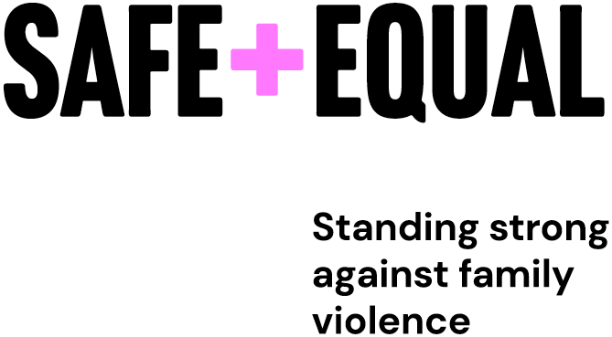
safeandequal.org.au
Wurundjeri Country
PO Box 435
Carlton South VIC 3053
Australia

