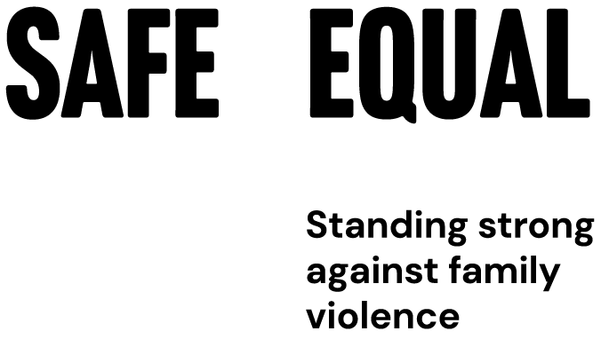

Partnering in prevention
  - Building equitable partnerships
in primary prevention
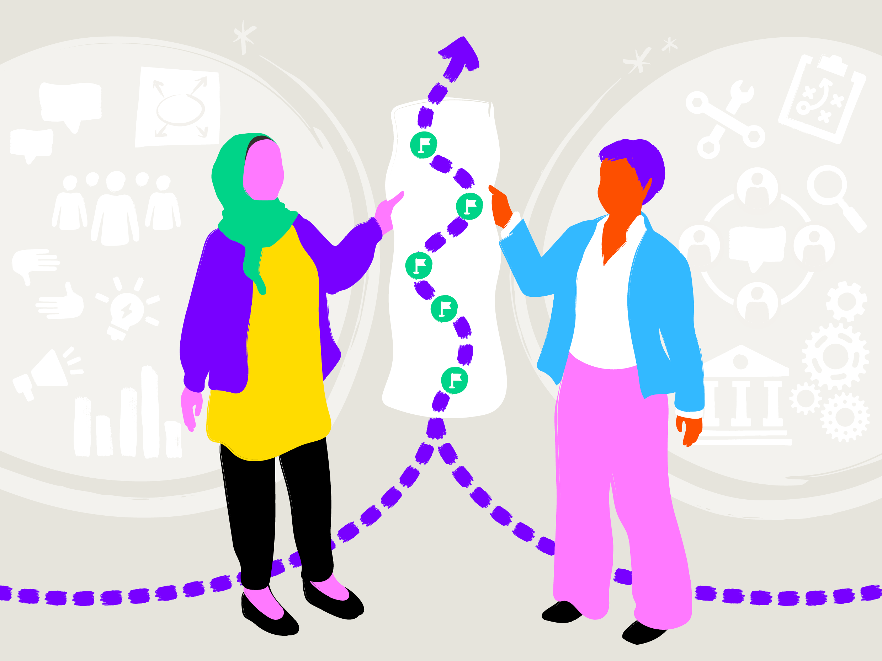

Partnering in prevention
Building equitable partnerships in primary prevention
Authors: Meghan Cooper and Jackson Fairchild

Contents
Acknowledgement of Traditional Owners 3
Note of thanks 3
Introduction 4
What is Primary Prevention? 5
Purpose 6
Defining partnership – is it a partnership? 9
Types of collaboration 12
Partnership as a process 14
Brokering partnerships 15
Bringing things together 16
Building equity within the partnership cycle 18
Final thoughts 26

Acknowledgement of Traditional Owners
Safe and Equal acknowledges Aboriginal and Torres Strait Islander peoples as the traditional and ongoing custodians of the lands on which we live and work. We pay respects to Elders past and present. We acknowledge that sovereignty has never been ceded and recognise First Nations peoples’ rights to self-determination and continuing connections to land, waters and community.


Note of thanks
This resource has been written from the perspective of Safe and Equal based on existing literature and consultation with a range of stakeholders. The authors would like to extend our thanks to Starlady, Julia Earley, Bel O’Connor, Yeshe Smith, Lesly Zambrano, Anna Wark, Dr Maria Hach, Andrea Shepherd, Naomi Taranto, Amelia Ditcham and Marina Carman for their contributions in the development of this resource.

Introduction
Transformative, lasting change to prevent family and gender-based violence requires collective action.
Achieving this will depend on the effort and commitment of many people and organisations willing to share their time, stories, labour and resources in pursuit of a shared goal.
Partnering or working in partnership is about building intentional ways of working across organisations, grounded in authentic relationships and towards a common goal. When done well, partnering can reshape how individuals and organisations do their work and enhance their impact.
Working in partnership and collaboration is a key feature of Safe and Equal’s work. As a peak body, we are committed to applying an intersectional approach in our role providing workforce development and practice leadership across the sectors engaged in primary prevention of family and gender-based violence.
Over the years, Safe and Equal have drawn extensively from the work of the Partnership Brokers Association to inform the way we think about partnerships, particularly in building and maintaining formal partnerships with community-led and organisations working with a range of communities.
Safe and Equal have also collaborated with the Partnership Brokers Association to share their approach to partnership through targeted delivery of their foundational training in Partnership Brokering to people working in the family violence sector.

What is Primary Prevention?
Primary prevention is about the social and systemic change needed to stop family and gender-based violence before it starts. It works across the whole population to address the attitudes, norms, practices, structures and power imbalances that drive violence, in places where people live, learn, work, socialise and play. The national framework for the prevention of violence against women, Change the Story, has established that men’s violence against women is driven by:
- Condoning of violence against women
- Men’s control of decision-making and limits to women’s independence in public and private life
- Rigid gender stereotyping and dominant forms of masculinity
- Male peer relations and cultures of masculinity that emphasise aggression, dominance and control
These gendered drivers of violence intersect with violence that is driven by systems of oppression such as racism, the ongoing impacts of colonisation, myths about culture, homophobia, transphobia and ableism. This heighted inequality and discrimination is experienced by particular communities such as Aboriginal and Torres Strait Islander people, people from migrant and refugee communities, people of colour, lesbian, gay, bisexual, trans and gender diverse, intersex and queer (LGBTIQ+) communities and people with disabilities.
Primary prevention works at multiple levels, addressing these multiple and intersecting drivers of violence. This is why primary prevention must be seen as a system of efforts – and partnerships are often essential for this system of efforts to be most effective.

Purpose
Partnership is a core part of primary prevention. It increases reach and impact, strengthens policy and advocacy and makes programs more relevant to the communities they seek to reach and serve. This is because different stakeholders bring distinct responsibilities, resources and expertise that, together, extend what any single organisation can achieve.
It also supports systems coordination. When organisations work together and well, they are more able to align their efforts. When systems and programs are aligned, it reduces duplication and helps organisations work in mutually reinforcing ways.
We cannot truly understand what is needed to prevent violence without working alongside and amplifying the leadership of the communities and organisations most affected. In partnerships between mainstream and community-led organisations in particular, centring experiences of structural and systemic oppression is essential.
It is important to recognise that the organisations and workforces working to change social systems that drive violence are also shaped by them. This can often result in power imbalances and privileges that cause inequity. When power imbalances and deeply held beliefs are left unexamined or unaddressed, partnerships can replicate harm and exclusion, reproduce colonial practices, reinforce hierarchies and silence those most affected by the inequities that primary prevention seeks to change.
Examples include:
- defaulting to ways of working that are top-down or reinforcing the authority of one partner over the other, with other partners being expected to adapt their ways of working
- decisions being made that affect the partnership without appropriate discussion
- extractive dynamics where contributions are valued and resourced based on institutional authority (size, reputation, proximity to decision-makers), not on actual work, expertise or impact
- smaller or less influential organisations are not trusted to fully participate and lead
- avoiding uncomfortable but necessary conversations about how power and privilege show up in partnerships due to fear of conflict or reputational risk.

An intentional approach is necessary to build equity in partnerships. It is particularly important to ensure clear and mutually agreed ways of working for relationships between community-led and specialist organisations working with specific communities, and mainstream organisations. Failure to do this can often reproduce historic and ongoing power imbalances.
An intentional approach to partnering reflects a commitment to intersectional practice. Intersectional practice requires collaboration and a commitment to transform our own work and understanding as a part of these collective efforts.
One of the most common partnership challenges is working out what equity looks like in practice. This resource doesn’t offer a single definition of “equity” or a checklist of actions that will guarantee an equitable partnership. Equity is context-specific, so partners are best placed to define what it means for their relationship and to notice where power, voice, decision-making or benefits are not being shared fairly.
However, we know that partnerships are most likely to succeed when all partners’ voices are heard, their contributions are respected and they can contribute from their unique strengths. This requires investing as much in building genuine, well-managed relationships as we do in program design and delivery. It also means naming and addressing issues of inequity early, so harm and exclusion is not reproduced through the ways we work with each other.
The primary audience for the resource is:
- primary prevention practitioners scoping, building or currently involved in multi-stakeholder collaboration
- practitioners working in a range of sectors and settings, with a primary prevention function or program.
The purpose of this resource is to share existing approaches to partnership to advance this work in primary prevention and to share experiences about how to build equity in such partnerships.
It is based on documented learning from practice and is designed to complement the VicHealth Partnership Analysis Tool. It also draws extensively on the Partnership Brokers Association’s foundational work, applied across sectors and contexts around the world. While this resource was written specific to primary prevention, many of the lessons it contains can be replicated across sectors.

Defining partnership – is it a partnership?
A Western lens of a relationship is transactional. When we think about support and walking alongside, we can’t have this transactional idea. So many times we reach out and ask for a piece of information or to do a thing and they said no. But did you go and have a cuppa? Did you go and have a chat? Did you present yourself? Did you show your authentic self? Or did you ask for something and then get a little annoyed because you didn’t get it?”
- Lauren French, BodySafety Australia, PreventX 2024
There are many ways that people and organisations can work together and relate to each other, and there are just as many words used to describe this.
One of the most common is ‘partnership’.
The Partnership Brokers Association defines a partnership as ‘an ongoing working relationship where risks and benefits are shared.’ While no two partnerships are the same, the Partnership Brokers Association argues that a partnership must be: ‘good enough to do what is required, fit for purpose given the context, and must add value.’
At its best, partnership is more than a label – it describes an ongoing process for working together that gives attention not just to what you do, but to how you work together.
The term partnership is often applied to any positive relationship between people working across organisations, from contracts to informal collaboration to collegial friendships. It is also a term that can be misused and overused.
When applied too loosely, it can obscure the true nature of organisational relationships and may even gloss over underlying structural inequalities, past or present. It can also undermine the work required to build and sustain a genuine, co-created partnership:
“It’s okay just to be a consultant, collaborator or contractor – those relationships have value too – just don’t call it a partnership, because doing so can hide or minimise all the work that genuine partnerships take.”
Being specific and intentional about what we call a partnership helps ensure clarity and mutual accountability to all involved. Not all relationships are about collaboration, with shared risk and benefit, and not all collaborations need to be partnerships.
The Relationship Continuum set out in Figure 1 is useful when considering where a partnership is or wants to be. If the relationship, or parts of it, are deemed as transactional, discuss ways to bring things closer to collaborative, or vice versa.
Not all aspects of a partnership need to be collaborative. Some tasks, activities or areas of work may only be possible through a transactional agreement (due to legal or funding requirements). Equally, one partner may be best placed, based on their unique expertise or strength, to lead a particular component of a shared body of work and a transactional arrangement will enable that.
What matters most is that everyone involved has a shared understanding of the nature of the relationship, so that the expectations and way you work together can be shaped to suit its purpose. Discussing where your partnership sits on this continuum can be a useful way to open a conversation about where you are and where you want to be.

Figure 1: Relationship Continuum
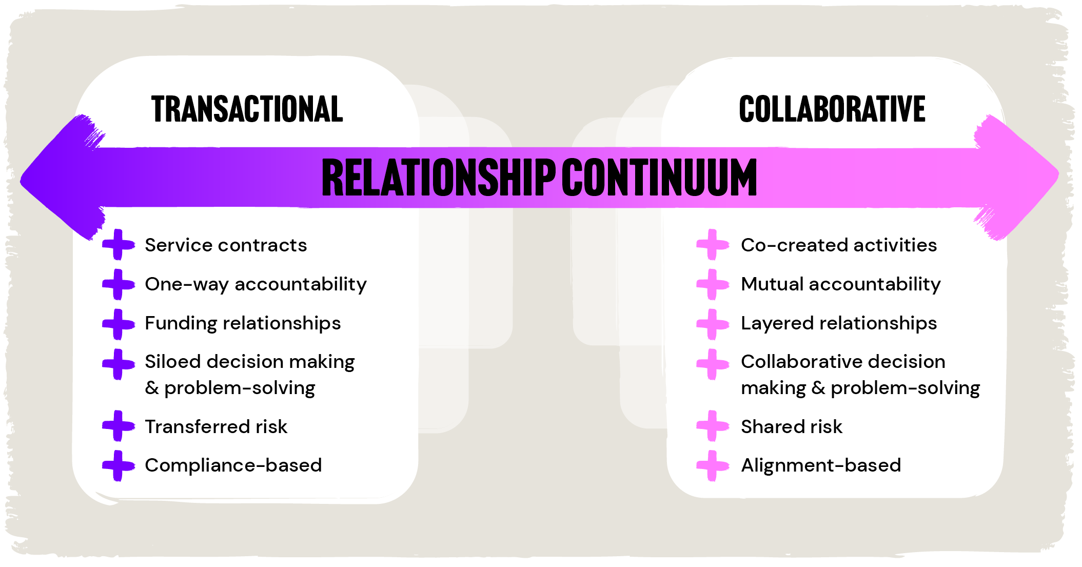
Figure 1: Relationship Continuum – text-equivalent version
The relationship continuum is a spectrum of relationship types from the transactional to the collaborative. The figure shows six key aspects of a relationship – presented below as a table – that may be implemented via contrasting transactional or collaborative approaches, or a combination of these approaches.
Transactional | Collaborative
Service contracts | Co-created activities
One-way accountability | Mutual accountability
Funding relationships | Layered relationships
Siloed decision making  and problem-solving | Collaborative decision making  and problem-solving
Transferred risk | Shared risk
Compliance-based | Alignment-based

Types of collaboration
There are many forms of collaborative relationships, from sub-contracting through to a
co-designed partnership. Below are some terms that are commonly used to describe different forms of collaboration in the context of family and gender-based violence prevention.

Networks (information-sharing and connecting)
This type of collaboration generally involves a large group of individuals and organisations sharing information for mutual benefit. There is often little dedicated time for trust building between those involved, but they are joined by a shared understanding of the overall purpose.
For example, the Partners in Prevention Network has over 4000 people involved. All receive a monthly email. Some meet monthly to connect or attend events, trainings, Communities of Practice and conferences.

Advisory Group (coordinating or informing)
This involves exchanging information, sometimes to inform other activities towards a common purpose. It includes more structured engagement than basic communication, although interactions are often short or infrequent. Some level of trust building is still needed so that those involved feel confident their views will be respected and used appropriately.
For example, many primary prevention projects have coordination or advisory groups. These typically consist of people and organisations involved in or affected by the project’s work. Some groups are made up of subject matter experts. Such groups also exist to support sector coordination or advice within the broader family violence system. Many are convened by peak bodies or government to support information sharing and alignment across policy, programs and research.

Alliances (cooperating)
While similar to coordination, alliances also involve sharing resources to help achieve a shared goal. Usually, there are one or more staff involved, and resources (ideas, positions, funding etc.) may be ‘pooled’ to deliver an agreed action.
For example, organisations might collaborate to co-host events during the 16 Days of Activism or to advance a shared policy goal. This requires more trust and deeper engagement among those involved to help identify how and where resources are shared.

Partnerships (collaborating)
This type of collaboration typically involves two or more organisations explicitly and purposefully working together towards a clear, shared goal that offers mutual benefit. Achieving this often means each partner giving up some degree of autonomy and decision-making power over how the work progresses. This requires greater attention to trust building than the arrangements described above.
For example, two organisations agree to work together to deliver a program over a specific period, with dedicated staff in each organisation or one staff member servicing both organisations, focused on delivering the shared piece of work.
Formal collaboration and sub-contracting arrangements are often used interchangeably with partnership –but should not be confused. A partnership may include formal sub-contracting as a part of dividing financial resources. However, these contracts must be in addition to an overarching process and documentation about the relationship as well. Without this or an explicit process of transparency and power sharing, sub-contracting arrangements can often create or reinforce a negative power dynamic.
The categories noted above may vary in different contexts. They are not intended to be prescriptive – rather, they are shared to reinforce that not all relationships are a partnership. A working relationship that is not a partnership can still be useful, empowering and productive. The title matters less than ensuring that all organisations involved agree to the terminology, understand what it is involved and have a shared ability to shape what the relationship is.

Partnership as a process
Partnership requires a shared commitment to an ongoing process of building relationships and finding ways of working together that are fit for purpose for all involved. At their best, partnerships offer “a model of working that draws on the unique competencies and expertise of what different communities, organisations and sectors have to offer in ways that are intentionally designed to be inclusive and that are dedicated to building sustainable solutions.”
When we understand each other, we are better able to identify how each organisation can contribute and manage risks or concerns in doing so.
According to the Partnership Brokers Association, there are ten key factors required for effective partnering:
- A clear understanding between the partners of the word ‘partnership’
- Agreement to a shared vision and common purpose
- Account and allowance being made for individual partners’ interests
- The co-creation of design, decisions and solutions
- Commitment to sharing risks as well as benefits
- Every partner contributes resources (whether tangible or intangible)
- Partners share decision-making and leadership responsibilities
- Partners commit to mutual/horizontal accountability
- Partners work together to develop a principled approach to their partnering endeavours
- Attention is paid to the partnering process as well as the partnership’s projects
These actions are best addressed by understanding partnership as an ongoing process, giving close attention to the quality of the relationship alongside joint work on a specific project or program. It does not mean that organisations endorse the entirety of each partner’s mission, strategies or practices, but it does mean an intentional approach to collaborating on “common goals, to learn from each other and find new ways of working together based on that learning.”
Effective partnering requires a willingness to have potentially difficult conversations about the differences between the people and organisations involved. Differences might include ways of working and knowing, access to resources, decision-making processes, accountabilities or funding sources.
Avoiding discussion about these differences can lead to misunderstandings. Often, we avoid these conversations because they can lead to disagreement and discomfort, particularly when they involve differences in access to power. However, recognising and actively managing power differences early, rather than avoiding them, is key to building strong and equitable ways of working together.
The following section explores this in greater depth.

Brokering partnerships
The process of partnering can bring new inspiration and be fraught with challenges. All too often, partnerships fall short of expectations or lead to frustration because the partnering process receives little to no attention. This is where partnership brokering can help.
Partnership brokering is a discipline grounded in an intentional and proactive focus on how partners relate and work with each other. It involves a person or group who take on a bridging role, acting as intermediaries to support collaboration by recognising and balancing the diverse needs, interests and perspectives of all organisations involved.
Brokering is often invisible work. People acting in roles like coordinator, manager or advisor are often brokering partnerships between stakeholders, which may not be reflected in their title or position description. What sets this work apart is the shift in mindset that goes beyond operational matters to find new, fit-for-purpose ways of working together and relating to one another. Brokering is also a skill in holding dual attention to a piece of work and the process of a partnership itself.
The partnership process is often supported by one or more individuals from within one or more of the partner organisations. These are often referred to as internal partnership brokers. There is also a growing profession of external partnership brokers – individuals external to the organisations involved who are called upon to support specific aspects of the partnership process.
The Partnership Brokers Association has been formative in establishing and building the profession of partnership brokering. They offer a range of resources to help further unpack what brokering is, and the skills and attributes needed to do it well.

Bringing things together
Before any partnership begins, it is useful to get everyone in the room (virtually or face-to-face) for initial scoping and planning. These conversations help clarify purpose and set processes that can be reviewed and adapted through conversation over time.
This preparation is particularly necessary for individuals and organisations involved where significant inequities are known at the outset. It is also useful to ensure known power differentials are not reinforced in these early stages and is meaningful use of often limited resources.
We cannot assume that a partnership will lead to an equitable relationship, and that all power differences will be known at the outset. What is needed is to create a process that is purposeful, sensitive to power dynamics and reviewed so that issues can be surfaced, addressed and creates opportunities for learning along the way.
Here are some key things to think about before advancing these conversations:
- Is a partnership what is needed? Consider what kind of relationship you want to have and the best way for this to be supported. If not a formal partnership, how else might you build and support organisational relationships?
- Who is the person(s) who will keep conversations focused on relationships? Carefully consider what kind of conversations you want and need to have and who needs to be in the room (from each partner) for these. Do you require assistance (for example, from an external broker) to have these conversations? What are the pros and cons of doing this?
- What conversations do you need before you get together? What design work is needed? Ensure you have conversations with all partners before you get them in the room. What is the status of relationships between those involved? What are people nervous/worried about or hopeful for? What has worked well in the past, or not so well? Talk about how you are going to create an environment where people can have frank conversations before you start.
- How will you hold space for courageous conversations and sit with discomfort? Talking about relationships and what has or has not made them work may result in discomfort and/or disagreement. Discomfort and disagreement are not inherently unsafe. When handled with care and curiosity, they can create space for transparency, clarity, and growth. As a result, discomfort can be an important part of change.
Uncomfortable conversations work best when they are as courageous as possible. Consider your appetite for this and what is needed to support those courageous conversations. If partners can successfully navigate discomfort and disagreement together, without shutting either process down or smoothing them over, trust will be built and new ideas will emerge.
Consider how to design the process to help support this, while also enquiring about safety concerns or risks for the individuals and organisations involved and appropriate actions required. This resource could be a useful starting point for flagging the kind of conversations you wish to have.
- What else is needed to support this conversation? Once you know the kind of conversation you are going to have, where is a suitable place for this to occur? Who is paying for what and why? Do organisations or people involved need to be remunerated for their time? How will notes and agreements be documented and shared, etc.?
Many people tend to want to problem solve or pull conversations back to project work. This can shut down important conversations and lead to hasty decisions that overlook deeper dynamics or challenges from the past (specific to the partnership or to the family violence system more generally) and cause problems down the track.
You don’t need to address every issue that arises, but you do need to talk about how you are going to address them in the future. Some issues can be addressed through the partnership, while others need to be worked through before the partnership can begin. It’s always better to talk about challenges early and often, rather than struggling later on because there wasn’t enough time invested to explore how you will work together at the start. What matters is being clear about how you will work together to address issues as they arise and how you will proactively strengthen your relationship to support this.
The following section outlines some questions and actions for surfacing and support building equity in each stage of the partnership cycle. These are aligned with both the VicHealth Partnership Analysis Tool and the Partnering Cycle. While the two frameworks use different language, they are complementary to the proposals put forward in this resource.

Building equity within the partnership cycle
The VicHealth Partnership Analysis tool presents four phrases of partnership, similar to those that form the phases of the Partnering Cycle promoted by the Partnership Brokers Association as shown below:
Image: The Partnering Cycle, Partnership Brokers Association
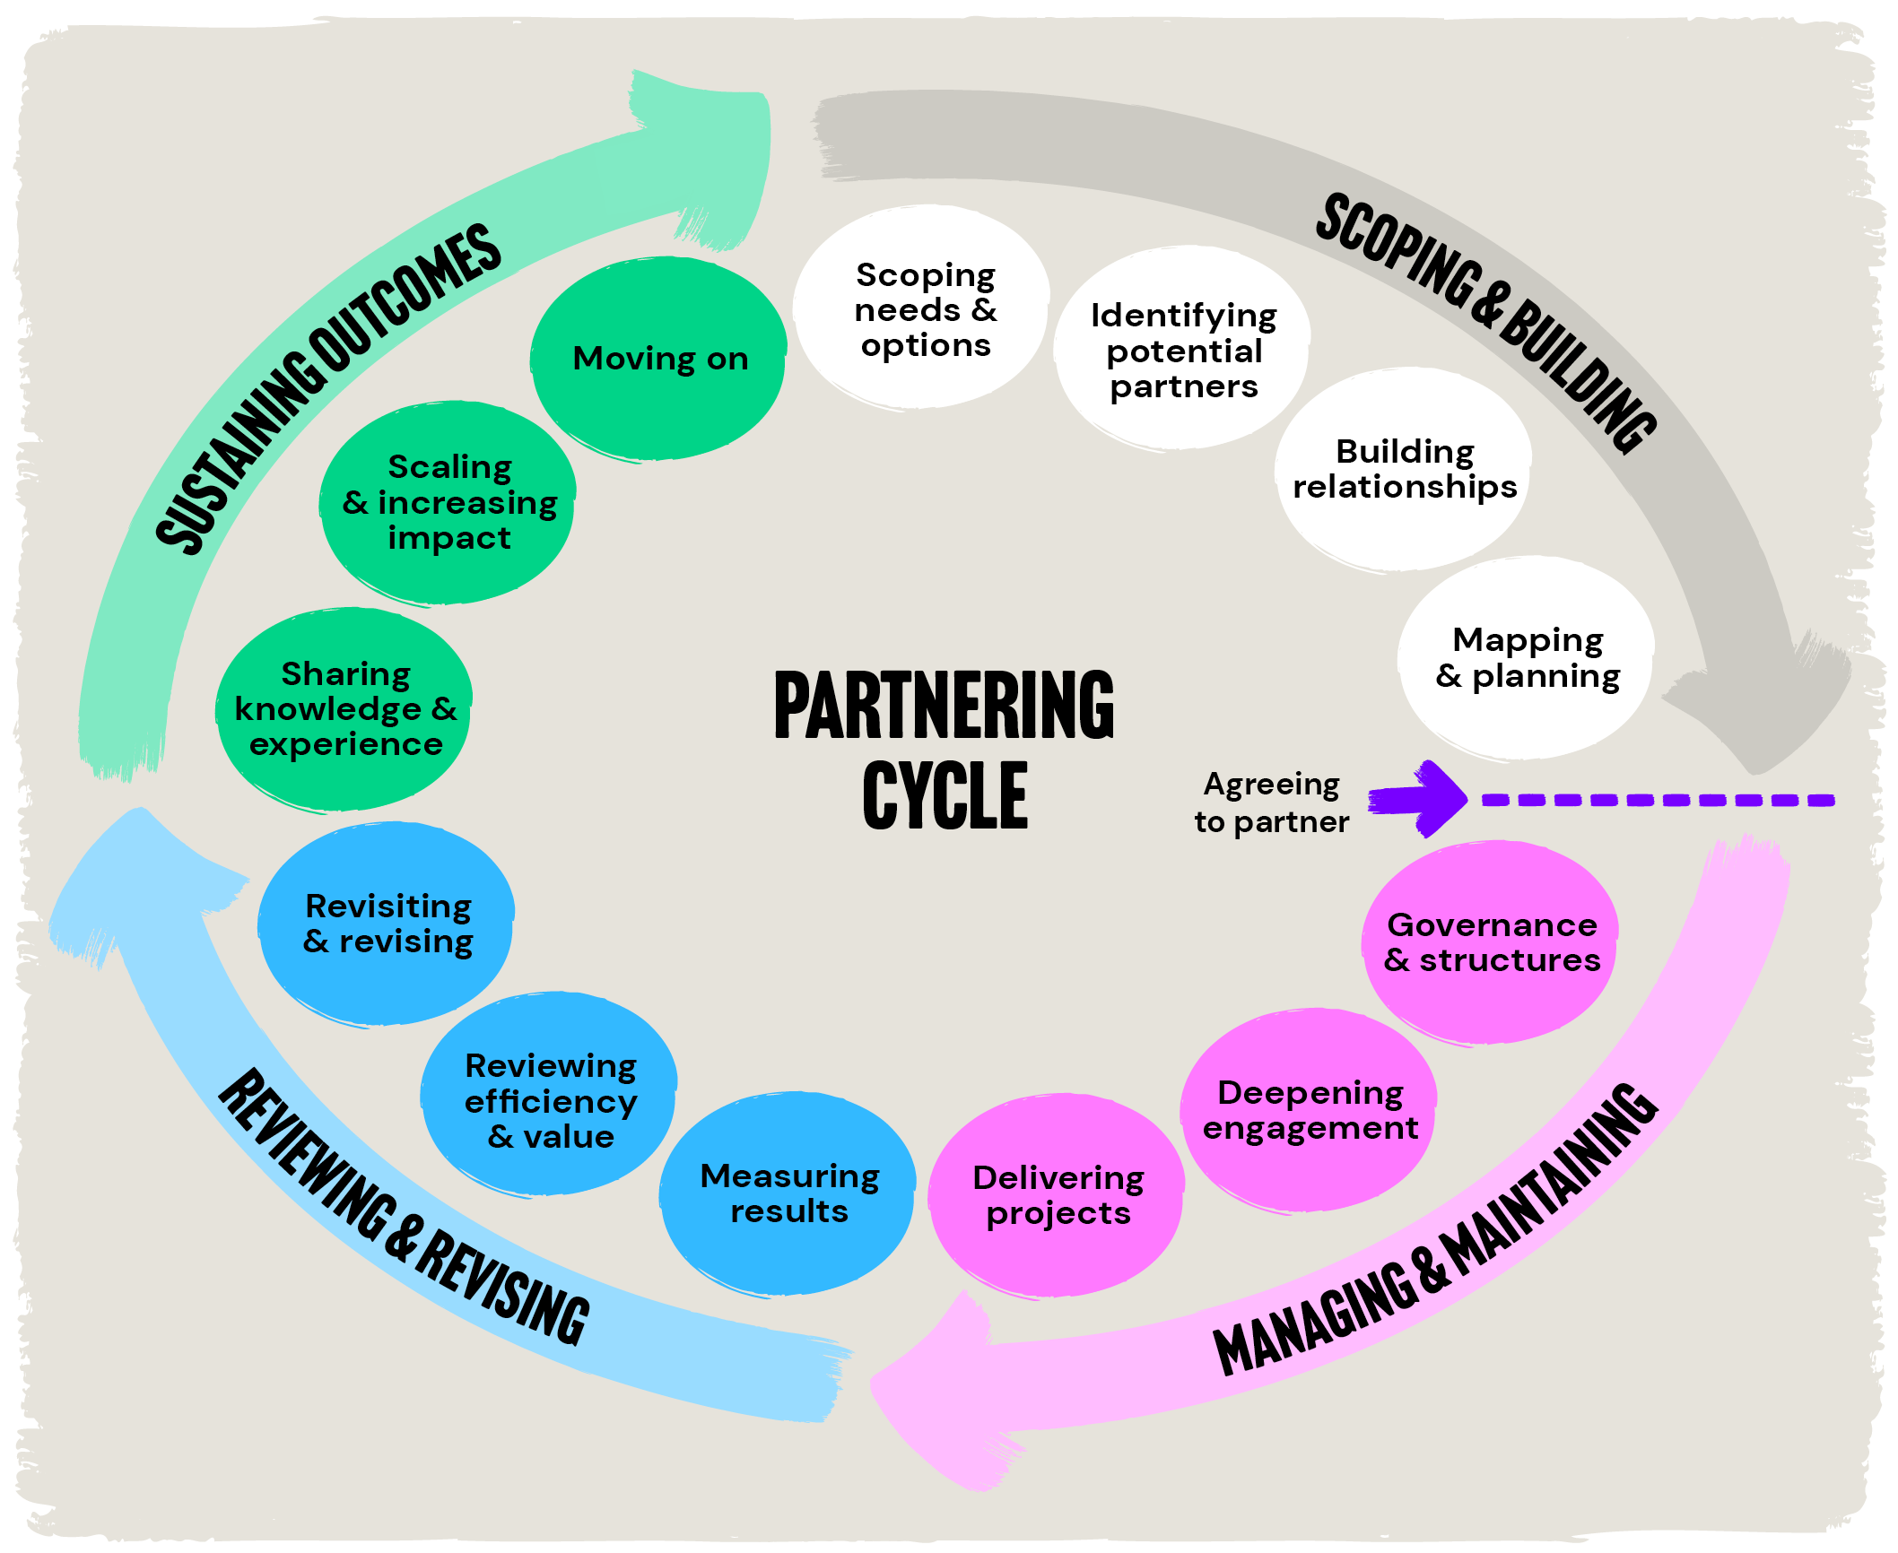

Image: The Partnering Cycle, Partnership Brokers Association
– text-equivalent version
- Scoping and Building
- Scoping needs and options
- Identifying potential partners
- Building relationships
- Mapping and planning
This is the point of ‘Agreeing to partner’.
- Managing and maintaining
- Governance and structures
- Deepening engagement
- Delivering projects
- Reviewing and revising
- Measuring results
- Reviewing efficiency and value
- Revisiting and revising
- Sustaining outcomes
- Sharing knowledge and experience
- Scaling and increasing impact
- Moving on
While these phases are presented as a sequence, the actions and questions presented are not linear and may be needed at multiple, different points throughout a partnership.
The steps taken in a partnership process will also vary depending on a number of factors: number of organisations involved, organisational locations, resources available etc.
The information below explains each part of the cycle. Specific actions related to surfacing and addressing equity challenges follow on from this foundational understanding of each phase.
The information in this section is not about doing it all and may require external support. The ideas are intended to be prompts for practitioners to reflect on themselves and discuss with collaborators or partners about what is needed for your specific relationship.

Scoping and Building
Before you begin any collaboration, take time to assess its purpose and potential. This means exploring each organisation’s expectations and interests or motivations to partner, sharing your experience in the broader political and institutional context of primary prevention, agreeing on principles for working together and setting explicit processes for how the relationship will work (the partnership), as well as how you will deliver your work together (the project).
Speak about who you are what you want from the partnership, what you bring, what power dynamics may be known and where there may be worries. If there’s agreement to proceed, develop documentation that describes this. Such documentation could be a partnership agreement, or memorandum of understanding or terms of reference. Like the partnership itself, the document just needs to be co-created from title to content. It is not legally binding but is something that can be used to guide how your relationship will work overtime.

Tips for building equity in scoping and building
- Ensure you have a clear purpose and rationale for partnership.
This can be built through exploring questions like:
- What does partnership mean to us?
- Why do we need a partnership?
- What sort of partnership do we need (collectively and each organisation)?
- How will we resource the partnership?
- What are our individual and collective objectives?
- What are our expectations – of each other and the partnership?
- What are our differences?
- What are the risks that we share or for each organisation?
- What sources of power does each partner hold? Where do we have power imbalances and can these be addressed?
- How do we want to work together?
- Invite and hold space for conversations about context. Ask what each partner does, how they work, the challenges they face and their experiences in past partnerships.
- Building a shared understanding of context early and continuously is essential to help partners appreciate the different ways each organisation experience collaboration and their work in primary prevention.
- Invite conversation about hopes and fears for the partnership. These may be held by individuals or organisations as a result of experiences in the various sectors involved in primary prevention and the broader family violence system.

- Discuss imbalances in resources from the outset. For community-led organisations, much of their time can be taken up in meetings and responding to high demands across community or providing advice to mainstream organisations. The partnership may unintentionally reinforce this strain.
- Consider ways that mainstream or larger organisations may be able support and resource the partner to engage in a process at the outset. This is often about operational capacity, not knowledge or project capacity. Mainstream organisations could also find ways to resource community-led organisations in areas that are mutually beneficial for them (i.e. staff training) if necessary, whilst always recognising the range of skills and knowledge they also bring, particularly about their communities.
- Consider your internal capacity to work with a particular community or organisation facing oppression. This is particularly important for mainstream organisations to consider before engaging with community-led organisations. For example, when working with Aboriginal organisations:-
- Have you assessed your internal capacity in cultural safety?
- Where are your gaps in knowledge and capacity?
- How will this foundational knowledge be resourced and processes put in place to support it to be enacted?
- Do not avoid or skim over conversations about historical or ongoing challenges in your work or relationship. Consider:
- What happens if something goes wrong?
- How will we monitor the partnership and ‘check-in’ over time?
- How will we evaluate the partnership?
- What does success look like?
- Discuss organisational and individual histories and experiences of collaboration. What made them work or made them more challenging? This can be a useful way of opening past experiences of inequity and how that impedes effective partnering.
- Make the partnership a distinct part of the process. Many projects use program logics, work plans and budgets. Make the partnership process (like partnership workshops and reviews) distinct outputs with associated budget. This ensures that the time and effort invested in relationships is resourced and evaluated alongside project outputs. Such effort results in this crucial relational work being valued and potentially resourcing for time into this often-invisible work.

Managing and Maintaining
- Once you are working together, co-create governance arrangements that reflect shared goals and responsibilities. Also consider how you will evaluate the partnership – what does success look like for your relationship? Knowing this now will help you review and revise later. You may face new and complex challenges, such as adapting to different ways of working or navigating external pressures. This is the time to build your collective capacity and develop systems that support collaboration, rather than defaulting to one organisation’s way of working.

Tips for building equity in managing and maintaining
- What sources of power does each partner hold? What resources do we each have? Which sources of power are subtle and which are explicit? Acknowledge and explore the different sources of power and the specific dynamics that could shape the partnership.
- Power is often viewed only in negative terms or linked solely to financial resources. Other sources of power which will impact everyone involved and the partnering process – such as size of organisation, political connections, networks, technical knowledge, hierarchical position of participating individuals, identity markers of participating individuals – should all also be discussed with reference to how the partnership will work. While these are important to discuss, it is equally important to consider the assets, strengths and influence that each partner can contribute for the benefit of the collaboration.
- Mapping resources and what each partner can bring to a partnership can be a powerful equity building measure. One that acknowledges financial resources while also valuing contributions such as community trust, lived experience, and diverse forms of knowledge.
- Once you understand power and resources, important questions to explore:
- How can we reduce negative power imbalances? What adjustments in governance mechanisms need to be made?
- Budget: how are resources in this partnership being acknowledged? Which resources need budget to be accessed? Which partner is prioritised and do any adjustments need to be made? Be careful not to make assumptions about the time and effort required of personnel to be a part of the partnering process itself. Meetings or workshops within the partnering process also require time, effort and resources, particularly when working with and in community or community organisations.

- Discuss organisational operating systems. Be mindful of relying on one organisation’s systems (i.e. project templates, budget processes for finances, meeting agendas) as a default option, particularly those who may hold the most power or funding for a program delivered through partnership. Instead, discuss the systems you need to make the collaboration work and identify where or how those can be found or created.
- Sometimes existing systems will work, other times new ways of working will need to be created. Try to identify systems that are flexible and responsive to the different perspectives and strengths of those involved.
- Discuss decision-making and self-determination. Who gets to decide on what and why? This is a crucial discussion for any partnership, especially for work with community, community organisations and Aboriginal communities. In this case, be careful of defaulting to ways of working that are top-down or reinforcing the authority of one party over the other. Be open to new ways of working that allow all partners to shape how the partnership works. Too often projects and partnerships default to ways of working that come from systems shaped by colonial thinking, where decision-making is concentrated in the hands of a few, certain ways of knowing are privileged over others and relationships are treated as transactional.
- Be open about your limits and possibilities. If you are working within a large or inflexible bureaucracy, be open about those limits. Explain what that means in practice so your partners can understand the constraints. This makes it easier to navigate power differences and find shared ways of working that feel fair and respectful to everyone involved.

Reviewing and Revising
Just like projects, partnerships need regular check-ins. Make time to reflect on how the relationship is working, what could be improved and how everyone is feeling about the process. Celebrate wins and successes as a way to build confidence and solidarity. Use what you learn to adjust governance structures, communication methods or agreements as needed.

Tips for building equity in reviewing and revising
- Ensure that relationships are reviewed alongside the program or project itself.
- Never forget to ‘check-in’ on the relationship. The people best placed to assess the partnership are those directly involved. Relying solely on external or ‘objective’ evaluations can overlook the progress, trust and relational outcomes that only partners themselves can fully understand.
- At times seeking external objectivity can also become a way of avoiding the challenging but necessary conversations that help a collaboration evolve and strengthen. Consider: What are we excited about, nervous about or looking forward to? Why or why not? How are we navigating power within our partnership? These processes of review are often referred to as ‘health checks’ and can be profound moments for learning and adaptation.
- Celebrate wins and successes and document learning. Even if things have been tough and progress is not where you thought it would be, the commitment to a partnership process deserves recognition. Try to document learning along the way. What steps did you take to build relationships and trust? How did you approach it? What worked and did not? What were the hard conversations and how did you deal with them?
- Documenting the partnership process helps to take learnings into future work and builds an evidence-base for good partnering practices.
- Identify opportunities to deepen and expand the partnership beyond individuals. A partnership that sits too closely with one or a few individuals can limit the potential for organisational and sustainable change. “Arrangements based on individuals are fragile” thus limiting the potential for any good practice to be expanded upon and built into how organisations work.

Sustaining Outcomes
‘Partnerships are a means to an end, not an end in themselves’. It is okay for a formal partnership to conclude. But the relationships you have built do not need to end altogether. This is a good time to talk about what ongoing collaboration could look like, even if informal, and how you want to continue relating within the broader family violence system. It is also useful share learning from the collaboration across organisations involved, so this can inform ongoing work with the family violence system.

Tips for building equity in sustaining outcomes
- Bring learning into your ongoing work in primary prevention. If we see primary prevention as a system of efforts – and even broader when connected to other areas of the family violence system – it is essential that organisations are equipped with the skills to relate to one another.
- Organisations do not need to be in a partnership for a collaborative relationship to be effective and meaningful. If moving on from a partnership or form of collaboration: how do you integrate what you have learned into how you work together as a part of your ongoing roles in primary prevention? How do we want to relate to one another ongoing to avoid repeating mistakes of the past or work together better and over time?
- Repeat and adapt. At this stage in the cycle, many organisations may adapt their relationship or end it. New partners may be brought in and steps in the partnership cycle may occur again.

Final thoughts
Creating equity in a partnership is never fully achieved. Partnerships operate within inequitable systems that one partnership alone cannot not solve. Yet the mutually reinforcing work required for primary prevention to be effective requires partnership.
This resource exists to help create partnerships with purpose and ideas of processes that can be used to do that. It is about ideas to help us face into, not avoid, the difficult conversations. Committing to a process of having these conversations early and often so we better understand the inequities around us makes it less likely we unintentionally reproduce the very inequities we are trying to address.
Committing to such conversations help us to build the kind of authentic relationships we need for the primary prevention system to work and the sector of organisations working within that system to be able to more effectively prevent violence, together.
Safe and Equal acknowledges the support of the Victorian Government.


Carman, M and Farha, T., Safe and Equal’s Commitment to Intersectionality in Primary Prevention [PDF], 2023.
A range of training opportunities are available via the Partnership Brokers Association.
Our Watch, Change the Story [PDF], page 36.
Our Watch, Change the Story: A shared framework for the prevention of violence against women in Australia, 2021, page 8.
The Partnering Initiative, Managing power imbalances [PDF], 2022.
Some specific examples of such practice are referenced within Multicultural Centre for Women’s Health and Safe and Equal, Together for Impact, Connecting Communities Partnership Case Study [PDF], 2024, page 6.
These descriptors are informed by a broad understanding of organisational types as used in Carman, M et al. Foundations for Action Understanding the primary prevention workforce in Victoria, 2024, Safe and Equal, Melbourne, Victoria. We understand there are a range of ways these phrases may be used across sectors and within the family violence system itself. By community-led we refer to organisations driven by and embedded within specific population groups; by specialist we refer to organisations with a specific focus on a particular community , part of the community or area of practice; and by mainstream we refer to organisations with a broad remit offering services or focus on the general public than a specific area of practice or community.
Pride in Prevention Partnership Guide [PDF], page 11.
Carman, M and Farha, T., Safe and Equal’s Commitment to Intersectionality in Primary Prevention [PDF].
Mundy, J. Embedding ethical and principled partnering approaches, Shaping Sustainable Change: The Role of Partnership Brokering in Optimising Collaborative Action, 2019, New York: Routledge, page 71.
Multicultural Centre for Women’s Health and Safe and Equal, Together for impact: Connecting Communities partnership case study [PDF], 2024. Carmen et al, Pride in Prevention Partnership Guide, 2022. Djirra and Safe and Equal, Partnering to uphold self-determination: Djirra and Safe and Equal Partnership Case Study, 2025.
VicHealth, The partnerships analysis tool A resource for establishing, developing and maintaining partnerships for health promotion [PDF], 2011.
Safe and Equal, PreventX: Messaging for a Movement – Tips and insights for messaging and advocacy to address the drivers of family and gender-based violence [PDF], 2024, page 7.
Partnership Brokers Association, Brokering Better Partnerships by investing in the partnering process [PDF], 2019, page 5.
Partnership Brokers Association, Brokering Better Partnerships [PDF], page 5.
Bobenrieth, M. ‘Partnerships’: Strong Language – vernacular or meaning? [PDF]. 2025, page 6–7.
Lucy Peckham, Multicultural Centre for Women’s Health and Safe and Equal, Together for Impact, Connecting Communities Partnership Case Study [PDF], 2024, page 10.
These terms have been adapted from the Partnership Brokers Association and the VicHealth Partnership Analysis Tool.
See example of budget management as a means of building transparency and overcoming negative power dynamics in Together for Impact, Connecting Communities Partnership Case Study [PDF], page 11.
Partnership Brokers Association, Brokering Better Partnerships [PDF], page 4.
Partnership Brokers Association, Brokering Better Partnerships [PDF], page 5.
Partnering to uphold self-determination: Djirra and Safe and Equal Partnership Case Study, page 5.
Partnership Brokers Association, Brokering Better Partnerships [PDF], and Partnership Brokers Association.
Partnership Brokers Association, Brokering Better Partnerships [PDF], page 9.
These examples have been drawn from the ‘Questions to ask’ in Carmen et al, Pride in Prevention Partnership Guide [PDF], Rainbow Health Australia, page 27.
See examples of this process applied in Together for Impact, Connecting Communities Partnership Case Study [PDF], pages 8 and 11, and Partnering to uphold self-determination: Djirra and Safe and Equal Partnership Case Study, page 11.
Pride in Prevention Partnership Guide [PDF], page 12.

