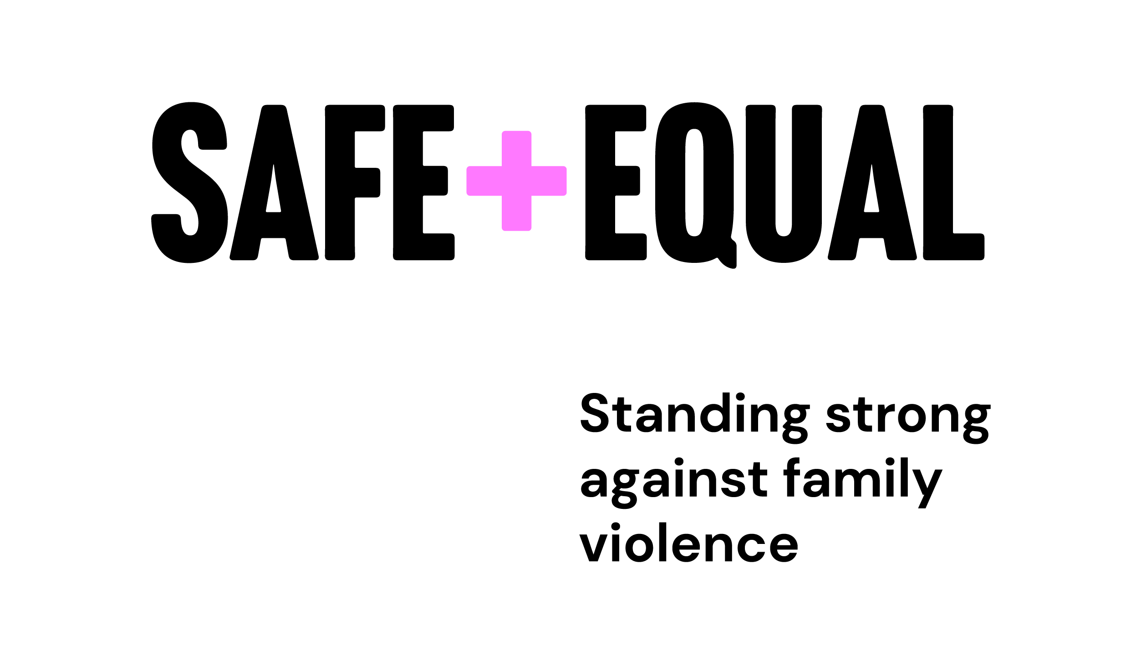

Story of Change

Towards a culturally responsive and accountable specialist family violence sector
2024

STORY OF CHANGE

VISION
Aboriginal and Torres Strait Islander people receive culturally responsive, inclusive, and accessible family violence services, wherever they seek support.

IMPACT FOR ABORIGINAL COMMUNITIES

Outer ripples
- Aboriginal people’s rights to self-determination, choice, and cultural safety are upheld.
- Aboriginal people receive person-centred flexible service responses.
- Sector advocates to the broader system to uphold the rights of Aboriginal people

Inner ripples
- Aboriginal people have equitable access to family violence services and resources.
- Aboriginal people receive the right service for them at the right time.
- Services advocate for more flexible service models.
- Aboriginal people’s right to cultural connection is respected.
- Aboriginal people have choice about the service they access.
- Services monitor enablers and barriers of culturally responsive practice.
- Service delivery reflects key Aboriginal and sector frameworks.
- Eligibility and practice reflect Aboriginal definition of family violence.
- Aboriginal people receive support that enacts justice-doing with Child Protection and Police.

IMPACT FOR RELATIONSHIPS

Outer ripples
- Relationships between Aboriginal and non-Aboriginal services are equitable

Inner ripples
- Services repair relationships where trust is broken.
- Aboriginal services have equitable access to sector resources.
- Relationship protocols for self-determination are in policy.

IMPACT FOR WORKFORCE

Outer ripples
- Aboriginal staff are culturally safe
- Sector has capability to provide culturally responsive services
- Sector has a culture of continuous learning and accountability

Inner ripples
- Services actively challenge oppressive and racist practices.
- Ongoing capability building responds to workforce needs.
- Services attend to colonial load
- Services understand how they enact colonisation, Whiteness and racism.
- Workforce capability is regularly reviewed with Aboriginal guidance.
- Aboriginal staff have access to cultural supervision and cultural leave.
- Knowledge and skills are reinforced through policy, practice, and supervision.

SPLASH
- Embedding Aboriginal-led and sector frameworks.
- Participating in communities of practice.
- Implementing policy and practice guidance.
- Dedicating time to foster meaningful relationships.
- Listening, truth-telling, and accountability.
- Providing cultural supervision and cultural leave.
- Realigning resources toward culturally responsive service provision.
- Undertaking training and professional development
- Prioritising dedicated spaces for reflection.

VISUAL REPRESENTATION
The ways of working are visualised through four illustrations:
- Uphold Aboriginal self-determination is represented by a message stick.
- Bring cultural humility is represented by a handprint.
- Disrupt Whiteness is represented by two figures and leaves.
- Move at the pace of trust is represented by a curved pathway with footprints.

SOURCE AND CREDIT
Illustrations by Emma Bamblett (Wemba Wemba, Gunditjmara, Ngadjonji and Taungurung).
Developed in partnership between Djirra, Elizabeth Morgan House and Safe and Equal, with deep engagement with Aboriginal women, and Aboriginal and non-Aboriginal family violence services. More information on Safe and Equal’s website.
The Story of Change was designed in Canva. This accessible version was prepared to ensure all text content is readable by screen readers and compliant with accessibility guidelines.

