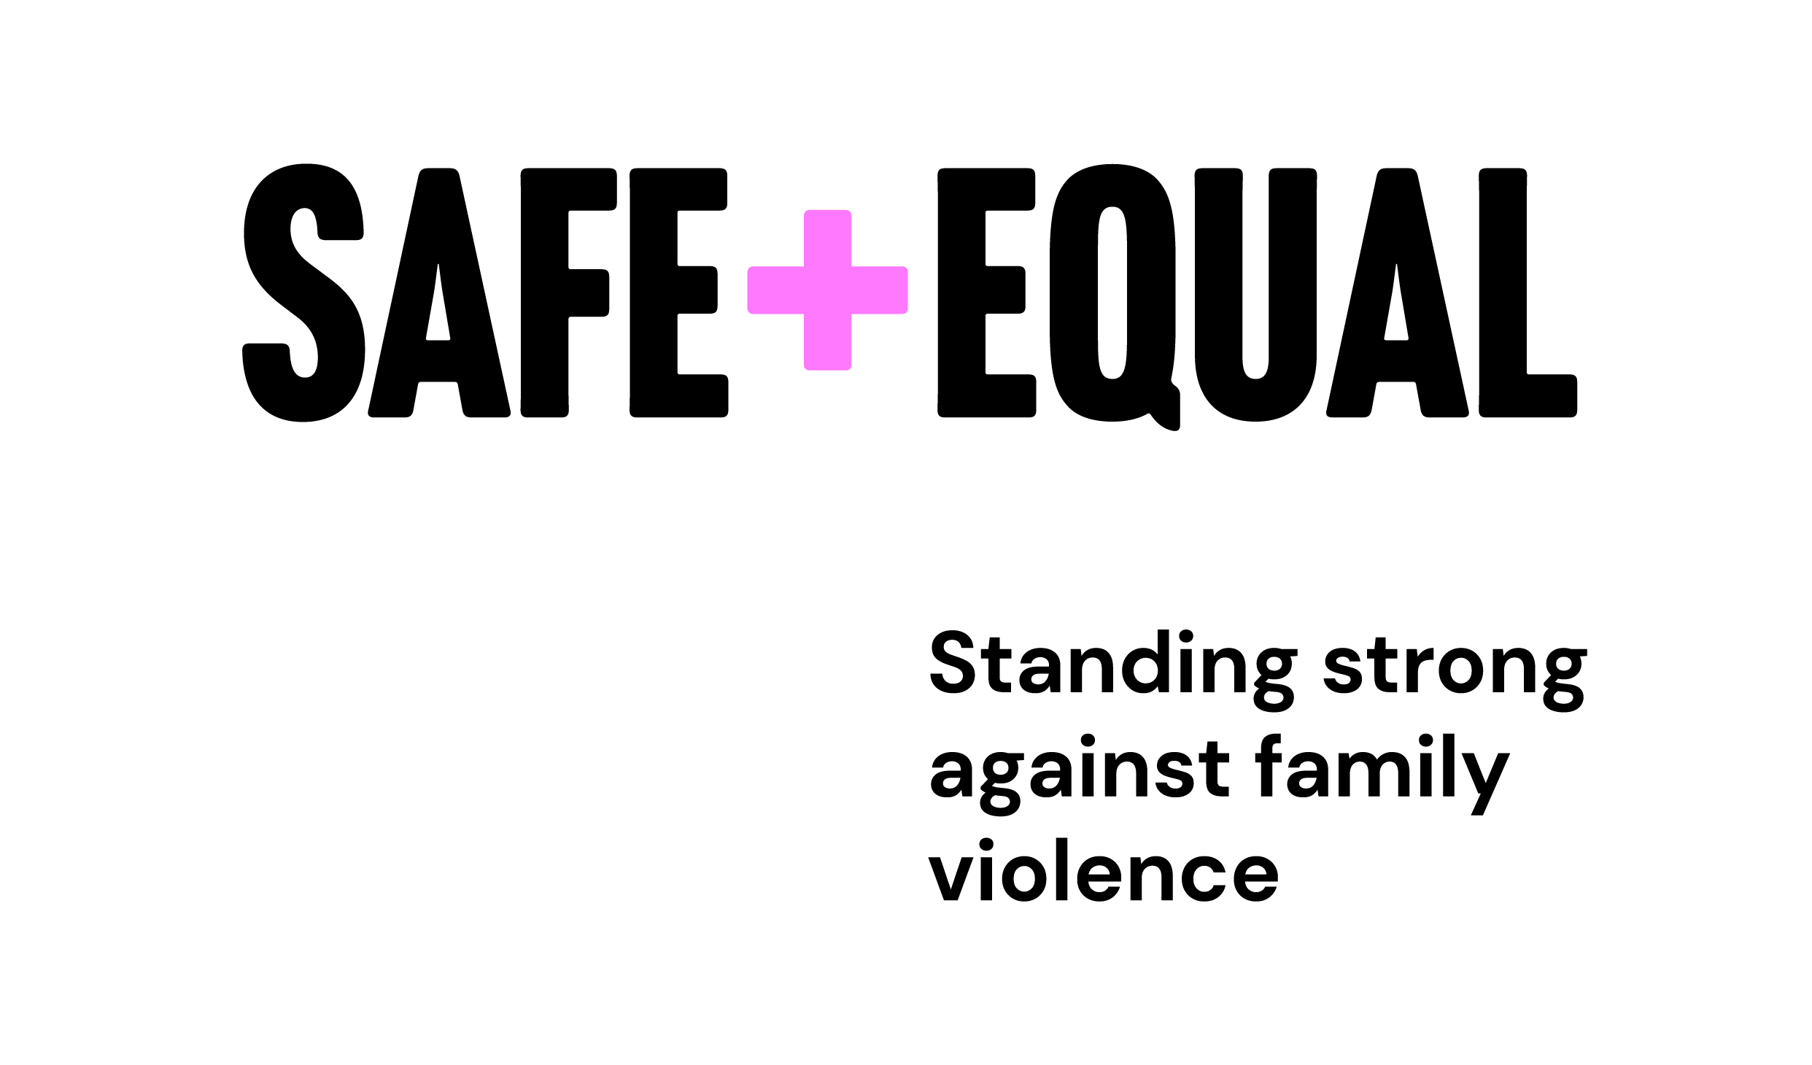

© Safe and Equal

Our Commitment to Action

Towards a culturally responsive and accountable specialist family violence sector
2024

OUR COMMITMENT TO ACTION

Towards a culturally responsive and accountable family violence sector
Aboriginal and Torres Strait Islander communities are culturally diverse, with rich and varied heritage and histories. The links between their past, present and future remain unbroken despite the impacts of two and a half centuries of colonisation, which continue to this day.
As non-Aboriginal family violence services, we work on unceded Aboriginal lands across so-called Victoria. The ongoing impacts of colonisation continue to cause harm to Aboriginal and Torres Strait Islander peoples in different places and spaces in which our services operate.
We recognise the rights of Aboriginal and Torres Strait Islander women, children and community members to receive culturally responsive, inclusive, and accessible family violence services, wherever they seek support. It is our responsibility to ensure the services we provide uphold these rights and are demonstrably accountable to Aboriginal communities. This is an ongoing process that must be undertaken by our sector in relationship with Aboriginal services, without demanding more from Aboriginal communities, who are not responsible for correcting the wrongs of racism and colonisation.
This statement sets out our collective commitment, as a sector. Acknowledging what we have heard, the tangible actions we will take and how we will demonstrate accountability.

WHAT WE HAVE HEARD
Aboriginal women have cultural strength and resilience, possess creativity and joy, and are loving mothers, aunties, grandmothers and Elders. They are keepers of knowledge, change makers, advocates, and leaders.
Through the generosity of Aboriginal women and Aboriginal family violence services, we know there are examples of culturally responsive practices by non- Aboriginal services and reciprocal relationships between local Aboriginal and non-Aboriginal family violence services. However, we also know experiences are not embedded or consistent across services and regions.
Aboriginal and Torres Strait Islander people look for visible signs of safety and inclusion, but actions speak louder than flags and posters. We heard Aboriginal women have experiences of being treated like a number and not being listened to or heard. Our services make assumptions and work at a pace driven by bureaucratic processes and overwhelming demand, rather than the needs and rights of Aboriginal people coming to us for support and safety. Our practices do not consistently uphold the Aboriginal definition of family violence in practice, and this impacts Aboriginal women's and children’s access to safety, support and resources. Regardless of whether our rules are intended to keep women safe, we understand that requirements which disconnect Aboriginal people from community and Country can create further harm, and may result in them disengaging with our services. When it comes to working with Aboriginal people, we know our services, at times, fail to enact justice-doing and trauma informed practices and can apply harmful labels and assumptions.
We know our services can be quick to ‘handball’ Aboriginal people to Aboriginal services, without taking the time to understand their needs, enable people to make informed decisions, or support facilitated referrals. This undermines Aboriginal people’s self-determination, choice and control, and puts additional pressure on Aboriginal services.
There has long been a legitimate distrust of non-Aboriginal services amongst Aboriginal people, and our practices continue to perpetuate this. While our sector has a history of a rights-based advocacy with statutory agencies, this is not always reflected in the experiences of Aboriginal women and children, who continue to experience harmful state intervention, over-policing, misidentification and child removal.
We heard that Aboriginal people working in non-Aboriginal services experience a colonial load. We know that Aboriginal-led training that addresses the intersection between family violence and the historic and ongoing impacts of colonisation is needed. Training alone is not enough. To enable meaningful and sustainable change, learnings must be reflected in organisational policy, practice guidance and supervision.
We understand the critical importance of having strong relationships with Aboriginal services, that are respectful, equitable and built on trust. However, we know that Aboriginal family violence services have experienced extractive dynamics in our sector and have had their expertise undermined. We aren't always sure how to build and maintain reciprocal relationships that can withstand staffing changes, and sometimes our worries about 'doing the wrong thing' can get in the way of meaningful action. We know that, ultimately, Aboriginal communities bear the burden of our inaction.
.

THE ACTIONS WE WILL TAKE
As a sector, we have the power to fundamentally shift and improve Aboriginal people’s experiences of seeking family violence support. While our services are under ongoing pressure and strain, it is critical we maintain a focus on learning, adapting and evolving our practices to effect meaningful change, not only as individual services but through our collective efforts, resources and strength.

Uphold Aboriginal Self-Determination
We will respect and uphold the right to Aboriginal self-determination, choice and cultural safety. We know that for Aboriginal people and communities to be safe, respected and thriving, we must have self-determined systems and services. We will work towards strong relationships with Aboriginal Community Controlled Organisations, Elders and communities and will work with, learn from and respect community-led solutions. We will develop practices that are aligned with the leadership and goals of Aboriginal communities. We commit to maintaining and building momentum for truth-telling and Treaties, recognising that these will bring about shifts of power, decision-making and resources towards Aboriginal communities and organisations.

Bring cultural humility
We will approach our work, relationships and service provision with cultural humility. For too long, our services have relied on and privileged White knowledge systems.
We will value and respect Aboriginal and Torres Strait Islander expertise and ways of knowing, doing and being, because we recognise that expertise and knowledge come in various forms. We understand cultural humility is a life-long process of self-reflection to understand our personal and systemic biases. Humility is necessary to ensure we respect and adapt to Aboriginal contexts without expecting Aboriginal contexts to adapt to us. We commit to listening deeply to Aboriginal people and services – to what is said and what is unsaid – and to reflecting, learning and transforming over time.

Disrupt Whiteness
We will increase our understanding of Whiteness and address racism in our service provision and in our relationships with Aboriginal services. Our services are operating on stolen lands, under a legacy of invasion and colonisation, and racist Government policy and legislation.
Our efforts to respond to racialised gendered violence require examination of our own histories and power dynamics, reflecting on where our work maintains Whiteness and perpetuates colonising approaches and discriminatory practices. We will dedicate time and space for critical reflection, build our understanding of the ongoing impacts of colonisation and other forms of discrimination, examine Whiteness in our knowledge and practices, and work to shift our focus from seeking to understand Aboriginal people towards actively disrupting Whiteness and racism.
We will stand alongside Aboriginal people and services to challenge oppressive and racist practices that harm Aboriginal people, both within our services and the broader system. Recognising that we will misstep, and may not always recognise when we cause harm, we commit to respectfully holding each other accountable within our sector.

Move at the pace of trust
We will work alongside Aboriginal women, children, and services at the pace of trust. We understand demonstrating trust takes time and is earned, not owed. We will dedicate the time that is needed for the right work and conversations. We will prioritise collaborative and iterative processes that centre Aboriginal voices and decision- making over predetermined timeframes and outcomes. We recognise the immense pressures and demands on Aboriginal services. We will look for opportunities to share and redistribute our collective resources to support the work of Aboriginal services, without demanding more from them for less. We will approach our relationships with Aboriginal services in ways that promote equity, openness and accountability.

HOW WE WILL BE ACCOUNTABLE
Aboriginal women and family violence services told us that accountability means being open to critique, acknowledging mistakes and, most importantly, demonstrating change.
As non-Aboriginal family violence services, the responsibility for upholding this Commitment to Action sits with us. This commitment is supported by a Story of Change, which illustrates the splash, or activities we will undertake, the ripples this will create and the impacts we are working towards for Aboriginal people, for relationships and for sector workforce sustainability and capability.
We will monitor our progress and demonstrate our learnings, change and impact, working with Aboriginal services to design what that looks like. Our services work across regions, each with different contexts, histories and existing relationships, how this commitment is brought to life will be unique to each service. Recognising this, non-Aboriginal services will focus efforts on the pathways within the Story of Change most relevant to their context.
We acknowledge as non-Aboriginal services this is an ongoing journey as individuals and as a sector. This work has no end point. It requires sustained commitment and leadership.

More information
The Commitment to Action was developed through a collaborative process across 2023 - 2024. It was led in partnership between Djirra and Safe and Equal, with deep engagement with Aboriginal women, and Aboriginal and non-Aboriginal family violence services. In 2025, Elizabeth Morgan House formally joined the partnership, bringing their expertise and insights to this critical work. More information is available on Safe and Equal’s website.

