

PreventX 2026:
Stories for Change
  - Insights and tips about sharing stories for impact and change to address the drivers of family and gender-based violence


Acknowledgement of Traditional Owners
Safe and Equal acknowledges Aboriginal and Torres Strait Islander peoples as the traditional and ongoing custodians of the lands on which we live and work. We pay respects to Elders past and present. We acknowledge that sovereignty has never been ceded and recognise First Nations peoples’ rights to self-determination and continuing connections to land, waters and community.


PreventX 2026: Stories for Change
Insights and tips about sharing stories for impact and change to address the drivers of family and gender-based violence
Prepared by Naomi Taranto, with thanks to Meghan Cooper, Hannah Dwyer and Marina Carman
June 2026
Contents
Acknowledgement of Traditional Owners 2
PreventX 2026: Stories for Change 3
Introduction 4
Insights from PreventX 2026 5
Why stories matter 5
Why storytelling matters 6
Practicing storytelling ethically and intentionally 7
Tips for storytelling from PreventX 2026 8
Ethical and impactful storytelling 8
Power, consent and agency 9
Stories for systems change 10
Story listening: listening for understanding 11
From extraction to relationships 13
Framing a story 14
Bring people and place into focus 16
Highlighting processes through narrative 17
Engaging emotion and imagination 18
Ending with hope and possibility 20
Further reading and resources 22

Introduction
This resource shares insights and tips that were gathered throughout Safe and Equal’s PreventX conference, held 24-26 March 2026. PreventX is the largest national gathering of professionals working to prevent family and gender-based violence. The theme for 2026, Stories for Change, explored how stories can be gathered, shaped and shared in ways that are impactful, ethical, community-led, culturally responsive and grounded in lived experience.
More than 450 practitioners gathered in Naarm and online to reflect on stories shaping primary prevention and to explore how storytelling can support meaningful, sustained change. Safe and Equal has analysed session recordings and participant input throughout the conference to synthesise a high-level summary of insights about storytelling in prevention, along with tips for practitioners to take this work forward.

Insights from PreventX 2026

Why stories matter
In primary prevention, the stories we tell – and how we tell them – can help shift attitudes, relationships and systems.
“Stories shape how we understand the world. They influence our attitudes and behaviours, and sometimes they help us recognise things we couldn’t quite see before.”
Linden Deathe, The Sexual Assault and Family Violence Centre
On the lands of the Wurundjeri Woi Wurrung (where PreventX was held), and across First Nations cultures, storytelling has always been a vital way of carrying knowledge, culture and responsibility across generations. These traditions demonstrate that stories do more than describe the world – they actively shape how we understand relationships, community and change.
Acknowledging First Nations storytelling traditions points to the powerful role stories play in shaping values, behaviours and systems. This includes recognising both the strength of these traditions and the ways colonisation has disrupted, devalued and silenced many stories and voices. It also calls on us to create space for multiple ways of telling and holding stories, and to reflect on whose knowledge is centred in prevention work on stolen land.
“Prevention has been here from the first sunrise, and First Nations women have been weaving social fabrics of safety, respect, inclusion and equity since the first sunrise. And in these fabrics are the teachings held within our stories, songlines and the languages of our Country.”
Kowana Welsh, Proud Dharawal, Gumbaynggirr and Gomeroi woman, Women and Girls Emergency Centre
Sharing stories across the prevention workforce is essential to strengthening primary prevention as a connected and visible system of social change. Beyond individual narratives, these stories remind us that we are a part of broader efforts taking place across sectors, settings and communities. They help surface the depth and skills of the work, from engaging communities and shifting norms, to navigating complexity and uncertainty in pursuit of long-term change.

Why storytelling matters
Storytelling is the intentional practice of shaping how stories are gathered, framed and shared. Storytelling moves beyond sharing experiences to shaping narratives that influence how people interpret problems and solutions. It is about knowing how to engage and consult, how to distil and craft messages.
“Storytelling is about how we build narratives and tell stories that convince, mobilise and inspire people for social change … It is how we tell simple stories about complex things in ways that bring people with us.”
Marina Carman, Safe and Equal
How stories are told also shapes how problems are understood. Dominant or simplistic narratives often reduce violence to individual behaviour, overlooking the social, cultural and structural conditions that enable it. In doing so, they flatten complexity and shift responsibility away from systems.
More intentional storytelling challenges this, inviting audiences to reflect more deeply on power, accountability and the conditions that perpetuate harm.
We need to be having yarns, naming how systems are perpetrating violence. I think sometimes we tiptoe around the conversations with keeping systems and organisations accountable … even our own organisations or governments in particular. It’s important that we’re thinking about ways to invite people to sit in a critically deep reflective process.”
Sam Ivancsik, Restoriative Yarns
Storytelling for prevention cannot just be about immediate emotional impact. Stories designed to shock or evoke pity may capture attention, but rarely build lasting understanding and may reinforce stereotypes, deficit framing or helplessness. Effective storytelling instead supports gradual, sustained shifts in how people think and see their role in change.
“The change that you see might not always be in the room. It’s always long term. It always has an influence on people’s lives, and it may show up later down the journey.”
Leticia Burton, Djirra

Practicing storytelling ethically and intentionally
Because storytelling shapes meaning, it also carries responsibility. Every story reflects choices about what is included, what is left out, whose voice is centred and what meaning is drawn. Without careful reflection, storytelling can become extractive – taking people’s time, knowledge and experiences without recognising their value or context.
“Western ways are also very extractive, they don’t value people’s time and compensate them properly, especially for their … cultural knowledges … We really want to work in cultural ways that embody storytelling, relationships and connection”
Leticia Burton, Djirra
Ethical storytelling is about creating the conditions for stories to be shared in ways that honour people’s agency, complexity and lived experience. It needs to create space for intersectional understanding, recognising how overlapping systems of oppression shape people’s lives and how these complexities must be held, not simplified.
“Young women consistently tell us they … feel spoken about, not spoken with. Their stories appear in headlines around forced marriage, honour, extremism. But when their lives are reduced to these narratives, something important disappears: their agency; the complexity of their experience disappears … and what remains is often a simplified story.”
Shahad Al-Bidiri, Australian Muslim Women’s Centre for Human Rights
Storytelling is not just a communication tool. It shapes how prevention is understood and practiced. This calls for care in how stories are gathered, framed and shared and attention to the impact they have within communities.

Tips for storytelling from PreventX 2026
PreventX demonstrated that embedding a storytelling approach means going beyond presenting information. Instead, it uses narrative and experience to create connection, deepen understanding and build momentum for action.
The following tips translate these insights into practical guidance for prevention practitioners.

Ethical and impactful storytelling
Storytelling requires particular skills and capabilities.
Ethical storytelling requires a trauma-informed approach. This means asking thoughtful questions and creating safe, respectful spaces for sharing. It also demands cultural knowledge and sensitivity to support ethical engagement across contexts.
- Ensure staff are equipped to use a trauma-informed approach in their work and create safe spaces for communities. This should include building their confidence in responding to disclosures and managing resistance that may arise from sharing stories.
“I need to know that you are safe as a practitioner … as a service … for me to come to you.”
Julia Rovery, Centre for Multicultural Youth

“We are holding so much inside privately … and it’s only when you walk into a space where there is inclusion that you do start saying, ‘this is me’.’”
Elise Sampson, cohealth
- Invest in sustained support. Embed storytelling within ongoing structures such as reflective management, regular check-ins and communities of practice that strengthen practitioner capability and ethical decision-making.
“The impact we achieve is not incidental, it is a result of highly intentional and sustained approach to workforce development … [our] commitment is reinforced through ongoing consistent support … which really fosters connection, learning and professional growth … long term impact depends on a well-resourced, respected and recognised bilingual workforce.”
Andrea Shepherd, Multicultural Centre for Women’s Health
- Recognise and resource lived and community expertise as an essential component of the evidence base for practice, valuing community knowledge and leadership.
“We have the knowledge. We are the experts. And we should be recognised for that work.”
Starlady, Zoe Belle Gender Collective

Power, consent and agency
Power sits at the centre of all storytelling processes.
Critical reflection on power, agency and consent throughout the storytelling process is central.
- Create conditions for consent, choice and care. Ensure that consent is not a one-off transaction or a signed form; it must be an ongoing, relational process.
- Be clear about how stories will be used, where they will be shared and for how long, ensuring no harm is caused if the storyteller alters or withdraws their story.
- Be clear about purpose, boundaries and potential impacts, ensuring storytelling processes are voluntary, paced and responsive to participants’ needs.
- Continuously reflect on your role, power and positioning. Reflect on whether we are the right people to tell these stories, under what conditions and for what purpose.
“People can be asked very personal information … such as their phone number, or where they live … without those asking offering the same level of openness themselves.”
Tilly Mahoney, Women’s Health In the North
Ethical storytelling prioritises the agency of storytellers, challenging narratives that position organisations as the agents of change and individuals as passive recipients. It also centres the wellbeing of the storyteller above audience interest or desired outcomes.
- Be accountable to the people behind the stories. Stay connected beyond the moment of sharing – check in and seek feedback.
- Authentic and resonant storytelling is grounded in community ownership and leadership.
“Storytelling, it’s a political act, right? When you choose to share something with someone … it’s an act of you connecting. And that connection builds trust. You’re receiving some form of knowledge … I constantly ask myself: who is sharing the story? Who is being allowed to share the story? Whose perspective is this story being told from? Who is receiving it and how is it being used?”
Michelle Reddy, Pacific Feminist Fund

Stories for systems change
Stories are a powerful tool for understanding, challenging and reshaping systems.
Stories play different roles in systems change, helping us understand what is happening, imagine what could be different and reflect on what has shifted over time.
- Connect personal experiences to broader social and structural conditions. Rather than isolating stories as singular experiences, locate them within the social patterns and structures that shape them. Open space for storytelling to move beyond individual narratives and toward challenging the systems that make such resilience necessary.
“When I say we need to centre survivors in primary prevention, it is because our lived experience illustrates that the task is not only to respond to the most visible ruptures, nor only to promote equality, but to recognise and to interrupt the everyday intrusions that sit between the two.”
Professor Anastasia Powell
- Model compassionate accountability by challenging harmful norms and systems in ways that are clear and firm, while actively centring empathy, understanding and respect.
“It is our job to promote a vision of the future where we challenge these systems of harm. Yes, we need to hold people and systems to account, but we also need to be doing that with empathy and compassion.”
Starlady, Zoe Belle Gender Collective
- Make visible how policies, norms, histories and shared social justice movements help shift change over time.
“It feels like meeting them where they’re at becomes the most important thing, and allowing people to be homophobic, transphobic, misogynistic or racist seems to be a starting point. I think we can be braver in demanding that this is unacceptable.”
Steve Roberts, Monash University
- Think about how stories can transform your advocacy messages and help build a shared vision for the future by amplifying voices.
“A lot of the ways that we … shift the dynamic is by placing movements first, and also being really clear about our role. In the area of gender-based violence, you’re one piece of a story – one sector of a story. Your work connects with other sectors and it’s your collective work that drives the movement. The moment that you forget that you are part of another story, it becomes harder for you to shift collectively.”
Michelle Reddy, Pacific Feminist Fund
Stories for systems change need to reflect how change happens in practice, bringing visibility while capturing the incremental, complex and evolving nature of prevention work.
- Focus on tracing how change unfolds over time, what has shifted, what remains uncertain, and what possibilities are still emerging.
- Highlight key moments of decision, action or impact, even when they are small or ongoing.

Story listening: listening for understanding
Storytelling cannot happen without deep, intentional listening.
This form of listening recognises that stories contain meaning, tension and contradiction. Through intentional listening we can better understand and communicate complexity instead of trying to simplify it. Listening must be an active and generative practice. This enables people to bring their experience to their work, name what matters to them and shape the meaning of their stories.
- Listen to understand: listen with curiosity, humility and care, rather than listening to respond, judge or extract messages.
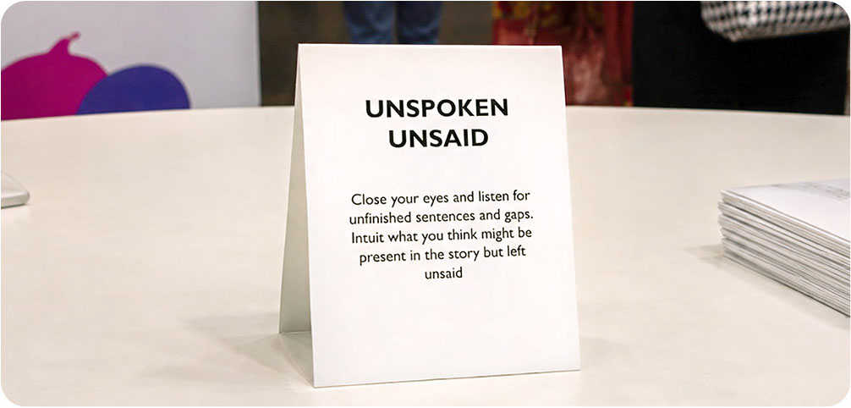
Image 1: story cards from Melbourne Playback Theatre handed out during PreventX.
“Are you really listening or are you thinking about the story that you were hoping to be told?”
Dr Léna Molnar, Women with Disabilities Victoria
- Practice holding space without interrupting, fixing or redirecting.
“When we talk about trust, emotional safety and really listening, it’s about creating spaces where people feel respected and heard. Trust doesn’t happen overnight. It’s built over time through consistency, understanding and cultural respect.”
Mikaelewa Amberber, Settlement Services International
- Listen critically for intent: notice not just what is being said, but why it is being raised. Be alert to when issues are used to introduce or reinforce harmful narratives and be prepared to question and challenge this.
“When you’re working with people around gender and sports, we should find out why they are interested? Do they have a history of genuinely caring about safety and fairness for women in sport, or LGBTIQA+ inclusion? Or are they just jumping on sport, and using it to put their other story in and promote ideas about gender essentialism that ultimately hurt us all?”
Belinda O’Connor, Rainbow Health Australia

From extraction to relationships
Storytelling in prevention practice must move away from extraction and toward relationship, trust and care.
Shifting away from extraction means valuing process as much as product.
- Prioritise relationships: invest time in building trust and connection first, recognising that meaningful storytelling emerges from relationships, not transactions.
“Connection builds trust, trust creates safety, and safety makes prevention possible.”
Agnes Kyriakou, PRONIA
- Slow the process down if needed: allow stories to unfold over time, valuing care, consent and readiness over speed or completeness.
“Prevention is about changing attitudes and norms and it cannot start with a lecture. It has to start with relationships, and that requires us to slow down our process.”
Julie Raciti, Springvale Rise Primary School
- Practise reciprocity, not extraction: be clear about what is being asked and what is offered in return.
- Create conditions where safety can grow: actively foster environments where trust can build over time.
- We must be aware of the labour involved in storytelling. In some situations, creating space to amplify voices is essential, but we also need to avoid overburdening practitioners or communities by asking them to repeatedly share their experiences. Strong, trusting relationships should guide how we approach this balance.
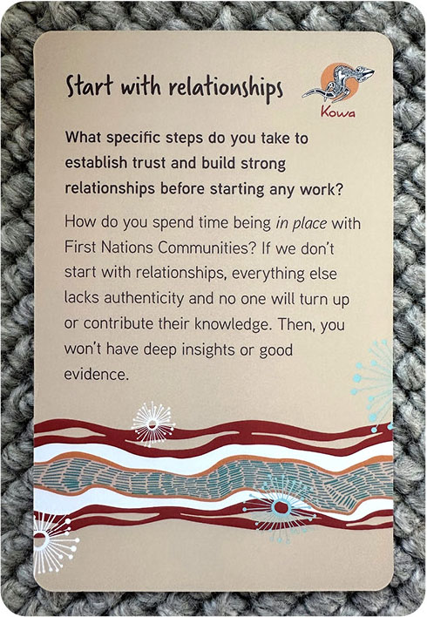
Image 2: a card that describes one of the eight principles that grounds Kowa Collaboration’s 2WUMEL framework as shared during the PreventX Workshop series.

Framing a story
How a story is framed shapes how people understand, connect with and respond to prevention work.
Effective storytelling is often grounded in moments drawn from lived experience.
- Centre lived experience: ensure it informs project planning and design, not just the stories that are shared.
“You would have all have noticed when you walked in a little card on your seat. These are solidarity cards made by our lived experience groups. We wanted to create space for victim survivors who’d gone on that journey with us. It’s something we use to connect, and a really nice conversation starter when we do outreach in the community.”
Dr Clare Shamier, Centre for Non-Violence
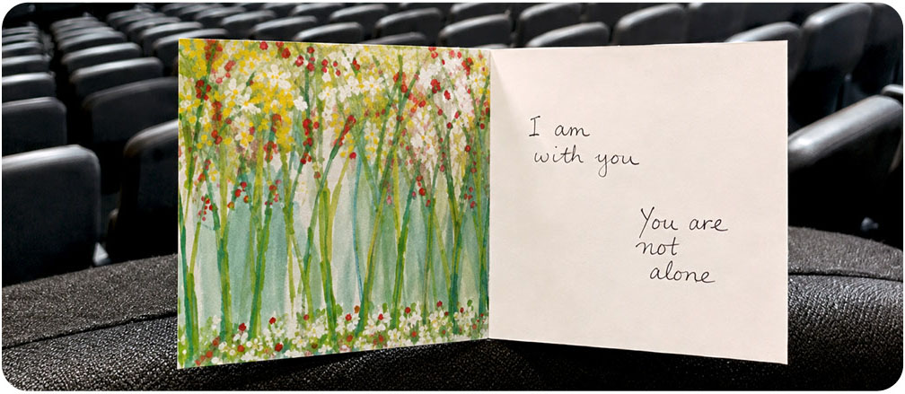
Image 3: photo of cards containing messages from victim survivors of violence provided on chairs for participants in a PreventX session.
- Start with a specific moment, person or place to help establish meaning and connection, before moving into the broader context, challenges or actions that follow.
- Be deliberate about what is centred. Consider whose voices, experiences and perspectives are foregrounded and what this signals about power and priority.
“I think the beauty of telling stories of positive and healthy masculinity is in the possibility. Not minimising harm and not minimising the harmful, but minoritising them.”
Steve Roberts, Monash University
- Adapt messages for different audiences. Tailor how stories are introduced and contextualised while staying true to the core intent and integrity of the work.
“We start by framing all of our work within the context of colonial violence, and that’s local, national and global, then we reference our messaging from there.”
Sarah Drury, Men and Family Centre

Bring people and place into focus
Storytelling needs to be grounded in the people and places at the centre of the work.
Providing a clear sense of context helps audiences visualise the setting and better understand the conditions shaping both the work and its impact. By bringing people and place into focus, we learn more about what makes communities and individuals unique, what they care about and why their experiences matter.
- Clearly convey who is involved in our work, what matters to them and the context in which the work is taking place.
- Bring place into focus: describe the settings, environments and histories that shape the work.
- Highlight what matters to people: centre the values, memories and meanings that individuals and communities attach to their experiences, rather than focusing only on outcomes.
“The biscuit tin project was designed to challenge sexism and ageism that older women experience … nurturing across cultures and generations. They might have inherited it from their grandmother, used it to store their sewing supplies or keepsakes, or it was tied to a memory, a special person, a place. We created … a resource that highlights each women’s story in their own words. The impact is not just that resource, but what the process made possible. We saw older women being recognised as knowledge holders and contributors. We saw respect grounded in everyday actions, not just fancy slogans or campaigns.”
Breanna Doody, City of Ballarat
- Recognise and position people as knowledge holders. Start where communities are by framing participants as experts whose knowledge, experiences and priorities shape the story.
“Prevention basically lands when we start where communities are and not where systems expect them to be.”
Malavika Kadwadkar, Women’s Health in the South East (WHISE)

Highlighting processes through narrative
Using narrative helps make the processes and reasoning behind prevention work visible.
Rather than presenting activities or outcomes in isolation, effective storytelling shows how work unfolds over time, tracing key moments, decisions and challenges. This includes being open about uncertainty, obstacles and tension, not only successes. This also helps audiences see how this work connects to broader efforts, supporting them to recognise relevance to their own contexts and consider their role in contributing to change.
- Show impact through everyday moments. Capture the relational and often unseen signs of change that signal meaningful shifts, using stories to add depth and nuance to data.
“What encourages me are the stories that staff keep coming and telling me [about] how we’ve created change [together] … that’s really what you can’t capture in a data set or survey.”
Aimy Skym, Department of Education
- Normalise and work with discomfort. Name discomfort when it arises and treat it as part of the process of reflection and change, rather than something to avoid or resolve quickly.
“We work with hesitation and not against it. We normalise discomfort. We usually name it.”
Katie Gomes, Women with Disabilities Victoria

“Should we change our language? Should we soften it? I would say no. We need to learn to sit in discomfort because transforming systems and societies that were built in a gender inequitable and white supremacist world is necessarily uncomfortable.”
Dr Chay Brown, Her Story Consulting
- Resist the urge to smooth over tension or complexity: make space for uncertainty, contradiction and learning.
“A young woman might be deeply connected to her faith, but also want to experience relationships. She might move differently at home than she does at school. She might honour her parents and her roots, but also want to discover who she is. This isn’t contradiction, it’s complexity.”
Shahad Al-Bidiri, Australian Muslim Women’s Centre for Human Rights
- Avoid reductive narratives of linear progress and instead expose the conditions that enable or constrain change. Be willing to learn and adapt.
“We have to be ready to say when we got things wrong, that we forgot something, we left something out, we pitched too high or we didn’t pitch hard enough.”
Marina Carman, Safe and Equal

Engaging emotion and imagination
Drawing on emotion and imagination helps deepen connection, enhance understanding, and invite audiences into the work.
Creative and participatory approaches can strengthen storytelling. These approaches create opportunities for people to build relationships, reflect together and engage with stories in ways that feel active and embodied. Creative storytelling can also support collective care and responsibility, where communities not only share experiences but also connect, imagine and respond together.
- Draw on sensory detail to help audiences connect more deeply with the experiences being shared. This includes what was seen, heard, or felt, as well as the use of different forms of expression.
“I wanted to gift back the story to everyone, for them to see themselves in our stories of practice, this work is embodied, we carry it with us.”
Shelley Hewson-Munro, RMIT University
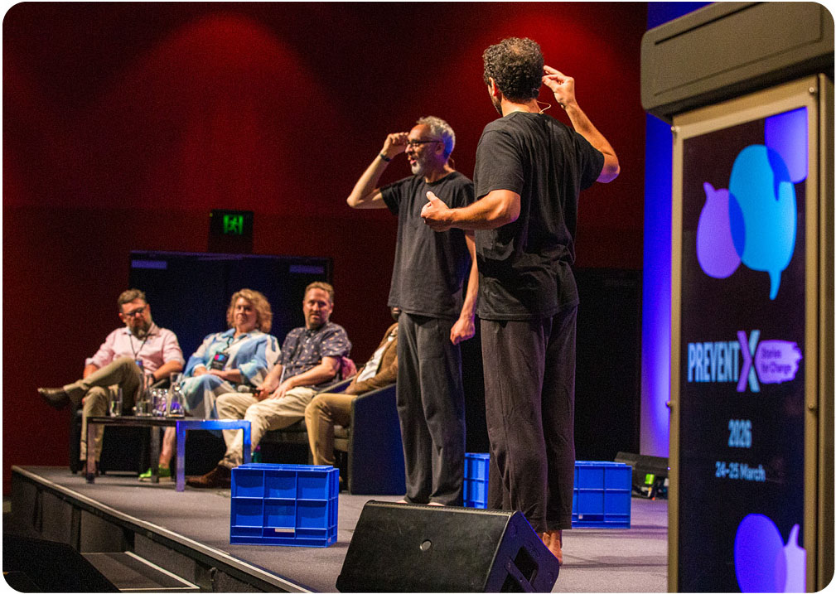
Image 4: this session run by RMIT University in collaboration with Melbourne Playback Theatre and Women’s Health Grampians combined practitioner storytelling with performance, using movement, music and embodied theatre to bring practice experiences to life. Using a panel format, practitioners associated with the Working Together with Men (WTWM) model, shared their journey of undertaking the work, with actors and musicians performing an unscripted interpretation of those stories. Translating the complexity of practice into something felt and shared.
- Consider ways you can draw on practice and learnings from other sectors: creative approaches need to be adapted to a range of settings, communities and contexts.
- Actively expand our understanding of what prevention can look like in action.
“I wanted people to dive in and really get a sense of what it feels like – not just understanding, but feeling it. I wanted to create something playful and interactive … so people could experience stories rather than just hear them.”
Mitch Nivalis, Proud2Play
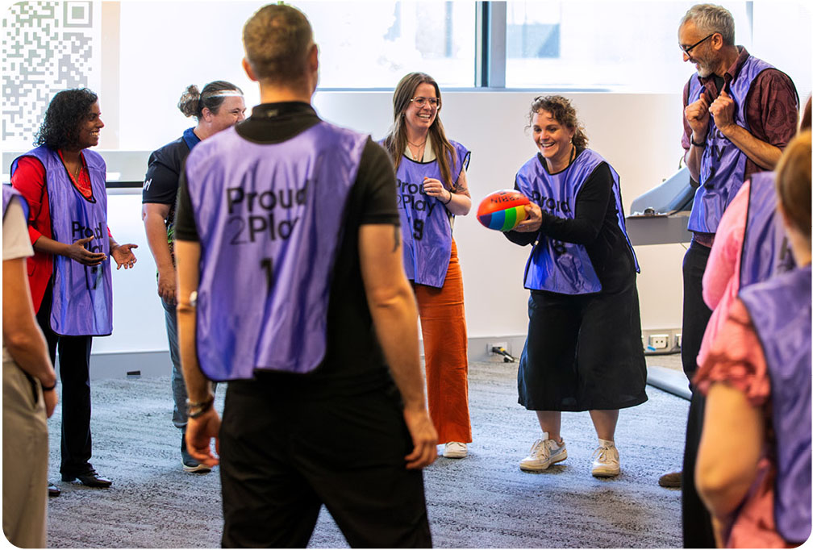
Image 5: Proud2Play The Game used an immersive approach to move participants beyond intellectual understanding into lived and felt experience. By stepping into real-life scenarios, participants encountered the barriers faced by LGBTQIA+ people in sport, engaging both emotion and imagination to explore inclusion and belonging. Through play, the session created an embodied form of storytelling. It invited participants to reflect not just on what happens, but how it feels and how to translate these insights into action.

Ending with hope and possibility
How a story ends shapes what people carry forward.
Stories that end with hope invite people to see their role in creating change and to imagine different futures.
“Be brave, say the thing. You’re in good company here. Be braver. See what’s next. See what else could be shared.”
Dr Léna Molnar, Women with Disabilities Victoria
- Endings to our stories should evoke a sense of possibility, making visible that change is not only needed, but already happening.
“Inclusion is not about perfection. It is about participation. Lean-in. Practicing doing the work doesn’t mean that you became an expert. It means you were willing to share power, uplift, empower opportunities for people with disabilities to provide our expertise.”
Katie Gomes, Women with Disabilities Victoria
- Nurture our own sense of hope as an active way of sustaining and caring for ourselves and each other.
- Celebrate wins along the way to remind ourselves that meaningful change is achievable.
“Ek Zindagi badalne se puri Qayanat badal jaati hai. In English it means: so you change one life, you change the universe.”
Shweta Dakin, GenWest
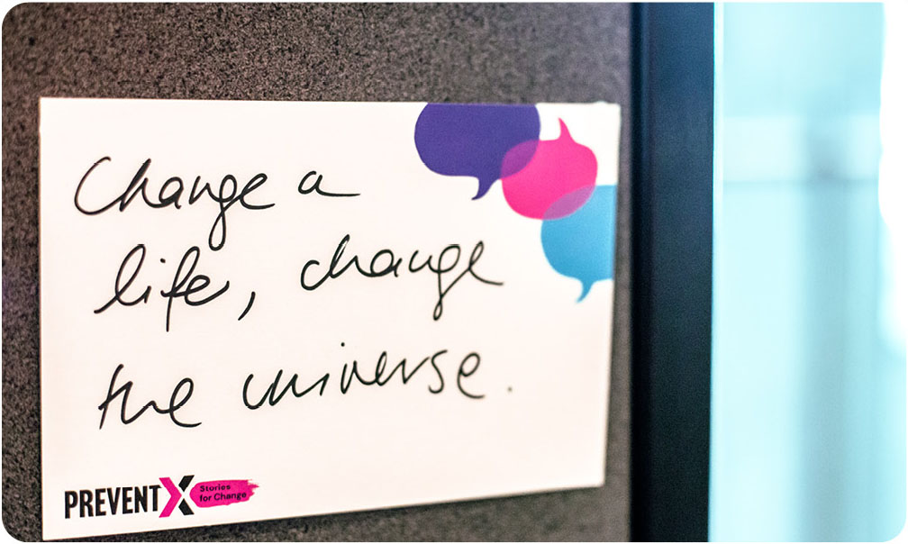
Image 6: post-it note from PreventX story wall.

Further reading and resources
These resources informed the development of the PreventX theme and this guide, and are recommended for further exploration.
- Can Counter-Storytelling Enact Black Justice? By Jade Robertson.
- Communicating for Connection: Values-based messaging for multicultural and faith-based communities by Multicultural Centre for Women’s Health and Safe and Equal.
- Does This Feel Dignifying? Considering, Telling, and Sharing More Ethical Stories by Morgan Cataldo.
- Ethical storytelling: Power, consent and dignity in practice by Common Cause Australia.
- Experts by Experience Framework by Safe and Equal.
- Framing Gender Equality Message Guide by Common Cause and VicHealth.
- Guide To Messaging Our Freedoms by We Make The Future & ASO Communications.
- Loud Way Home by ACON.
- Messaging this Moment Handbook by Centre for Community Change.
- Most Significant Change (MSC) evaluation method by United Nations Development Programme.
- Passing the Message Stick and associated resources by Common Cause, GetUp, Original Power and Australian Progress.
- Right Story, Wrong Story: Adventures in Indigenous Thinking by Tyson Yunkaporta.
- Sand Talk: How Indigenous Thinking Can Save the World by Tyson Yunkaporta.
- Sources of Lived Experience in the Family Violence Sector Issues Paper
by Safe and Equal.
- Stella Young: I’m not your inspiration, thank you very much -TED Talk.
- Story Support by Our Race.
- Storytelling for Systems Change resources by Centre for Public Impact.
- The danger of a single story by Chimamanda Ngozi Adichie.
- The Power of Story: The Story of Self, Us and Now by The Commons Social Change Library.
- Tools and resources by Centre for Story-Based Strategy.
- Transfemme resources by Zoe Belle Gender Collective.
- Weaving Truths and many other First Nations storytelling resources
by Common Ground.
- Who Tells the Story? A Guide to Empathetic Social Change Storytelling
by Kate Marple.
- Why Am I Always Being Researched? Chicago Beyond.

Safe and Equal acknowledges the support of the Victorian Government.

