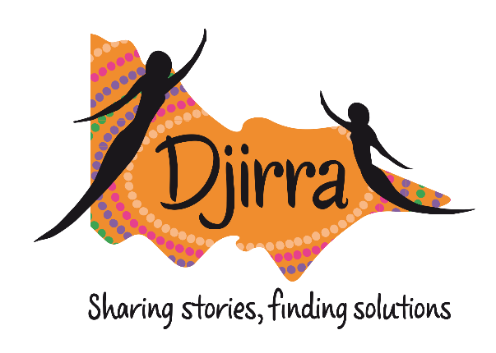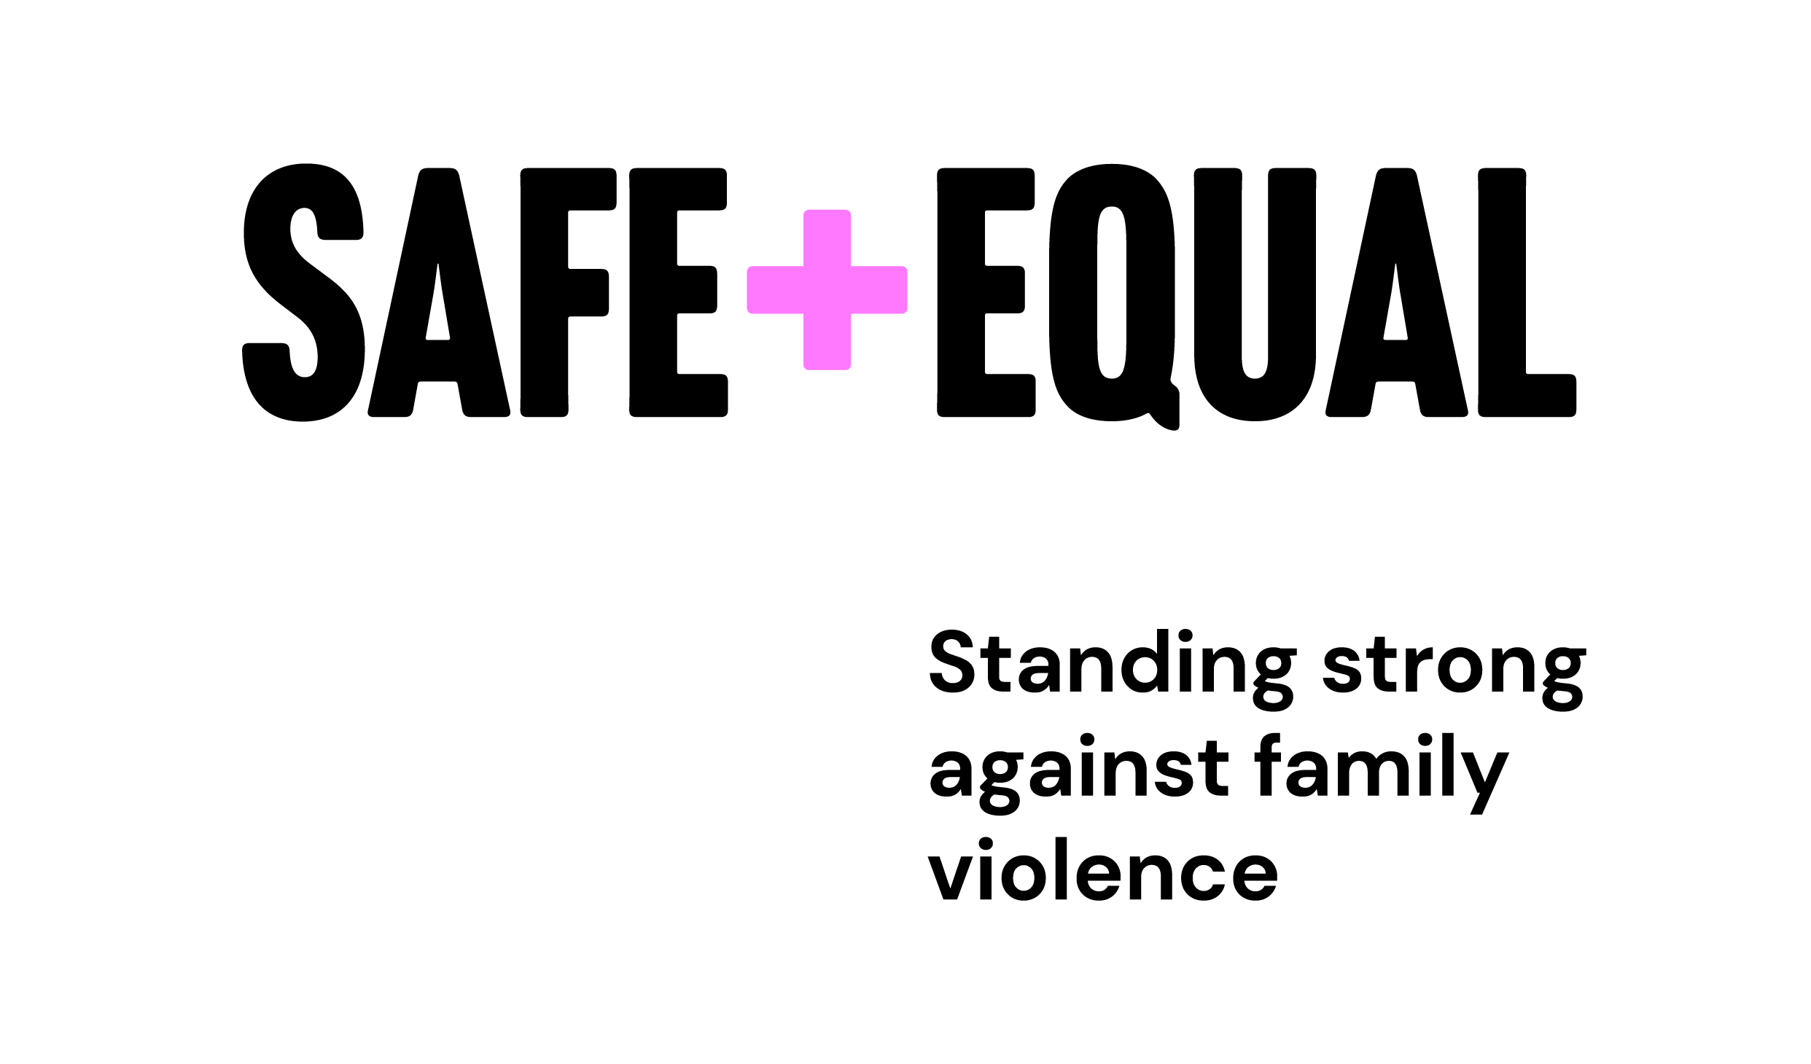



Partnering to Uphold Self-Determination Insights Report

***Djirra and Safe and Equal Partnership Case Study***

**2022-2024**

# ACKNOWLEDGEMENT OF TRADITIONAL CUSTODIANS

We acknowledge Aboriginal and Torres Strait Islander peoples as the traditional and ongoing custodians of the lands on which we are fortunate to live and work. We pay respects to Elders past and present. We acknowledge that sovereignty has never been ceded and recognise First Nations peoples’ rights to self-determination and continuing connections to land, waters, community and culture. It always was and always will be, Aboriginal land.

© 2025 Djirra and Safe and Equal  

# ABOUT THE PARTNERS

**Djirra** is a specialist Aboriginal Community Controlled Organisation (ACCO) with over 22 years’ experience accompanying Aboriginal and Torres Strait Islander women, and their children, on their individual journeys. Djirra celebrates women’s strength and resilience, finding solutions through Aboriginal and Torres Strait Islander women sharing their stories, journeys, and experiences. Djirra delivers holistic, culturally safe, specialist family violence support, legal services and case management, alongside cultural and wellbeing workshops and programs with state-wide reach.

**Safe and Equal** is the peak body for Victorian organisations that specialise in family and gender-based violence across the continuum, including primary prevention, early intervention, response and recovery. They are an independent, non-government organisation that work with and for their members to prevent and respond to violence, building a better future for adults, children and young people experiencing, at risk of, or recovering from family and gender-based violence.

Contents

ABOUT PARTNERSHIPS 5

THE STORY SO FAR 6

PARTNERSHIP IN PRACTICE 7

ESTABLISHING THE PARTNERSHIP 8

Building the relationship 8

Finding shared intent 8

Defining equitable resources 9

Enacting partnership principles 9

Co-creating a Partnership Agreement 10

SUSTAINING THE PARTNERSHIP 11

Creating communication structures and protocols 11

Holding partnership health checks 11

REVIEWING THE PARTNERSHIP 12

OUR LESSONS LEARNED 12

Uphold self-determination 12

Bring cultural humility 12

Disrupt Whiteness 13

Move at the pace of trust 14

THE STORY AHEAD 15

PARTNERSHIP EVOLUTION 15

REFLECTION 16

# ABOUT THIS RESOURCE

Djirra and Safe and Equal established a strategic partnership in 2022 with the aim to support mutual capability building, strengthen connections between Aboriginal and non-Aboriginal family violence services and to improve outcomes for Aboriginal and Torres Strait Islander people experiencing family violence.

This resource documents the processes and learnings developed through the first stage of the partnership (2022-2024). It draws from an internal partnership review, co-led by Djirra and Safe and Equal, to capture the lessons learned.[1] This case study is shared to contribute to the growing evidence base on equitable partnership approaches between Aboriginal and non-Aboriginal organisations, with the hope that it may inform future partnership practices across the family violence sector.

# IN SUMMARY

Establishing partnerships that uphold Aboriginal self-determination is not only possible but transformative for everybody involved.

To enable this, an intentional shift and critical reflection is needed from non-Aboriginal organisations to move from extractive and power-over approaches to mutual benefit and power-sharing relationships with Aboriginal organisations.  This requires efforts and practices to disrupt colonial and white ways, while embracing Aboriginal relational ways of doing; to engage in deep listening and move to the pace of trust; to centre and prioritise Aboriginal voices, expertise and knowledge; to enact cultural humility; and to redistribute resources.

# ABOUT PARTNERSHIPS

Partnerships are a crucial tool for transforming systems and strengthening practice within organisations seeking to work collaboratively with Aboriginal and Torres Strait Islander people and communities.

All partnership work in so-called Victoria is taking place on unceded Aboriginal lands, where the impacts and actors of colonisation continue. In the context of partnerships between Aboriginal and non-Aboriginal organisations, there is memory of the history and current practices of non-Aboriginal organisation’s role in replicating colonial structures, racism and harm. Taking a partnership approach means being intentional in how organisations work together in ways that resist transactional and extractive interactions to create conditions for equitable relationships and self-determination.

**Partnership continuum
Heading: Transactional relationships
Service contracts
Compliance based 
Siloed problem solving
Transferred risk
Siloed decision making
Pace of demand
Extractive
Funding relationships
One-way accountability
Uninterrogated power

Heading: Collaborative relationships
Co-created activities 
Alignment based
Collaborative problem solving
Shared risk
Collaborative decision making
Pace of trust
Reciprocal
Layered relationships
Mutual accountability 
Shared power

**

**Image 1:** Partnership Continuum, adapted from Partnership Brokers Association[2]

Importantly, being in partnership does not mean that partner organisations endorse the entirety of each other’s mission, strategies, or practices. It does mean that they are committing to collaborate on common goals, to learn from each other and find new ways of working together based on that learning.

# THE STORY SO FAR

Aboriginal and Torres Strait Islander people’s resistance and leadership has long shaped self-determined solutions that address family violence against their communities. Aboriginal Community Controlled Organisations (ACCOs) providing family violence services are fundamental – they provide culturally safe, holistic and healing-informed care.

In some cases, Aboriginal and Torres Strait Islander adults and children experiencing family violence also engage with non-Aboriginal family violence services. The Dhelk Dja Partnership Agreement[3] recognises that non-Aboriginal services have a role in providing equitable access and culturally responsive services. This is essential to ensure that Aboriginal and Torres Strait Islander people can exercise their right to access culturally safe and appropriate service options from any part of the service system.

There is warranted distrust between Aboriginal and Torres Strait Islander people and non-Aboriginal organisations. In part due to harmful state interventions, community family policing[4] and social and structural racism that means Aboriginal and Torres Strait Islander people face overall higher rates of systemic violence and increased barriers to accessing support and safety.

“Mainstream organisations always want to take from Aboriginal organisations. ‘Can you help us with this’… ‘we are doing our RAP’… ‘we are doing this and that’. We receive the request all the time. I was hesitant about what was going to be the result for us. Were you really going to listen and hear what we were saying? Were you going to be respectful of our space?” – Djirra

Safe and Equal was aware that despite significant reform and investment since the 2016 Victorian Royal Commission into Family Violence (RCFV), Aboriginal and Torres Strait Islander people continue to experience barriers and racism from non-Aboriginal family violence services. While Safe and Equal and their non-Aboriginal family violence member services were starting from a place of good intent, urgent change is required to improve outcomes for Aboriginal people experiencing family violence. Safe and Equal knew as a White feminist organisation they do not hold the appropriate knowledge to do this work in isolation. Any steps taken should not ask more from Aboriginal communities, who are not responsible for correcting the wrongs of colonisation.

# PARTNERSHIP IN PRACTICE

The partnership between Djirra and Safe and Equal followed a structured yet flexible process, allowing for continuous learning and adaptability to meet the changing needs of both organisations. This process was internally facilitated, drawing from training from the Partnership Brokers Association[5] and SNAICC Partnership Resources.[6]

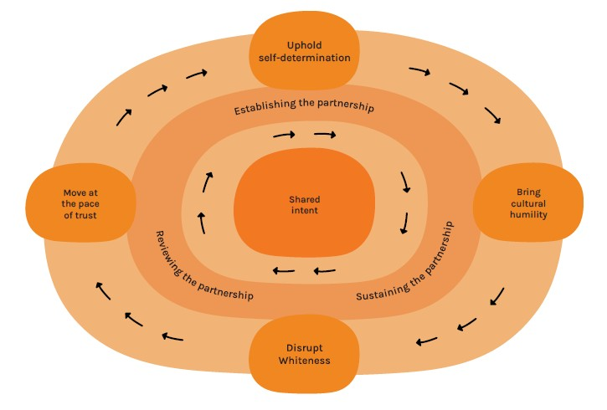

**Image 2:** Partnership cycle, adapted from SNAICC Partnership Tool

# ESTABLISHING THE PARTNERSHIP

### Building the relationship

Building on an existing relationship between Djirra and Safe and Equal, the CEOs engaged in exploratory conversations throughout 2022, followed by meetings and workshops between senior leaders. Developing a strong and trusting relationship was a critical step. This foundation and regular engagement allowed the organisations to explore what a partnership might look like. It created fit-for-purpose processes based on what we hoped to learn from each other, which in turn helped to strengthen the relationship.

“You have to start with the relationship with the organisation, so we get to know what you’re about, you get to know what we’re about, and we see if there are mutual benefits for both of us in that.” – Djirra

### Finding shared intent

Through early discussions, Djirra and Safe and Equal explored what each organisation hoped to bring and gain from a potential partnership. From this base, shared intent surfaced to improve outcomes for Aboriginal and Torres Strait Islander people experiencing family violence, through ensuring access to culturally responsive, inclusive and equitable services. This was documented in a Statement of Intent and provided both organisations with the clarity and confidence needed to progress towards a formal partnership.

### Defining equitable resources

Both organisations identified the access to power and resources they hold and could offer to the partnership to bring mutual benefit and equity. To support the partnership and coordinate activities, a fixed-term Partnership Lead position funded by Safe and Equal was created. In efforts to maintain cultural integrity and leadership, the role was embedded within the organisational structure of Djirra, with strong formal and informal links with Safe and Equal and its membership. Some resources that could be shared were identified up front, while others emerged through the process of the partnership.

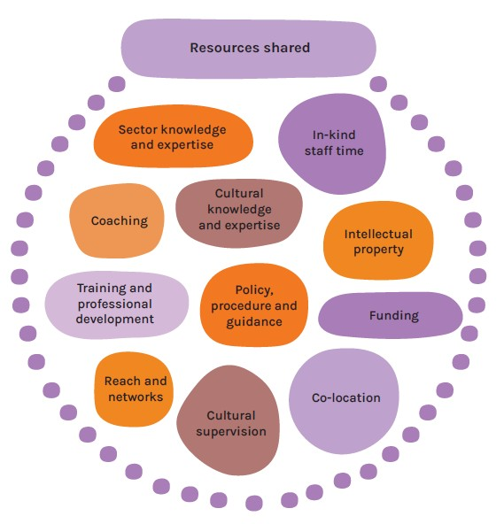

**Image 3:** Examples of resources shared between Djirra and Safe and Equal during the partnership.

### Enacting partnership principles

Good intentions alone are not enough – each partner organisation enters the relationship with their own expectations, and past positive or negative partnering experiences. Identifying and enacting principles was critical to support an equitable partnership, especially where extractive and tokenistic power dynamics can show up.

Together, partners defined:

* Starting from a place of presumed good intent, mutual respect, openness and willingness to work together in new ways.
* The partnership should not benefit one partner at the expense of another.
* The partnership should always be in the interest of Aboriginal women and children accessing services.
* The partnership is intended to be action oriented.
* Both partners will bravely voice issues, turn up genuinely to resolve them.
* Aboriginal organisations will be paid for their time and expertise.
* No single Aboriginal organisation can be the definitive voice of cultural knowledge or represent the views and experiences of all communities.
* Key senior leadership representatives will champion the partnershipand embed organisational relationships.

“There can be a little bit of suspicion on behalf of an ACCO, for very good reasons, about the extractive processes of mainstream organisations. The individuals in the working group were cognisant of that and took the time to build the relationship, come together regularly, come together with good faith, which reflected that breathing the life into those principles”. – Djirra

### Co-creating a Partnership Agreement

Staff from both organisations participated in interviews and yarning sessions, the insights from which informed the co-design of the partnership agreement.

Clearly defined shared goals, alongside articulating what each organisations hoped to gain and bring to the partnership helped to strengthen understanding of each other, ensured both organisations could see equitable benefit, and set pathway to navigate through difficulties and challenges when they arise.

“Naming up front ‘these are the shared objectives…this is what we’re hoping to get out of this… and this is what another organisation is hoping to get.’ We can ask ‘is there anything we can do to ensure Djirra gets what they’re seeking and vice versa.” - Safe and Equal

The agreement is a living document that reflects the evolving relationship between Djirra and Safe and Equal. It provided a foundation for regular partnership health checks and is reviewed and updated as the partnership grows and matures. The Agreement also serves as an essential induction tool for new staff from either organisation who will work within the partnership.

#### Djirra

**What do we hope to gain?**  
To strengthen Djirra’s connections to the family violence sector and increase the platform and reach of Aboriginal-led policy, practice and advocacy.

**What do we hope to bring?**

* Cultural knowledge, expertise, and Aboriginal leadership
* Expertise in culturally safe specialist family violence case management, legal services, and early intervention and prevention wellbeing workshops
* Connection to and representation on Aboriginal governance mechanisms

#### Safe and Equal

**What do we hope to gain?**  
To strengthen Safe and Equal’s capacity to support culturally responsive services and embed ways of working that uphold Aboriginal self-determination and challenge tokenistic practices.

**What do we hope to bring?**

* Openness, self-reflection and humility
* Systems view and expertise in family violence policy and practice in mainstream settings
* Experience with workforce development, training, and capability building
* Resourcing to support partnership and project coordination

# SUSTAINING THE PARTNERSHIP

### Creating communication structures and protocols

Clear governance mechanism and communication channels supported the day-to-day functioning of the partnership.

As both organisations were stretched with high demands on time, the partnership needed to bring realistic expectations. Arrangements were co-created and adapted as needed. Adhering to the partnership principles guided the approach, ensuring organisations remained accountable to the partnership and each other’s wellbeing amidst the challenges of the work.

Regular partnership working group meetings helped to keep a focus on context, and emerging issues and opportunities for the partnership.

### Holding partnership health checks

Health checks are an important mechanism for sustaining the health, integrity, and development of the partnership in alignment with shared goals. The health check objective was to gain a deeper understanding of how each partner was experiencing the partnership and identify actions to strengthen the relationship.

A health check was held face-to-face at 12 months and facilitated internally. This approach was effective because the existing trust among partners encouraged honest and open reflections, including leaning into discomfort which helped to continually build trust and accountability.

# REVIEWING THE PARTNERSHIP

## OUR LESSONS LEARNED

A review of the first phase of partnership from 2023-2024 was undertaken, focusing on lessons learned that could be taken forward to strengthen the partnership and future partnership practices for both organisations.[7] These learnings are offered below, grouped under the interconnected ways of working central to the sector Commitment to Action.[8]

### Uphold self-determination

**Centring Aboriginal leadership across all levels of the partnership ensured Aboriginal people guided the processes.**

Intentional steps were taken to ensure the partnership was grounded in Aboriginal leadership across all levels of the work.

“I feel quite confident in the way that we've been able to approach this partnership, that it has centred Aboriginal women's voices in decision-making at different levels of the work and in the partnership.”  - Djirra

“We’ve always prioritised Djirra’s final voice... the project has been community-led, Safe and Equal has really been there to support and ally, not to determine how this goes.  We’ve taken the lead from Djirra.” - Safe and Equal

**Embedding the role within Djirra enabled closer connection and accountability to Aboriginal staff.**

Intentionally structuring the Partnership Lead role within Djirra disrupted default ways of working and created space for deeper cultural accountability and learning.

“If we had been trying to progress this partnership, but the Partnership Lead role was based in Safe and Equal, as a white woman I would have just been drawing on the same ways of working and knowing that I always have. Being embedded in an ACCO challenged me to think and work differently and to be more accountable to Aboriginal colleagues.” - Djirra

### Bring cultural humility

**Enacting cultural humility created a more culturally responsive approach.**

Cultural humility requires recognising and valuing cultural differences, being open to learning from others, and acknowledging limitations and biases. For Safe and Equal, this required acknowledging the limits to understanding of Aboriginal people’s experiences and knowledge systems.

“Always go in with cultural humility – everything is a lifelong lesson, and we don’t have the answers to everything, but if you have good intent and you’re going into a partnership [knowing] that you don’t hold all the answers, that is the whole point of working together… to co-create outcomes and answers with community.” - Djirra

“To take advice from Djirra around what works in our space. That’s around Safe and Equal developing their cultural humility, and I think that’s happening.” – Djirra

**Moving beyond hesitation and embracing discomfort as a learning opportunity.**

Non-Aboriginal organisations can hesitate to engage in meaningful partnerships with Aboriginal organisations due to fear of making mistakes. However, true progress comes from moving beyond this hesitation with a willingness to misstep, experience discomfort and learn.

“There is good intent from non-Aboriginal organisations but there is also a lot of fear and hesitation. We can be frozen by that. ‘I don’t want to get it wrong, so I’m only going to do the smallest, safest, least risky thing’. We only get the learnings when we move into those places of discomfort, and we allow space for that.” - Safe and Equal

**Trusting advice and decisions, even when non-Aboriginal people do not fully understand the nuances.**

Non-Aboriginal people and organisations carry a responsibility to listen deeply, respect the boundaries of cultural knowledge and trust the expertise of Aboriginal people.

“Ambelin Kwaymullina’s poem ‘Humility’ offers the reminder that words about Aboriginal people have a weight. As a non-Aboriginal person, it’s not a weight I carry. This is always in the back of my mind…mindful I might get advice, or there might be a decision that I won't fully understand. Maybe there's information that I'm not entitled to or don't need to know. I need to trust the advice.” – Djirra

### Disrupt Whiteness

**Attending to power dynamics ensured discussions were not dominated by non-Aboriginal people.**

Both partners shared the importance of being deliberate and accountable in shifting power dynamics. This included creating more space for Aboriginal voices, acknowledging Whiteness, and changing non-Aboriginal ways of working to better respect Aboriginal leadership and decision-making. These shifts, both structural and relational, were necessary to address power imbalances and support a more equitable partnership.

“Through this partnership, ensuring we’re being intentional about having more Aboriginal voices in the space and having conversations about attending to power.” – Djirra

“As a non-Aboriginal person representing a non-Aboriginal partner, I was very intentional about remaining in the minority as much as possible. We recognise that there is a power imbalance, and one way of slightly rebalancing that is to not have so many people come and ‘stack the room’.” - Safe and Equal

**Embracing flexibility over rigid deliverables.**

Meaningful partnership outcomes emerged through an unfolding, relational process and interpersonal connections rather than rigid, pre-determined outputs. The partnership evolved through ongoing conversations, shared leadership, and a willingness to sit with uncertainty.

“… Leadership probably felt nervous because it was emergent and it took time. Trust that with a strong process, the right conversations, outcomes and learnings will happen for the partnership.” - Djirra

“It’s about the relationships being the point and not the output…Knowing and trusting that the outcomes would flow on from [the relationship] and that is what eventuated.” – Safe and Equal

**Valuing the mutual exchange of knowledge and resources.**

Both organisations brought different but equally valuable contributions to the partnership.

“Even though Safe and Equal provided the dollars, the expertise [at Djirra] was valued. It wasn’t ‘well Safe and Equal come with the money, so we need to make sure we’re acquitting ourselves to Safe and Equal’… Never was that seen as being more valuable than what Djirra was contributing to the partnership.” - Djirra

### Move at the pace of trust

**Building a strong and trusting relationship was a critical step.**

By paying attention to the relationship between people, trust grew. Fostering a trusting foundation enabled operational outcomes, which in turn helped to strengthen the relationship.

“Naming the elephants in the room – really being open with each other about obstacles. Just having that openness and honesty with each other. It goes back to building relationships, this work didn’t really kick off until those relationships and the trust was embedded within the [partnership] governance group.” – Djirra

“Take your time in building the relationship and do things a little differently... When approaching a partnership, it’s always with an intention. So don’t go in with an intention. Just take your time building the relationship as you would with any other relationship outside of work.” – Safe and Equal

**Investing time and focus on relationship-building made collaborations meaningful, rather than transactional.**

Building trust required time, commitment, intention and genuine deep listening. This might mean sometimes slowing down or showing up, or making things happen with urgency.

“Taking time to build trust. Traditionally mainstream organisations have reached into ACCOs. Our experience [with] Safe and Equal has been that they’re cognisant of that, not wanting there to be an unequal burden in the relationship, and not to be extractive.” – Djirra

“There are principles that align with the relational dynamics that have to be centred for meaningful, constructive and mutually beneficial, cross-cultural relationships between Aboriginal and non-Aboriginal organisations.” – Safe and Equal

# THE STORY AHEAD

**Fostering layered cross-organisation relationships and collaborations**

A challenge was ensuring relationships were embedded and the partnership understood across organisational structures rather than being contained or reliant on some individuals. This limited the opportunities for mutual learning and greater collaboration on other areas of work.

“There were efforts, but with the busyness, I imagine it was hard at times to feel across where the partnership is up to. Also to champion it, finding opportunities and connections to strengthen it, or connect people into it, or sharing the learnings…” – Djirra

“We need to keep the work alive for everybody and hold ourselves to account for progressing the work, not solely relying on the person who is leading the partnership [to remind us].”– Safe and Equal

**Extending the learnings to other collaborations between Aboriginal and non-Aboriginal organisations**

Both partners emphasised the importance of applying the lessons learned to future collaborations, both together and separately.

“[We could] do exactly what we’ve done with Safe and Equal, that we have an intentional partnership, that we’re writing our partnership agreement, we’re co-designing it together, that we have set principles that we all agree to and value, before entering the partnership...” - Djirra

“We’re trying to build what we’re learning back into the organisation to keep it going forward with continuous learning. [We’ve] got to be prepared to take [things] on board, pivot and do what we need to in the right way.” - Safe and Equal

**Expanding and deepening the partnership**

Recognising that no single Aboriginal organisation is the definitive voice for Aboriginal communities, both partners highlighted the opportunity to strengthen the partnership in the second phase of the work.

“[We] have all been really good at naming that Djirra can't be the only voice of cultural knowledge or answers and so have been really strong on trying to bring in other ACCOs into the work and now as we enter this next phase.” – Djirra

“No single Aboriginal Community Controlled Organisation can be the definitive voice… Both parties have been intentional in saying we need to go out and talk to others’.” – Safe and Equal

# PARTNERSHIP EVOLUTION

Drawing from these lessons, the partnership continues to evolve and expand as new people and new partners – namely Elizabeth Morgan House – formally joined the partnership in 2025. The experiences gained through this partnership can build the evidence base towards partnerships between Aboriginal and non-Aboriginal organisations that uphold Aboriginal self-determination.

# REFLECTION

**ESTABLISHING**

* What are our organisational histories of collaborations between Aboriginal and non-Aboriginal communities?
* What are the protocols for engaging with Aboriginal communities in our region?
* Is a partnership needed?
* Who will benefit from a partnership?
* What are our unique organisational hopes from this partnership?
* What is our shared intention or goal?
* What are our differences? What are the risks?
* What are our sources of power and resources?
* How can our power and resources be redistributed for equity?

**SUSTAINING**

* How will we monitor the partnership and ‘check in’ over time?
* How can we sit with discomfort in ways that support, rather than stall, meaningful action?
* How will we foster layered cross-organisational relationships?
* What steps will we take to centre Aboriginal leadership and self-determination?
* How will we attend to colonial load?
* How will we recognise and resist extractive/white/colonial ways of working?
* How will we repair when something goes wrong?
* How will we tell the story of the partnership, internally and externally?

**REVIEWING**

* How will we learn from and adapt the partnership?
* What does closing our partnership well look like?



1. Zambrano, L., Portillo-Baskett, N., Huynh, P. (2025) Djirra and Safe and Equal Partnership Lessons Learned Report (Internal document)
2. <https://www.partnershipbrokers.org/courses-2/partnership-brokers-training/>
3. Department of Health and Human Services (2018). *Dhelk Dja: Safe Our Way – Strong* *Culture, Strong Peoples, Strong Families (the* *Aboriginal 10 Year Family Violence Agreement 2018-2028).* Melbourne, Vic: State of Victoria.
4. 'Family policing' is a term used to critique the role of child protection systems and other community services in surveilling and disproportionately intervening in the lives of Aboriginal and Torres Strait Islander families. SNAICC (2022) SNAICC Submission to the Yoorrook Justice Commission; Tighe, J. and Beddoe, L. (2021). Social work and family policing: critiquing the carceral turn.
5. [Partnership brokers training – Partnership Brokers Association](https://www.partnershipbrokers.org/courses-2/partnership-brokers-training/)
6. <https://www.snaicc.org.au/resources/partnership-training-manual/>
7. Zambrano, L., Portillo-Baskett, N., Huynh, P. (2025) Djirra and Safe and Equal Partnership Lessons Learned Report (Internal document)
8. Commitment to Action: Towards a culturally responsive and accountable family violence sector