Contents
Contact information on the day 2
What to expect 2
What can I bring? 2
Getting there 3
By car 3
By train 3
By tram 3
By bus 4
By bike 4
By taxi and rideshare 4
Melbourne Skybus to Tullamarine Airport 4
Melbourne Convention and Exhibition Centre (MCEC) 4
Getting inside 4
Registration process 6
From Convention Centre Place 7
Entering the auditorium and other conference rooms 8
Level 4 8
Accessible bathroom details 9
Gender neutral bathrooms 9
Catering and water stations 9
Smoking areas 10
Additional facilities 10
Low sensory space 10
Individual support 10
Prayer room 10
Parenting room + feeding room 10
Cloak room 10
Cash free venue 10
Accessibility considerations 11
Seating + priority seating 11
Assistance animals 11
Mobility aid charging stations 11
Hearing Loop facilities 11
Live captioning 11
Changing Places 11
Additional access needs 11

Contact information on the day
prevention@safeandequal.org.au
We will have a staff member monitoring this inbox all throughout PreventX.
Safe and Equal staff will also be available at the registration desk throughout the conference if you have any questions.
For urgent on the day PreventX queries: Hannah Dwyer, Conference Lead, 0413 408 032

What to expect
To help you prepare for our conference, here’s an overview of what you can expect at PreventX 2026: Stories for Change:
- We are expecting up to 350 delegates to join us from all over Australia from a range of different organisations.
- You can view our conference program here on our website, and there will be printed copies available at the venue as well as large print copies.
- All our sessions will be seated (seats with backrests) with opportunities to move about during the tea breaks and networking sessions.
- There will be priority seating reserved for folks who need aisle seats or accessible seating arrangements (further details below).
- If you need a quiet space before, during, or after sessions we have a low-sensory room available that will be guided by Locky and Sam from Restorative Yarns. They will also offer one-on-one support for anyone who needs it throughout the conference.
- Tea breaks will be catered with food and drink options available appropriate to dietary requirements provided in your registration.
- There will be live captions displayed across all conference rooms.

What can I bring?
You might like to bring:
- Fidget tools and sensory objects
- A water bottle – there are water stations set up throughout the conference area
- A notebook and pens, or a laptop to take notes.

Getting there
PreventX 2026 will be held at the Melbourne Convention and Exhibition Centre.
There are two entrances; make your way to the Exhibition Centre entrance at 2 Clarendon Street, South Wharf, 3006.

By car
Wilson Parking offers flexible rates and secure underground parking at the Exhibition Centre.
Prevent X is closest to Door 1 parking, so head to parking area 1A and 2A for closest entrance. There is also accessible parking located here with lift access to Door 1 of the Exhibition Centre.
Early bird rate
An Early Bird rate is available if you arrive before 9am and leave after 3pm. You also have the option to prebook a parking space at this rate, which is approximately $22 a day.
Book online to secure your spot at Wilson Parking.
Additional parking is available at South Wharf Retail car park, Siddeley St car park, Freeway car park or Montague Street car park.

By train
The closest train station is Southern Cross Station.
From Southern Cross station, it is a 10-minute walk to the venue. You can also take tram routes 96, 109, or 12 to stop ‘124A Casino/MCEC/Clarendon Street.’ This is the closest tram stop to the Clarendon Street entrance.
For further information on Southern Cross Station, and a precinct map, click here.
All metropolitan trains are wheelchair accessible and have allocated spaces for passengers using mobility aids. There is a Traveller’s Aid service hub at Southern Cross Station, that includes accessible toilets, personal care service, mobility equipment hire and recharge point, free connection assistance, and travel and public transport information. Click here to find more information on services available, and to see the Southern Cross station visual story and virtual tour. Travellers Aid is located underneath the Bourke Street Bridge near the entrance to the coach terminal on Spencer Street.

By tram
Tram routes 96, 109, and 12 will take you to stop ‘124A Casino/MCEC/Clarendon Street’ which is outside the Clarendon Street entrance, closest to our conference rooms.
Routes 70, 75, and the City Circle will take you to ‘Stop 1 Spencer St/Flinders St’, then you will need to make your way down Clarendon Street, generally a 5-minute walk.
Trams on routes 96 and 109 are usually low floor. To find out if the next tram at your stop will be a low-floor tram, look for the wheelchair symbol on tramTRACKER®. Low-floor trams have allocated spaces for passengers using wheelchairs or mobility aids.

By bus
Bus route 237 from Southern Cross Station stops at ‘Eighteen Pence Lane/Lorimer Street’, a 10-minute walk from the Convention Centre Place entrance.

By bike
Bike hoops are available at South Wharf Promenade (Exhibition Centre) and Convention Centre Place (Convention Centre).

By taxi and rideshare
You will find a taxi rank/rideshare drop-off and pick-up point just outside the Clarendon Street entrance.

Melbourne Skybus to Tullamarine Airport
The Melbourne Skybus services Southern Cross Station to Tullamarine Airport. From Southern Cross station you can transfer to the tram or walk 10 minutes to the Clarendon Street entrance.
Buy a ticket for the Melbourne City Express

Melbourne Convention and Exhibition Centre (MCEC)

Getting inside
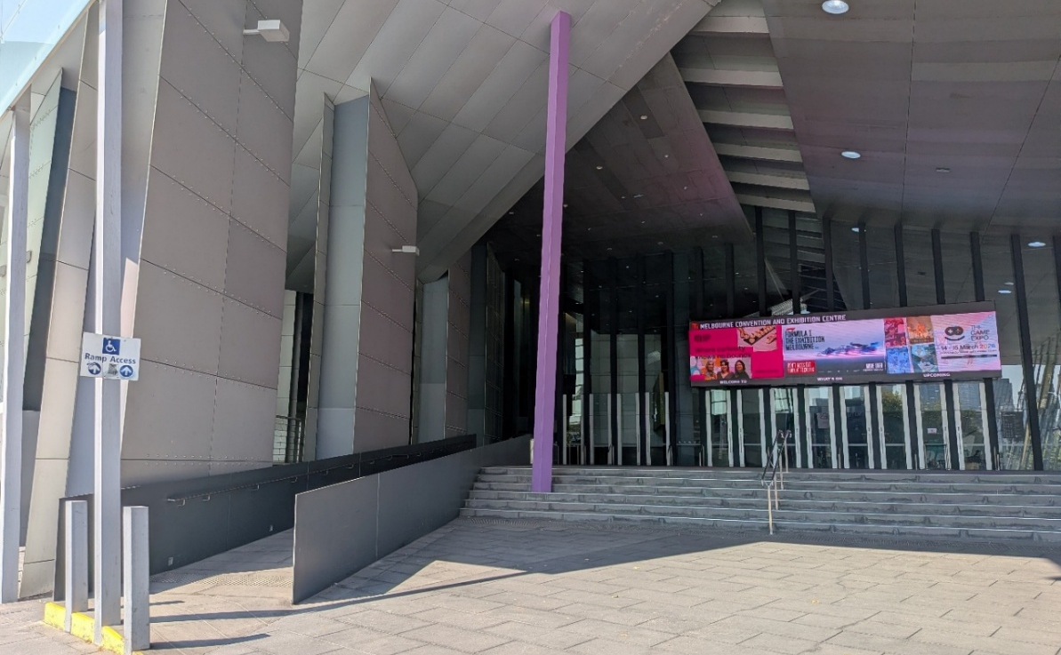
Our conference will take place in the Clarendon rooms in the Exhibition Centre within the MCEC. The closest entrance is 2 Clarendon Street, South Wharf. There are stairs and a ramp leading to the entrance. There is an automatic door in front of the ramp or pull to open doors along the top of the stairs.

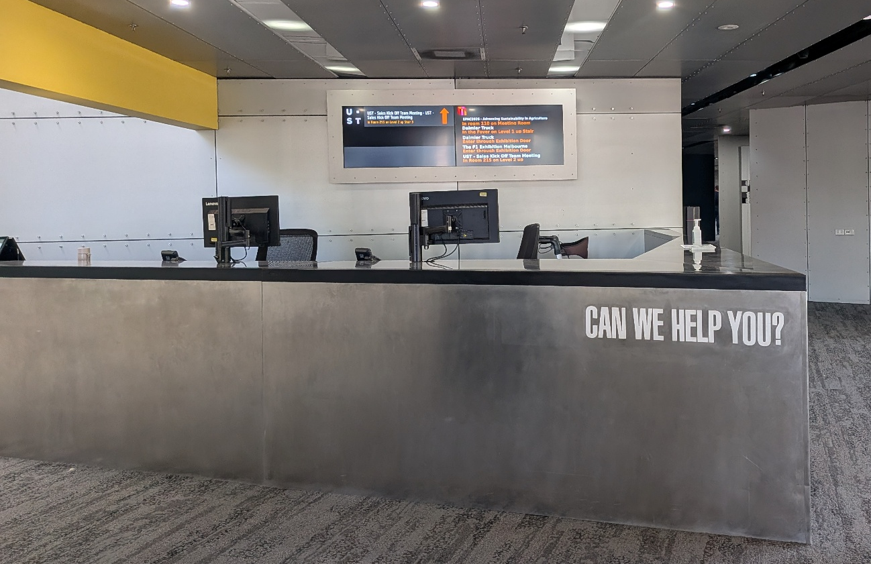
You will see a customer service desk once you enter the building, they can also assist with any questions you may have. Conference registrations will take place on level 1, behind the service desk towards the left. There are two lifts and a staircase.

Registrations will take place at tables stationed at the top of the stairs. This is located towards your right if you are exiting from the lifts on level 1.
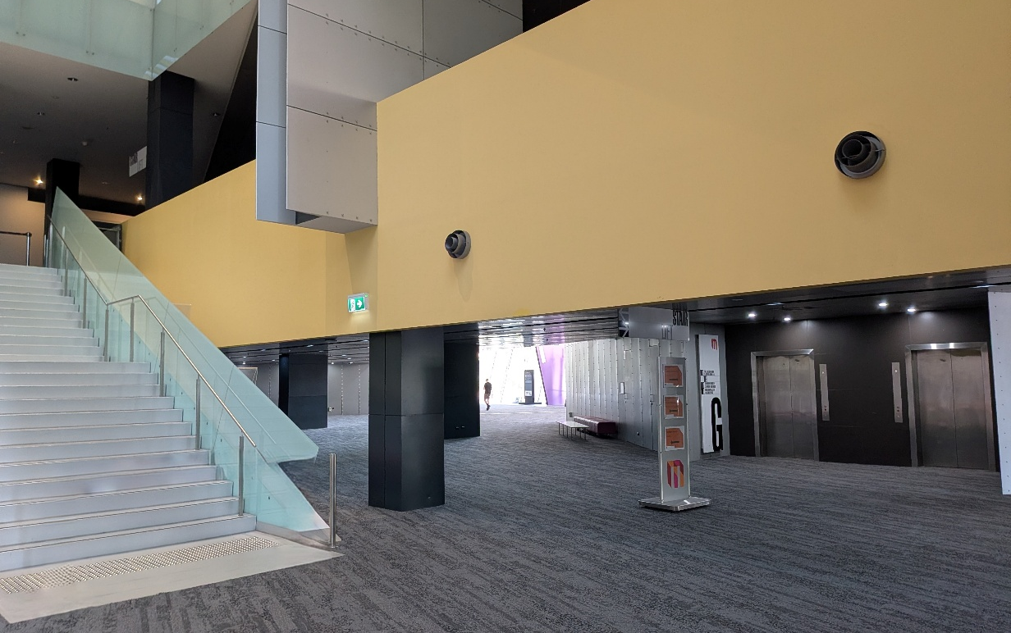

The closest bathrooms (including accessible) as you enter MCEC Clarendon entrance are to the left of the staircase on the ground floor.
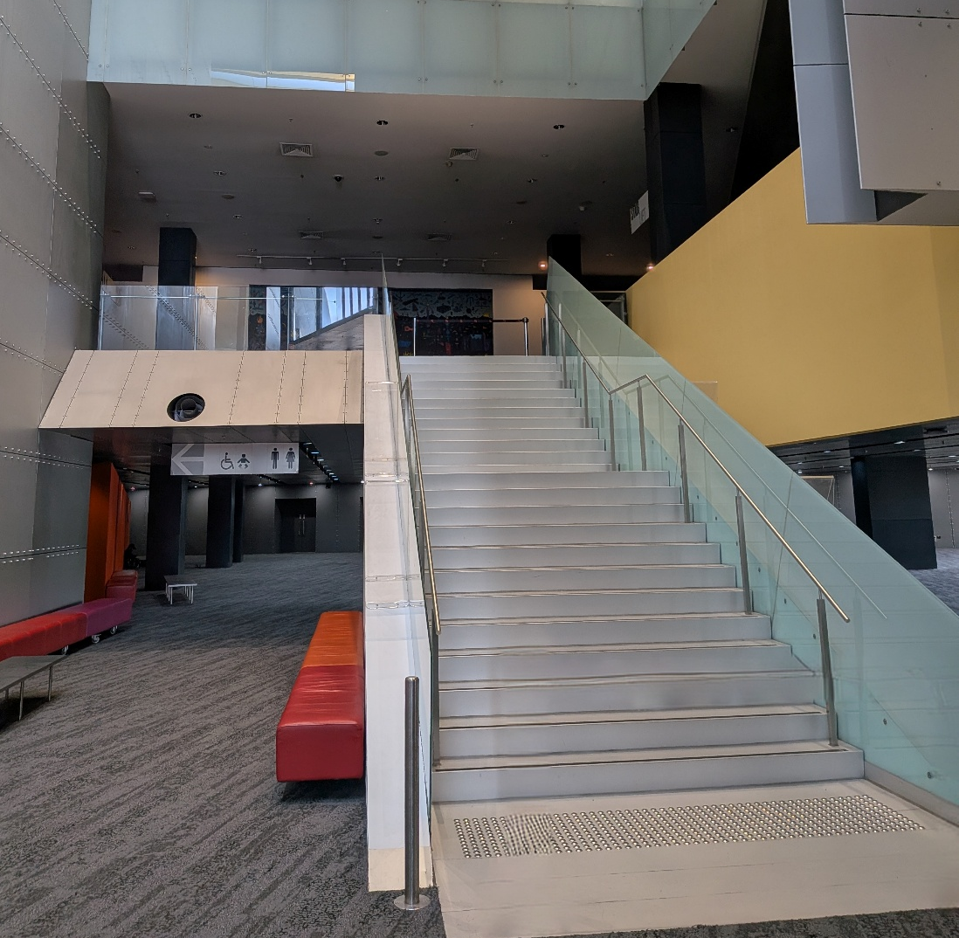

Registration process
The registration desks are located on level 1, at the top of the stairs pictured above. If you use a lift, they are located to your right as you exit. Registration is open from 8.00am – 9.30am on the first day of PreventX. Safe and Equal staff will be there to welcome and register you, share conference favours and a printed program.
You are welcome to explore the exhibitor booths located to the right of the registration desks, take a seat throughout the foyer area on level 1, get a coffee, or head to the low-sensory area in Clarendon Room C (level 1).
On the first morning, there will be a coffee cart open from 8-9.30am where you can get a complimentary coffee (or two).
The opening session will take place in the auditorium on level 1, to the left of the registration desks at 9.30am.

From Convention Centre Place
The second entry to MCEC is located at 1 Convention Centre Place, South Wharf. This is near the Pan Pacific hotel and DFO South Wharf. This entrance is a 5-7 minute walk to PreventX. From this entrance, you can head past the Goldfields café and through the corridor towards Exhibition Centre Door 1, and follow the signs to the Clarendon rooms on level 1.
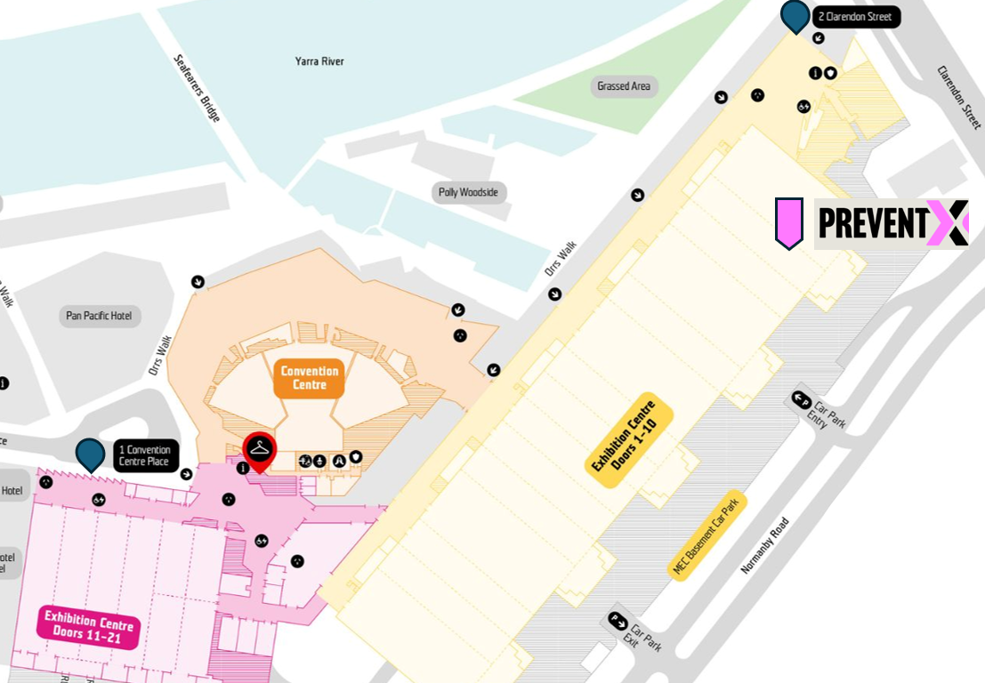

Entering the auditorium and other conference rooms
The auditorium and conference rooms have pull to open doors that are not automated. We will ensure there are Safe and Equal staff at each room to welcome guests and assist entering the space. During the session, the doors will be closed to reduce noise travel. Each room will be moderated by a staff member who can assist delegates using these doors throughout the sessions.
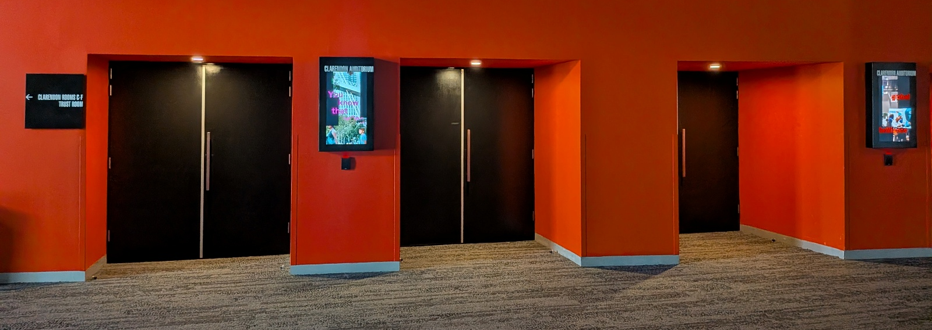

Level 4
Some sessions after morning tea and lunch will be held in rooms on level 4. To access level 4, you will need to take the lift from either the ground floor or level 1. We encourage you to allow a few extra minutes before your session to make your way to level 4 via the lifts. The rooms for PreventX are located to the right of the elevators as you exit on level 4.
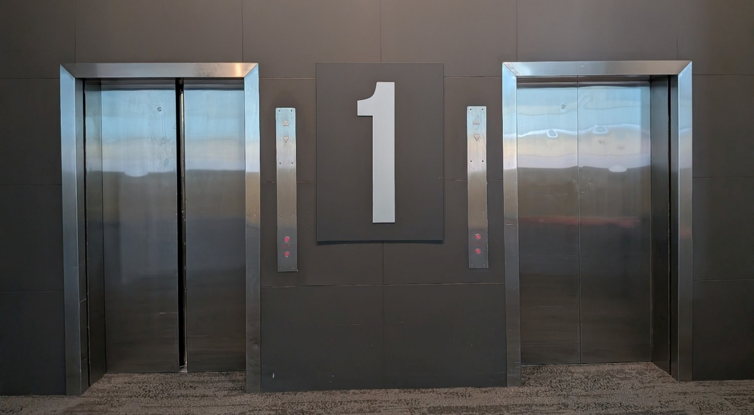

Accessible bathroom details
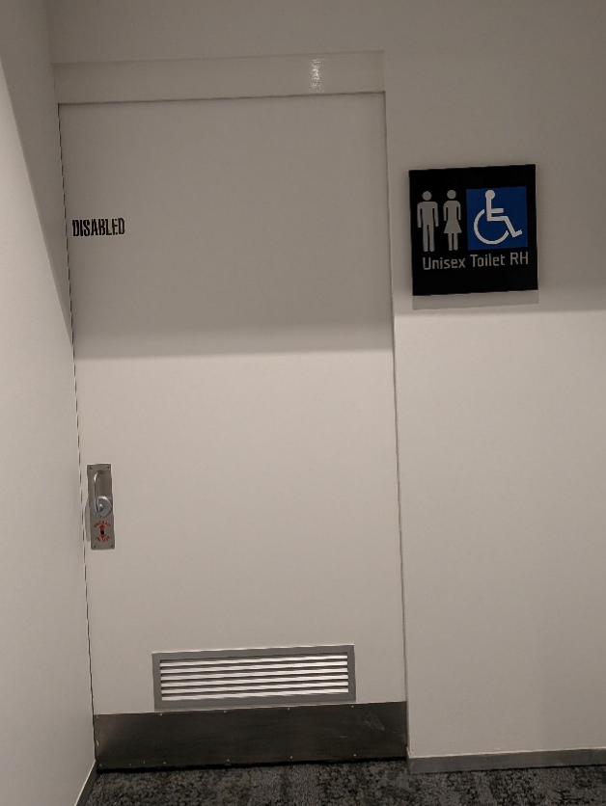
The closest accessible bathrooms will be located on the ground floor to the left of the staircase, and on level 4 (both gender neutral). The ground floor bathroom is push to open, and level 4 is slide to open. All accessible bathroom doors are approximately 85cm wide and include handrails.
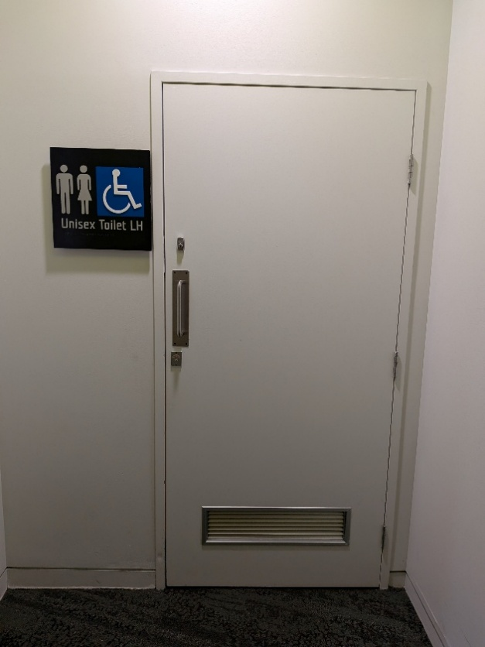

Gender-neutral accessible bathroom on level 4. Slide to open door, 85cm wide.
Gender-neutral accessible bathroom on ground floor to the left of the staircase. Pull to open door, 85cm wide.

Gender neutral bathrooms
There will be gender neutral bathrooms available on level 1 and level 4 near our conference rooms. The ground floor bathrooms are open to the public and are gendered, with one gender-neutral accessible bathroom.

Catering and water stations
There will be water stations available throughout the catering area and conference rooms. There is also a water fountain located past Door 3 on the ground floor. During meal breaks catering will be served in the foyer at the top of the staircase on level 1.

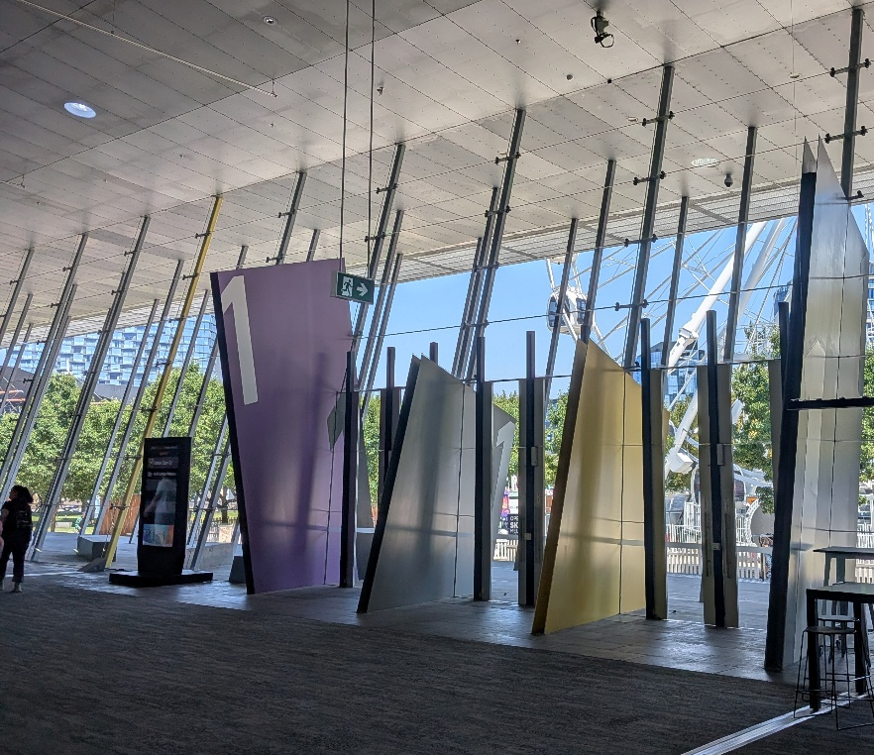
Smoking areas
The closest smoking area will be Clarendon Street, accessed via steps or a ramp. There is also a smoking area located near the entrance/exit signed Door 1, facing the river. To get there, there are push to open doors at Door 1, and an ashtray to the left.
There is also an automatic door located to the right of The Shed café that leads to this area.

Additional facilities

Low sensory space
We will have a low sensory space guided by Restorative Yarns located on level 1. To access this room, follow the signs for Clarendon C (past the auditorium). This door is push to open and 120cm wide, however we will keep this door open for folk to enter and leave as they please.

Individual support
Sam and Locky from Restorative Yarns will be available throughout the conference for one-on-one support as needed. We are holding an additional room that can be used for private discussions.

Prayer room
There are male and female purpose-built prayer rooms with a Wudu washing station and mats. This is located by the Goldfields Café, down the corridor by Door 9. This is approximately a 5-7minute walk from our PreventX area.

Parenting room + feeding room
There is a parenting room located near the Goldfields Café. This room also includes a private feeding room where a microwave is available and a combined child/parent bathroom.

Cloak room
Cloakroom facilities are available from the customer service desk by Convention Centre Place. This is located near the Goldfields Café at 1 Convention Centre Place (down the corridor by Door 9). Staff supervising the desk will store your items and ask you to fill out a tag with your details. Please note that the cloakroom is only accessible during staffed hours.

Cash free venue
Please note that MCEC is a cash-free venue and accepts electronic payment methods. If you need cash, there is an ATM located near Door 3.
To see where ATMs, charging stations, mobility aid charging stations, cloak room, changing places and prayer room are, head to their venue page where maps are provided.

Accessibility considerations

Seating + priority seating
There will be couches and seating areas located throughout the conference so folks can rest and be comfortable. Some will be highlighted as priority seating for people who require a seat through break times.
All seats through plenaries and sessions have backrests. There will be accessible seating allocated for wheelchair users, those with support animals, and others who need it. There will be priority seating for aisle seats along the first few rows, close to the exit.
In theatres, wider seats are available for use and are typically placed in accessible wheelchair spaces. Please contact bethmooney@safeandequal.org.au before the event to arrange an accessible seat.
There will be tables of various heights available in the catering area during mealtimes.

Assistance animals
MCEC welcome assistance animals inside their venue. To provide comfort for both patron and animal, consider booking a wheelchair bay with a carer seat due to limited space between seating rows. You can email bethmooney@safeandequal.org.au to arrange this.

Mobility aid charging stations
MCEC offer designated charging points for electric mobility scooters and wheelchairs, available free of charge throughout the venue. The closest charging station is located at the front of the Exhibition Centre entrance by Clarendon Street. Additional stations are located near the Goldfields Café.

Hearing Loop facilities
Hearing loop system is available throughout all conference rooms.

Live captioning
There will be live captioning available across all conference rooms.

Changing Places
There are some additional facilities available in MCEC near the Goldfields Café (approximately a 5-7 minute walk), through the corridor by Door 9. This includes the Changing Places facility MCEC have recently opened, with functional and hygienic fixtures and fittings such as a height-adjustable adult changing table, a ceiling track hoist system and a centrally located peninsula toilet, ensuring the facility is inclusive for all users.

Additional access needs
When registering for PreventX, we will also ask about any access requirements to ensure we can welcome you to participate and enjoy the conference. If you have any questions relating to accessibility, or have specific accessibility needs not mentioned, please reach out to us at prevention@safeandequal.org.au.

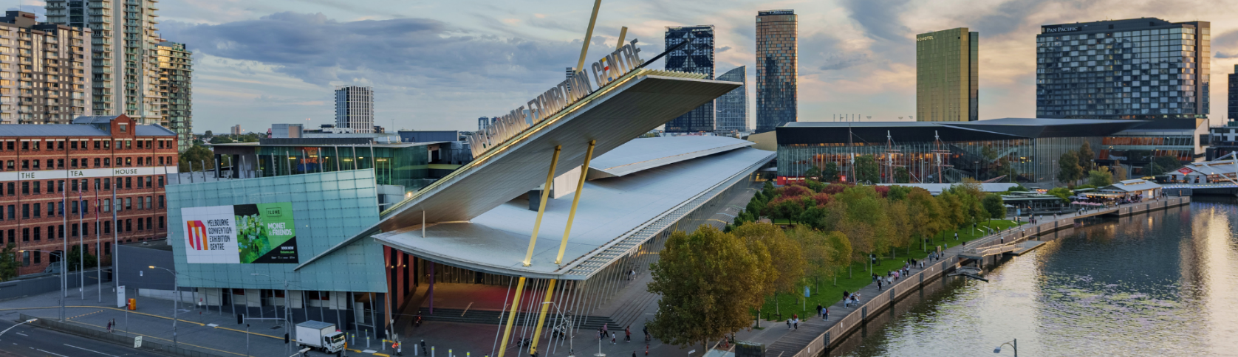
We look forward to seeing you at PreventX 2026: Stories for Change

